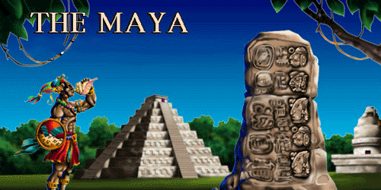

In English we will be…
- Reading a range of non-chronological reports about Mexico and the Mayans
- Reading a range of narrative tales from other cultures, with a focus on traditional Mayan stories.
- Writing a non-chronological report with a focus on:
  - Using the correct genre features
  - Using paragraphs effectively
  - Using titles and sub-titles
  - Using the correct punctuation
  - Using parentheses correctly including commas
- Writing a traditional narrative of our own, inspired by the Mayan tales, with a focus on:
  - Structuring our stories clearly and writing balanced paragraphs from the beginning to the end
  - Developing character, setting and atmosphere descriptions
  - Performing and re-telling our tales, and listening to the tales of others around our indoor campfire
- Developing our skills of planning, self-editing and evaluation
- Practising our handwriting so that we are using a cursive script, including lead-ins for all lower-case letters

In our reading we will be…
- Ensuring that our independent reading books are enjoyable, but that they are also stimulating and the correct level of challenge for us
- Introducing reading roles during our class reading as a way of carefully and thoroughly analysing texts
- Identifying features of different genres including narratives and non-chronological reports

In our ‘English Grammar, Punctuation and Spelling’ we will be…
- Learning how to structure our texts using titles, sub-titles and paragraphs that flow together
- Writing and punctuating direct speech correctly
- Reminding ourselves about types of noun; capitalising proper nouns; singular and plural nouns and the use of the apostrophe in possessive nouns
- Writing expanded noun phrases and adding prepositional phrases to them

In Mathematics we will be…
- Place Value: Recalling how we partition numbers, and understanding negative numbers
- Calculations: Practising mental maths strategies, and using accurate written methods for all four operations applying them when problem solving
- Measure: Y4: Using the four operations, decimal notation and scaling to solve problems involving length and mass, and converting between different units of metric measure. Y5: Converting between imperial and metric units, and reasoning and problem solving using units of measure
- Geometry: Y4: Describing movements between positions as translations of a given unit to the left/right and up/down; plotting given points to draw the sides to complete a polygon on a coordinate grid and describing positions on a 2D grid as coordinates in the first quadrant Y5: Identifying, describing and representing the positions of a shapes following a reflection or translation

In Science we will be…
- Learning about the human circulatory system: describing the functions of the heart, blood vessels and blood; recognising the impact of diet, exercise, drugs and lifestyle on the way the body functions; describing the ways in which nutrients and water are transported within animals, including humans

In History and Geography we will be…
- Using map skills to locate Mexico and the origins of the Mayan civilization
- Learning about the Ancient Maya civilization, their daily lifestyles, their beliefs, inventions and important Mayan places and buildings

In D.T. we will be…
- Practising cooking techniques, designing recipes, making traditional Mexican dishes, tasting and evaluating a range of Mexican food

In Art we will be…
- Analysing the work of famous artists and Mayan art
- Painting and creating performance art

In P.S.H.C.E. we will be…

Learning about healthy lifestyles
In French we will be…

Learning how to give directions in French

In Music we will be…

Listening to South American music and exploring dynamics, tempo and structure

In R.E. we will be…

Understanding Good and Evil through the Hindu celebration of Holi

In P.E. we will be…
- Learning salsa, samba, rumba and other Latin American steps in our dance sessions
- Playing invasion games such as netball and basketball in our games sessions

In Computing we will be…
- Learning how to create a database on the different countries of South America

