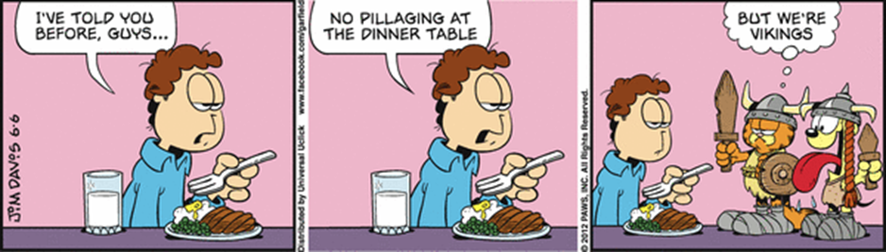
Y4/5 Homework Grid: Vikings and Anglo Saxons
Please choose one activity a week and record which activity has been completed by adding the date into the box provided. Please add comments, should you wish to, regarding your child’s engagement/enjoyment/understanding of each activity. Please choose at least two from each column during each half term.
English |  | Maths |  | Topic/Creative
Writing for pleasure:  Write a job advertisement for a Viking warrior.  Wanted – Viking Warrior - must be | Date:  Comments: | Draw a picture of a symmetrical Viking longboat or longhouse AND a Viking helmet. Draw in the line(s) of symmetry | Date:  Comments: | Write some messages using Viking runes. | Date:  Comments:
Enjoying your reading?  Research the Anglo Saxons. Where did they come from? Write a paragraph on why they came to Britain. | Date:  Comments: | Estimate the weight of a Viking’s sword using scaling.  That means – find something smaller with similar materials- how will its own weight and height help you make the estimate? Write down what you do AND the calculations you make. | Date:  Comments: | Choose one of the countries that the Vikings were from (Denmark, Norway and Sweden). Find out what the country is like now and make a poster to tell people all about it. | Date:  Comments:
With your family, create a list of 5 Viking related nouns, plus 5 verbs, adjectives and adverbs from everyday language. Who can make the silliest sentence using one word from each list?  Record the best examples in your homework book. | Date:  Comments: | Learn your times tables and division facts; focus on the tables you don’t know so well. | Date:  Comments: | Design a Viking-themed board game that you can play with your friends during privilege time. | Date:  Comments:
Spelling practice – take a week to really focus on your spellings, taking not only your list, but also words that you have corrected in your written work. | Date:  Comments: | Choose a recipe. Look at how many portions it makes. Change the recipe so it will serve 24 hungry Vikings. Show the old and new quantities in your homework book. | Date:  Comments: | Design a piece of Viking jewellery. | Date:  Comments:

