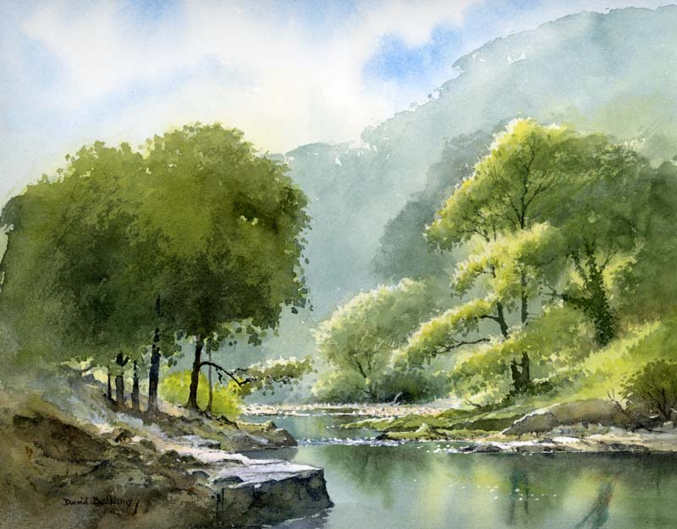
Rivers

In English writing, we will be…
- Writing an explanation text explaining the water cycle.
  - Using a dictionary and thesaurus to define and increase our vocabulary.
  - Using a range of conjunctions and cause and effect language.
  - Using expanded noun phrases to add detail.
  - Using formal language and technical vocabulary.
  - Using basic punctuation, commas to clarify meaning and punctuation for parentheses.
- Practising our writing skills through short pieces of writing inspired by a traditional novel ‘Watership Down’.
  - Writing descriptions of characters and settings.
  - Using paragraphs and the correct speech punctuation (Y5).
  - Using description and detail to create an atmosphere (Y6).
- Developing our skills of using a dictionary, planning, proof-reading, understanding the marking code and responding to feedback.

In English reading, we will be…
- Comparing, analysing and annotating a variety of explanation texts.
- Analysing, clarifying, summarising and retrieving facts from a traditional novel by reading extracts.
- Understanding the characters, plot, and themes (Y6) presented in a traditional novel using visual literacy techniques and drama and roleplay.
- Understanding the different ‘Reading Roles’ to help us to think about texts thoroughly and (Y6) from a more critical perspective. Please see the attached sheet.

In our ‘English Grammar, Punctuation and Spelling’, we will be…
- Reviewing our knowledge of the basic grammar terms, word classes and punctuation uses.
- Reviewing previous spellings patterns, practising Y5 and Y6 spellings words, introducing new spelling rules and learning different spelling strategies.
- Y5: Using modal verbs, adverbs, and relative clauses.
- Y6: Understanding synonyms, antonyms and subject and object.

In Mathematics, we will be…
- Place Value: Reading, writing and comparing numbers up to 10,000,000. Rounding any number up to 1,000,000. Identifying the value of each digit and multiplying and dividing by 10, 100, 1000. Y6: Decimal numbers, negative numbers and place value reasoning problems.
- Calculations: Practising mental adding and subtracting skills. Solving problems involving addition and subtraction using formal methods. Y5: Identifying multiples, factors, prime numbers and factor pairs. Multiplying and dividing whole numbers. Y6: Multiplying and dividing up to 4-digit numbers by a 2-digit number using a formal method.
- Measure: Estimating, comparing, measuring and calculating with different units of metric measurement. Y5: Converting between different units of metric measure. Y6: Converting between standard units of metric and imperial measure up to three decimal places.

In Science, we will be…
- Learning about the states of matter: solids, liquids and gases and the water cycle and conducting practical investigations.

In Geography, we will be…
- Recognising the features of a river and locating rivers on maps.

In Art, we will be…
- Practising watercolour techniques to create a watercolour landscape.

In PSHCE, we will be…
- Creating a class charter and understanding a range of relationships.

In French, we will be…

Learning and revising key communication skills and general greetings (Mrs Bartlett).

In Music, we will be…

Focusing on structure, timbre and dynamics inspired by rivers (Mrs Rennison).

In RE, we will be…
- Investigating the concept of freedom and justice in Christianity (Mrs Bartlett).
In PE, we will be…
- Creating a dance inspired by rivers (Mrs Bartlett).
- Playing invasion games with a focus on rugby (Mr Bint).

In Computing, we will be…
- Learning about E-Safety and creating presentations using PowerPoint or Google Slides.

This term’s vocabulary will be…
Science - States of Matter and Water Cycle: solid, liquid, gas, water vapour, melt, freeze, heat, cool, evaporate, condense, thermometer, temperature, evaporation, condensation, precipitation, transpiration, atmosphere, etc.
Geography – Rivers: source, mouth, estuary, delta, erosion, meander, floodplain, tributary, channel, weir, etc.

