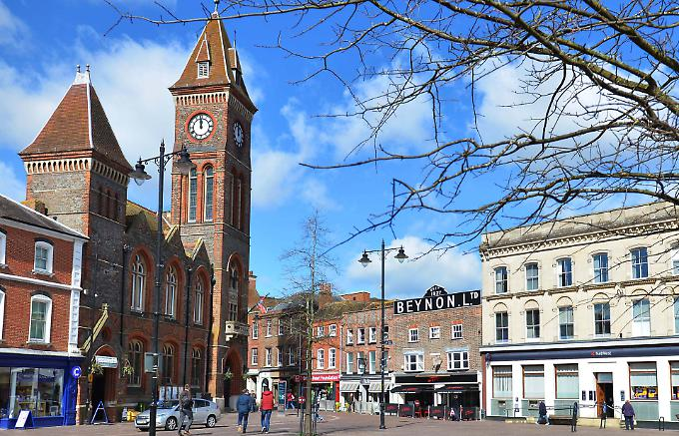
Our World!
Sycamore and Silver Birch Classes
Spring 2 2020
English
Writing
- Focus text and other themed texts around ‘Our World!’
- Key skills – (Y1) composing and recording sentences, thinking about capital letters, full stops and finger spaces, (Y2) focussing on using a range of sentence types, as well as conjunctions (and, because, when, if, so, but), using language for impact - including the use of expanded noun phrases, and editing our work, (Y3) continuing to embed our understanding of the difference between simple and compound sentences, and a range of conjunctions (although, while, since, until), and continuing to implement fronted adverbials, speech and the use of paragraphs in our writing
- Handwriting – continuing to focus on joined hand-writing (this will be a gradual process when children are ready). (Y2) thinking about the size of our writing and the relationship between the lower case and upper case letters, (Y3) developing a confident, quicker joined script
- Y1- Phonics- building on existing phonics knowledge and introducing alternative sounds
- Y2/3 Spelling – continuing our yearly spelling programme ‘No Nonsense Spelling’ – working on key word patterns each week in conjunction with the common exception words for each specific year group (spellings will come home associated with this programme weekly)

Reading
- Whole class reading activities linked to our focus texts and other similar texts
- Y1/2- Continuing to use our phonic skills to decode new words, and use word patterns to help us (linked to spelling)
- Focusing on our understanding of character motivation using our inference skills, and the author’s use of language for effect
- Recognising different themes and convention of texts

Mathematics
- Measure- (Y1) tell, write and draw the time to hour and half hour, (Y2) tell, write and draw the time to quarter to and past the hour, (Y3) tell, write and draw the time from an analogue clock, using Roman numerals, 12-hour and 24-hour clocks
- Place value- (Y1) counting on and backwards, (Y2) count in 2s and 5s, (Y3) count in multiples of 50 and 100
- Problem Solving – (Y1) solve one step problems, (Y2) solve multiplication and division problems, (Y3) solve one and two step questions using information in scaled bar charts, pictograms and tables
- Multiplication and division- (Y1) use arrays to show commutativity, (Y2) recall and use multiplication and division facts for 5x table/recognise odds and evens, (Y3) use known facts to generate new ones, link multiples to equivalent fractions
- Statistics-identifying and interpreting data in bar charts, pictograms and tables
- Fractions- (Y1) Recognise quarters of an object, shapes or quantity, (Y2) recognise 2/4 and 3/4 of a length, shapes, set of objects or quantity, (Y3) equivalent fractions with small denominators

P.E
- Develop fundamental movement skills, becoming more confident and competent
- Application of simple tactics and strategies
- Understanding of the short term effects of exercise on the body

Dance
- Exploring movement ideas, responding freely and imaginatively to stimuli
- Compose and perform dance sequences that explore different moods, ideas and feelings, comparing and evaluating our own work and others

Science
- Exploring things that are living, dead, and things that have never lived
- Describe how different habitats provide for the basic needs of different animals
- Recognise that environments can change and that this can sometimes pose dangers to living things
- (Y1 only) identifying seasonal changes

R.E - Hopes and Dreams
- Thinking about our hopes and dream for the future of the world
- Considering Palm Sunday and its impact on Christians
- Sharing stories of Hope

PSHCE
- Appreciate different sorts of families and communities, how we are proud to be British and how we are connected to other people and places around the globe

Design and Technology
- Design, create and evaluate:
Y1 pin wheels, Y2 windmills, Y3 windmills with an electrical element

Music
- Learn to sing songs related to the ‘Our World’ theme, working collaboratively with others
- Understand the musical elements of dynamics (loud and quiet) and tempo (fast and slow)

Computing
- Understand what a simulation is and how/why they are used in the real world
- Learn to play simple simulation games

Geography
- Locate the countries, capital cities and seas of the UK
- Comparing Newbury past and present
- Investigating maps and pictures
- Locating and identifying features on a map, creating our own

Role Play Corner - Inside a farm shop!

Topic Words
Local World Newbury
Habitat Environment Berkshire
Hampshire Wonders County
Urban Landscape

