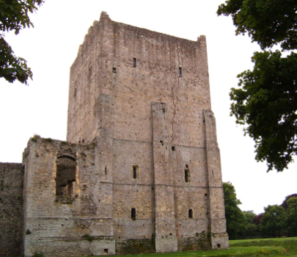
Castles!

Sycamore & Silver Birch Classes

Summer 2 2021

English
- Writing Y1, Y2 and Y3 Embedding all the writing skills we have learnt this year, and applying our understanding of these when writing stories based on our ‘Castle’ topic. Applying our understanding of writing for impact and using descriptive language to engage the reader when writing setting descriptions.
- Y3 Continuing to focus on writing tools such as fronted adverbials and different conjunctions within compound and complex sentences.
- Handwriting Y2 thinking about the size of our writing and the relationship between the lower case and upper case letters, Y3 remembering to join consistently throughout our handwriting.
- Phonics Y1 building on existing phonics knowledge and introducing and embedding alternative sounds.
- Spelling Y2/3 ‘No Nonsense Spelling’ – working on key word patterns each week in conjunction with the common exception words for each specific year group (spellings will come home associated with this programme weekly).
- EGPS Y2/3 English Grammar, Punctuation and Spelling-focusing on the application of writing skills and embedding them in our writing.
Reading
- Whole class reading activities linked to our focus texts and other similar texts.
- Y1/2 Using our phonic skills to decode new words, and use word patterns to help us with this (linked to spelling).
- Focusing on our understanding of character motivation using our inference skills, and the author’s use of language for effect.
- Recognising different themes and convention of texts.
- Asking and answering questions about the text.
Mathematics
- Statistics and Data Handling Y2 Interpreting and constructing simple pictograms, tally charts, block diagrams and simple tables, Y3 Answering questions about totals and comparison of discrete data.
- Reasoning Y1,Y2 and Y3 Developing reasoning skills to solve more complex problems in number and their relationships.
- Shape Y1 Recognising and naming common 2-D shapes such as common quadrilaterals and different triangles, and common 3-D shapes, such as cubes and cuboids. Y2 Comparing and sorting common 2-D and 3-D shapes, knowing that rotation is a turn and knowing that a quarter, half and three quarter turns represent a right angle (clockwise and anti-clockwise). Y3 Recognising 3D shapes in different orientations and describe them, knowing that two right angles make a half turn, three make a three quarter turn and four make a complete turn, identify whether angles are greater than or less than a right angle.
PSHCE
- Identifying ways for keeping physically and emotionally safe.
- Recognising that we share a responsibility for keeping ourselves and others safe.
- Describing our feelings, reflecting on the past year, and looking towards next year.
P.E.
Athletics
- Exploring different ways of throwing, showing awareness of space and safety
- Developing the quality, range and consistency of the techniques used for running and beginning to develop their ability to choose and use simple tactics and strategies in different situations
Striking and Fielding (Cricket and Rounders)
- Understanding and identify good striking and fielding techniques
- Combining skills to play effectively in a small sides striking/fielding game, and use simple attacking and defending tactics e.g. work as a team to field the ball
DT
- Designing and creating our very own castle out of a shoebox.
Designing and making a working drawbridge, looking into the reasons castles needed this defense system.
History
- Recognising and naming the features of a castle.
- Understanding the different roles within a castle and hierarchy.
- Comparing Queen Elizabeth’s I reign to Queen Victoria’s and finding similarities and differences.
- Exploring the life of Queen Elizabeth II and putting her key life events in chronological order.
- Creating a family tree For the Royal family.
Computing
- Exploring a range of simulation programs and games.
- Playing a digital castle escape room!
- Using the ‘Paint’ app to annotate a digital picture.
R.E
- Exploring and reflecting on our own ways of life.
- Considering the importance of Passover to the Jewish people.
- Discussing how and why it is important to remember significant times in our own lives.
Art and Design
- Researching historical portraits and collecting and developing sketches and drawings.
- Recognising and naming the primary, secondary and some tertiary colours.
- Using, recognising and describing lines, patterns, textures and basic shapes in their work and the work of other artists.
- Creating a Self Portrait highlighting their individual identity using symbolism.
Music
- Recapping the musical elements of structure, dynamics and tempo.
- Composing music using a castle video as stimulus.
- Using our voices to compose castle-themed lyrics to well-known melodies.
Role Play Corner In the keep!

Key Vocabulary!

Monarch
Drawbridge
Fortress
Moat
Noble
Trebuchet
Turret
Ramparts
Portcullis
Tower
Shield
Armour
Dungeon

