Cherry Class
Autumn Term 1 2020
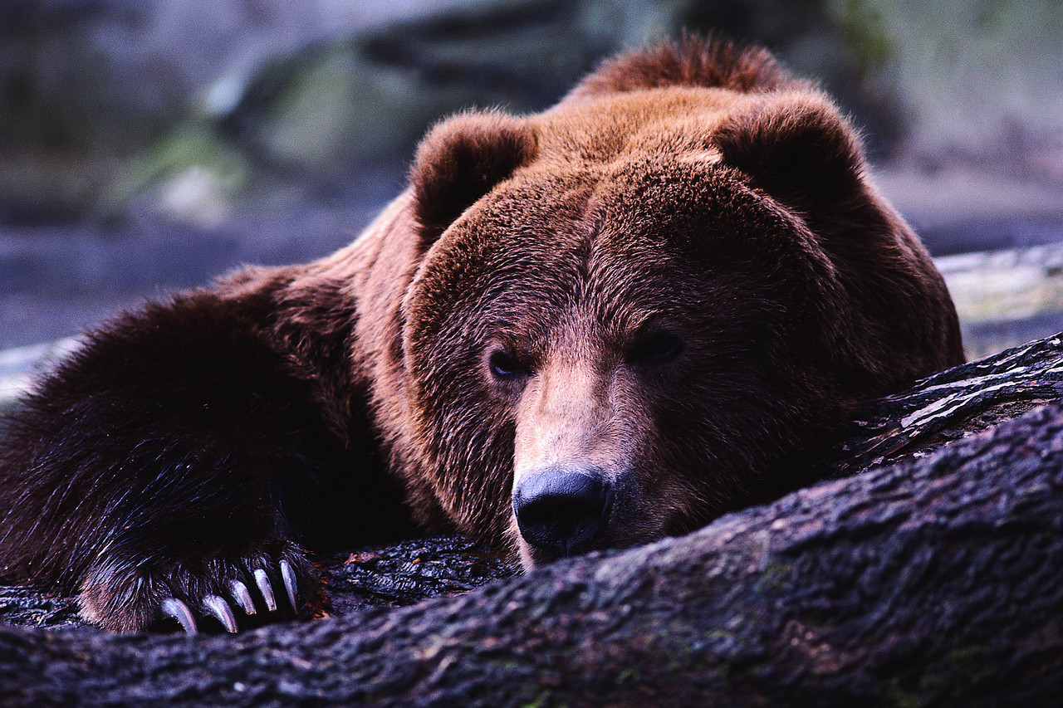
Bears and Rhymes

Here is a summary of our planned learning for this half-term. But remember:
No plan in Reception is ‘set in stone’!

BP KA September 2020

Communication, Language and Literacy
We’re going on a Bear Hunt
Goldilocks and the Three Bears
Get well card for Humpty Dumpty
Terrible sandwich recipe
Non-fiction books for ‘research’

Mathematics
Bear footprints - numbers in order
Numbers 1-20
Counting with bears
Make a bed and bedding, the right size for your bear
Sorting bears into sizes
Making a pattern with bears

Physical Development
Cutting out bears
Using tools safely for making beds
Games: Beanbags

The World
Bear Hunt in the Nature Area
Where do bears live in the world?
What kinds of bears are there?

Technology
Use Purple Mash to draw a bear on the computer
Logging on and playing phonics games

Expressive Arts and Design
Draw and Paint Bears
Bear Hunt collage
Bear Hunt Music

Personal, Social and Emotional Development
Class charter: rule and routines.
New Beginnings

RE
Welcome - We are unique and special

