Homework Grid Summer 1: Castles!
English |  | Maths |  | Topic/Creative
Write a letter to the queen asking her if we could visit Buckingham Palace. Try to convince her why you should have the opportunity to visit, and write about what you would like to see and do whilst you are there! | Date:  Comments: | Continue to practise your current level of mental maths challenge to help you move up to a new level.  Practise the level you are on by repeating it, writing it down and asking your family to help by testing you. Record your practice in your homework book.  Year 1: Can you count onwards and backwards from any given number (up to 20 and beyond)? | Date:  Comments: | Create your own shield using different resources and materials found around the house.  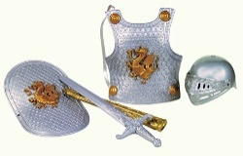  Y3: Write a set of instructions, explaining to someone how to make the shield. | Date:  Comments:
Focus on your Common Exception Words (CEW). Choose a few to practise your spellings. You could make up a silly mnemonic, a song or even a rap to help you remember how to spell them and record in your homework book. | Date:  Comments: | Adding and subtracting!  Have a go at adding and subtracting some numbers. Remember, to show your workings out!  Y1: Use numbers up to 20. (practise number facts i.e 12+8=20, 20-12=8).  Y2: 2 digit and 2 digit (blank number line).  Y3: 3 digit number and 3 digit number (column method). | Date:  Comments: | 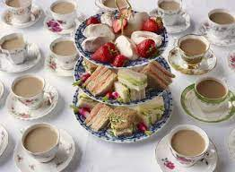  Have a Royal Tea Party with the members of your family. Take pictures of your experience and stick them in your homework books. | Date:  Comments:
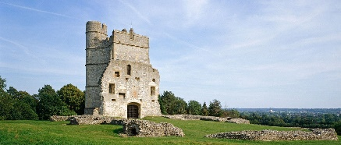  Research a castle or palace of your choice and create a fact file all about it. Who lived there? Who lives there/owns it now? When was it built? What was it used for? | Date:  Comments: | Purple Mash!  https://www.purplemash.com/login/  Log on to Purple Mash and practise your maths skills!  Year 1: Counting in 2s, 5s and 10s.  Year 2: x2, x5, x10 tables  Year 3: x3, x4, x8 tables  Please practise your multiplication and division facts for your timestables too, for example:  5 x 2 = 10 so, 10 divided by 2 = 5 | Date:  Comments: | 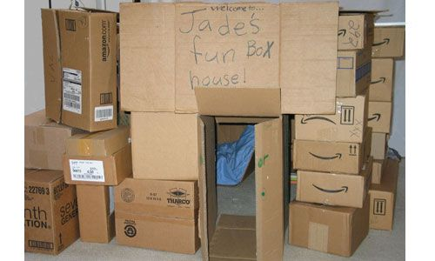  Build your own fort out of things you find around your house. You could use pillows, blankets, boxes or even build your fort outside, using sticks and twigs! | Date:  Comments:
Read a story that has a castle, knight or dragon character.  Y3: Write a review about the book you have read. What did you like about it? What didn’t you like about it? Would you recommend it to someone else? What story does it remind you of? | Date:  Comments: | Make up your own maths word problems for an adult at home to solve! These can be addition, subtraction, multiplication or division word problems. | Date:  Comments: | Interview the adults at home and create a family tree! | Date:  Comments:
Please choose one activity a week, and record which activity has been completed by adding the date into the box provided. Please add comments, should you wish to, regarding your child’s engagement/enjoyment/understanding of each activity. Please choose at least two from each column during each half term.

