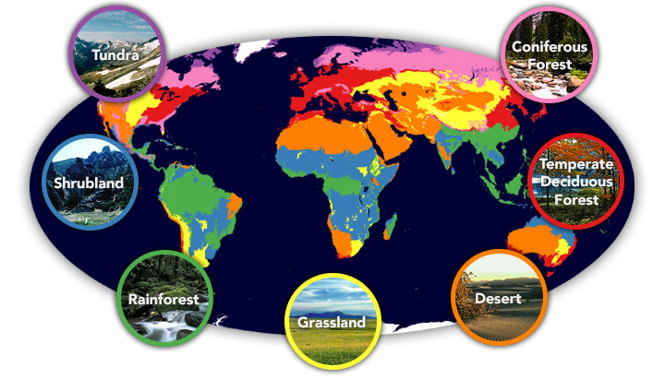Home, Sweet Home
(Biomes and Habitats)

In our writing we will be…
- Writing descriptions of a story setting using examples from ‘The Hobbit’ ,‘Harry Potter’ and “Scooby-Doo” as inspiration.
- Writing setting descriptions.
  - Using figurative language such similes, metaphors, onomatopoeia and personification.
  - Using language that describes the mood and atmosphere of a setting.
  - Varying sentence structures and using a variety of punctuation such as dashes, brackets and commas to add in relative clauses.
  - Using a range of cohesive devices to achieve flow and cohesion.
- Writing balanced arguments about plastic usage and deforestation in the Amazon Rainforest
- Developing our skills of editing and evaluation.

In our reading we will be…
- Using visualising, clarifying and summarising to help us understand a text.
- Exploring the ways in which grammar, punctuation and vocabulary can be used for effect.

In Mathematics we will be…
- Adding and subtracting with larger numbers (mentally - Y5; using written methods Y4).
- Solving problems using columnar addition and subtraction.
- Using negative numbers.
- Translating and reflecting shapes on a co-ordinates plane (Y4: 1st quadrant, Y5: all four quadrants).
- Converting and measuring in different units of measure (Y4 metric only; Y5 will also look at imperial measures).
- Practising mental methods, informal written methods (Y4 and 5) and short and long written methods (Y 5 only) for multiplication and division.
- Scaling and proportion (Y 5).
- Learning to order and equate fractions and decimals (both years) and percentages (Y5).

In Science we will be…
- Looking at Living Things and their Environment.
- Finding out how plants and animals are categorised.
- Using a range of keys to identify different plants and animals.

In Design Technology we will be…
- Developing our technical knowledge of how recipes can be adapted
- Designing, making and evaluating a snack using ingredients from a biome.

In PSHE we will be…
- Discussing the wider world and global issues.

In Geography we will be…
- Using our location knowledge to identify longitude, latitude, etc. on a world map.
- Describing key aspects of different biomes.
- Studying the physical and human geography of the Amazon Rainforest.

In French we will be…
- Learning how to talk about different animals.

In Music we will be…
- Looking at pitch and structure by creating a picture of the rainforest inspired by music from the Brazilian composer Heiter Villa-Lobos.

In RE our topic will be…
- Living Difference – Ummah: Community.

In PE we will be…
- Developing our invasion games skills through netball and basketball.
- Developing our skills in gymnastics.

In Computing we will be…
- Investigating The Crystal Rainforest simulation programme.

