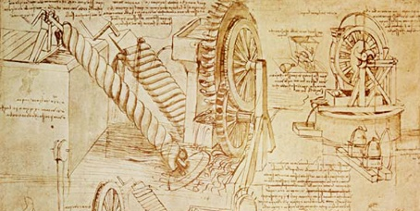

Hello Maple families! This term our topic is Ingenious Inventions! Please choose at least two from each column for this half-term, and record which activities have been completed by adding the date into the box provided. You can also add comments about how your child got on if you wish! I look forward to hearing what you have learnt about!
English |  | Maths |  | Topic
Spelling: Have a go at my new game Spelldle! Which one of your spelling words will win? To play, you begin with a spelling from your list. Then, can you change one letter in the spelling to make another word? You are not allowed to add or takeaway letters. If you can, keep going until you can’t make a new word. Sometimes you may not be able to change any letter to make a new word. The winning word is the word that makes the most new words. | Date:  Comments: | 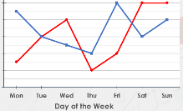  Statistics: With the help of an adult, keep a record of the amount of time you spend watching television and using a computer each day in minutes. Keep this record for two weeks and then draw a graph to show your results. Plot one week in red, and one week in blue. Y5: As well as plotting each day on the x-axis, also plot the average usage for that day of the week too. Do any patterns emerge? | Date:  Comments: | P.E.: Please invent a new game to play as a class warm-up for P.E. lessons! It could involve tennis balls or bean bags or hoops or no equipment at all! It must get everybody moving! Explain to me how it is played and draw a diagram if this helps you to explain it. Then, we may just play it! | Date:  Comments:
Reading: Research an invention from the year you were born. Find out as much information about it as you can and make a little fact-file. Challenge: You could also do this for the year a grandparent was born in, and a parent! | Date:  Comments: | 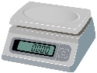  Measure: Please ask an adult to do this with you for safety. Weigh five inventions around your home e.g. a hair dryer, a screwdriver or a computer mouse. Record each mass in grams and kilograms. Y4: Can you also round each mass to the nearest 10 grams Y5: Can you also round each mass to the nearest 100 grams | Date:  Comments: | D.T.: Become an inventor! Design something that doesn’t already exist which you would use in your life. Draw and label a diagram of it, explain how it works and perhaps even what it might be made out of. | Date:  Comments:
Speaking and Listening: Interview some of the adults in your family. Ask them about an invention that they couldn’t live without. What do they use it for? Has it always been in their life or is it a more recent addition? You can think of more interesting questions to ask as well and then neatly present your interview questions and their responses. | Date:  Comments: | Statistics, Addition and Subtraction: Do you, or anyone in your family, own a device that records then number of steps they have taken? Please ask them to record the amount of steps they have taken at every hour that they are awake for one day at the weekend. [Challenge: Can you create a graph to show this?] How many steps do they walk in total? What is the difference between the highest and lowest amount of steps? | Date:  Comments: | Science: With an adult to guide you, research and then create a list of tips for electrical safety. Design a poster to show children how to be safe around electricity. | Date:  Comments:
Grammar/Handwriting: Can you think of five sentences that you can completely change the meaning of by putting the comma in a different place? Write both of the sentences for each example, in your best handwriting (remember your lead-ins and joined letters). | Date:  Comments: | 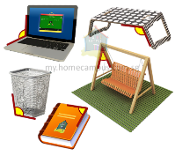  Geometry: Y4: Take photos, or draw diagrams, of angles made by objects in your house e.g. the angle between the arms of a pair of tweezers. Record whether the angle is acute, a right-angle, obtuse, a straight line or reflex. Y5: Take photos, or draw diagrams, of angles made by objects in your house. Measure the angles made with a protractor. | Date:  Comments: | Art: Choose an invention in your home, for example a tin opener, a remote control or a pair of scissors. Draw it using just your pencil but make it look as life-like as possible. Remember what we learnt about tonal scales last term in Art. | Date:  Comments:
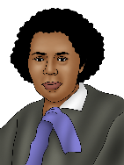  Reading and Writing: Who do you think the greatest female inventor of all time is? With the support of an adult, research female inventors. Then decide yourself which one you consider to be the greatest and then write about her, explaining why you think she deserves that accolade! | Date:  Comments: | Y4 Times Tables: Please practise the Times Tables Assessment on Purple Mash (as we do at school) regularly and try to beat your score. Learning those tricky ones that you get incorrect will really help!  Y5 Multiplying and dividing decimals by 10, 100 and 1000: Please revise this and then practise using the 2Do task on Purple Mash. | Date:  Comments: | Computing: Create a PowerPoint about an invention of your choice. When was it invented? Who was it invented by? Why has it been successful? How much does it cost to buy? How much does it cost to make? | Date:  Comments:

