English |  | Maths |  | Topic/Creative
On the computer or using books, research The RHS Chelsea Flower Show and create a fact file giving information about what it is, when it is, etc.  Your fact file could be made on the computer and printed for your homework book, or written. | Date:  Comments: | Continue to practise your current level of mental maths challenge to help you move up to a new level.  Practise the level you are on by repeating it, writing it down and asking your family to help by testing you. Record your practice in your homework book.  Year 1: Can you count onwards and backwards from any given number (up to 100 and beyond)? | Date:  Comments: | 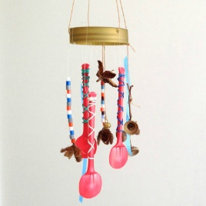  Make your own windmill or your own wind chime! Take a photo to stick in your homework book.  Y3: Write a set of instructions on how you made it! | Date:  Comments:
Design your own watering can.  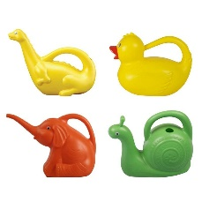  On one page, write a description of what it looks like. Then, on the other page, draw a picture of it.  Year 2: Can you use and, but, because conjunctions to extend your sentences?  Year 3: Can you include subheadings: design, colour, size, etc. | Date:  Comments: | Hit the Button!  https://www.topmarks.co.uk/maths-games/hit-the-button  Year 1: doubles and halves and number bonds!  Year 2: 2s, 5s, 10s  Year 3: 3s, 4s, 8s  Sumdog!  https://www.sumdog.com/user/sign_in  Practise your maths skills online! | Date:  Comments: | 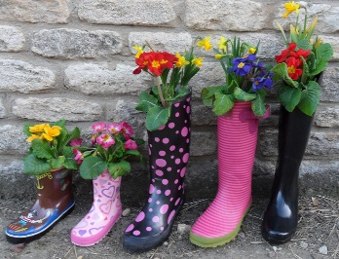  Design and make a plant pot using a recycled item. How adventurous can you be? | Date:  Comments:
Pick a flower that stands out to you. Write an acrostic poem about it. What does it look like? What does it smell like? What does it feel like?  Y2/ Y3: Think about using a range of expanded noun phrases to make your language more impactful for the reader! | Date:  Comments: | Pick some plants in your garden. Make a bar chart of the different types of plants you can see and how many different plants you can spot!  Y3: Make sure you label your axes! | Date:  Comments: | Go on a Nature Hunt and make a collage of the different things you find! This may be interesting leaves, flowers or plants! You could even make rubbings of the leaves or materials that you find using crayons or pencils. | Date:  Comments:
Grow your own plant at home and make a plant diary. Take pictures of its progress and write what you see. What does it need to be able to grow? | Date:  Comments: | Measure the different sized leaves in your garden. Draw them and then write their measurements in cm next to them. | Date:  Comments: | Go outside and help and adult with the gardening! Ask questions about the plants you see! | Date:  Comments:
Homework Grid Summer 1: Grow Your Own!
Please choose one activity a week, and record which activity has been completed by adding the date into the box provided. Please add comments, should you wish to, regarding your child’s engagement/enjoyment/understanding of each activity. Please choose at least two from each column during each half term.

