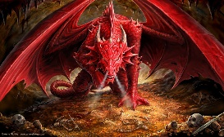
Willow Homework Grid: Dragons and Mythical Creatures
I I did this independently with no help.
S I did this with some support.
H I needed lots of help and found it tricky.

English |  | Maths |  | Topic/Creative
Writing:  Watch a movie or read a book with a famous dragon (Raya and the Last Dragon, Hobbit, How to train a Dragon, etc). Then, write a description of the dragon. Think about the dragon’s appearance: parts of the dragon (wings, tails, talons), height, shape, skin, face/head (shape, colour, texture, wound, scars, eyes, mouth, teeth, nose, ears), etc. Think about the dragon’s behaviour: smells, sounds, movement, abilities, actions, emotions, personality, etc.  Y6: Can you include similes and metaphors? | Date:  Comments: | Place Value, Number and Calculations:  Y5: Write a 7-digit number.  Y6: Write an 8-digit number.  a) Write the number in words.  b) Write the number in expanded form.  c) What is the value of the tens digit, thousands digit and hundred thousands digit?  d) Write the new number when you x10 x100 x1000.  e) Write the new number when you ÷10 ÷100 ÷1000.  f) Double the number.  g) Half the number.  h) What other maths skill can you use with your number?! | Date:  Comments: | Science activity: Choose your own activity!  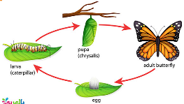  1) Research the life cycle of your favourite animal or an unusual animal. Draw the life cycle using diagrams, annotations and arrows. Remember to use the correct science vocabulary when you label the diagram.  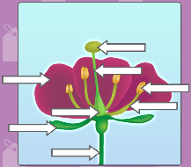  2) Dissect a flower from your garden. Can you identify the different parts of the flower needed for reproduction? Use these words to help you to draw a labelled diagram of your flower. stamen, stigma, stem, filament, anther, sepal, petal, ovary, pollen, style, etc.  3) Complete the life cycle activities or quizzes on Purple Mash. Go to Science – Topics – Plants and then choose ‘Seed Dispersal’ or ‘Life Cycles of a plant’ or watch the ‘Plant Lifecycle’ slideshow.  4) Find out what these words mean and create a picture glossary to define the words. Reproduction, metamorphosis, germination and pollination. | Date:  Comments:
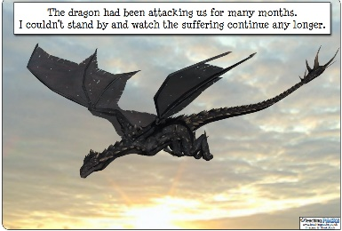  Writing:  Use one of the four story ideas to write a story about a dragon!  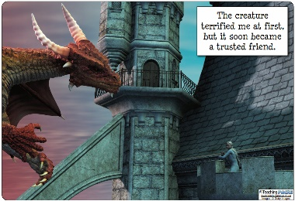  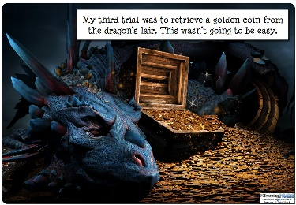 | Date:  Comments: | Measures:  Create a recipe for a magical potion that can turn the deadliest dragon into another mythical creature! Write the solid ingredients in both grams and kilograms and the liquid ingredients in millilitres and litres. Can you include some lengths too? For example, 1.74m=1740mm of serpent skin.  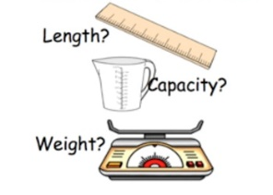  Y6: Using the conversion 1kg=2.2lbs (pounds), can you include some amounts in lbs? | Date:  Comments:
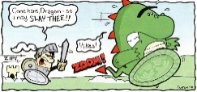  Reading:  Research a story with a mythical beast that interests you. Create a comic strip to retell the story ensuring you retrieve the key details and identify the main characters, settings and plot.  Y6: What are the language features of a myth or a legend? Can you include these in your comic strip? | Date:  Comments: | Mental Maths:  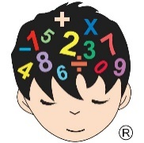  Make a ‘Times Tables Tips’ poster for your bedroom. Show quick strategies for remembering the multiplication facts for x0 to x12.  Y6: Present quick ways of working out ?x13, ?x15, ?x20, ?x0.1 and ?x0.5 mentally. | Date:  Comments: | Art / DT activity: Choose your own activity!  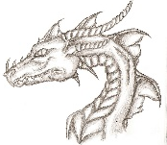  1) Create a 3D model of a dragon or mythical beast using junk modelling, clay, play dough, paper mâché or any other material you have.  2) Draw, paint, sketch, colour, outline or use any other art skill to create a picture of a dragon or mythical creature of your choice. | Date:  Comments:
Spelling Practice:  Make your own spellings crossword using the first 15 Y5/Y6 words (accommodate to bruise). Remember your clues can be synonyms of the word, a definition of the word or a sentence with the word missing. Spellings: accommodate, accompany, according, achieve, aggressive, amateur, ancient, apparent, appreciate, attached, available, average, awkward, bargain and bruise. | Date:  Comments: | Place Value / Rounding Practice:  Answer the place value questions about rounding numbers to the nearest 10, 100, 1,000, 10,000 and 100,000 on Purple Mash. The task has been set as a ‘2Do’ for you, but please make sure your login details are set-up before you do this homework! | Date:  Comments: | PSCHE / Family Discussion activity:  Discuss the different ways your family can keep safe when online. Discuss the potential dangers of using social media, exploring YouTube videos, gaming sites and being on a screen for an unlimited time. Can you all think of strategies to help keep you safe online and keep your screen habits healthy? | Date:  Comments:

