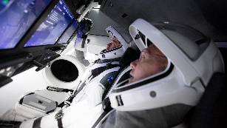

Hello Maple families! Rather excitingly, this term our topic is Space! Please choose at least two from each column for this half-term, and record which activities have been completed by adding the date into the box provided. You can also add comments about how your child got on if you wish! I look forward to hearing what you have learnt about!
English |  | Maths |  | Topic
Writing:  I cannot find any good books for children aged 8 – 10 about space! Unbelievable! So, please plan a space-themed story for children of your age! Use the story mountain steps: opening, build-up, conflict, resolution and ending. You also might like to include information about your settings and characters. Then write it if you like too! | Date:  Comments: | Measure:  With an adult, research the distance from Earth to the Moon, the Sun and the other 7 planets in our Solar System. Challenge: Try to draw a scaled diagram of the relative distances if you can! OR find the volume of the Earth and the other planets in our Solar System. Compare each other planet to ours. | Date:  Comments: | 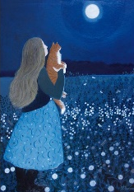  Art activity:  Create a piece of art inspired by the Moon. It could be 2D or 3D; realistic or entirely abstract or somewhere in between! You can use just a pencil and white paper or raid your craft box for other materials like tin foil and silver paint. | Date:  Comments:
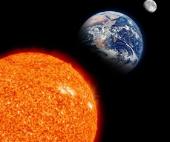  Reading:  Research the Sun and the Moon. Make a fact-file for each one. Try to find information from more than one source i.e. books and (with an adult) the Internet. | Date:  Comments: | 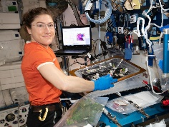  Time:  Research the life of an astronaut on board the ISS or a spaceship. Create a timetable for their activities during the day and include the duration in hours and minutes of each activity. | Date:  Comments: | 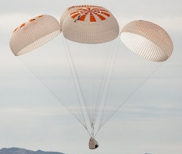  D.T. activity:  Design and make a 3d rocket capsule (the bit with the crew in that returns to Earth) with a working parachute to aid re-entry. | Date:  Comments:
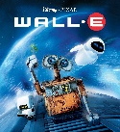  Writing:  Watch the Disney film Wall-E (U) and then write a film review OR a setting description of Earth in the opening scene OR a character profile for Wall-E (what is he like and what evidence is there in the film to support your opinions). | Date:  Comments: | 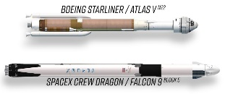  Shape:  Spend time looking at spaceships that have gone into space recently. Draw a diagram showing what the parts are called. Then on squared paper, design a simpler symmetrical rocket. | Date:  Comments: | 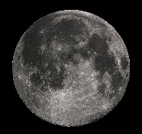  Science activity:  Keep a Space at Night journal for a week – or longer if you can! What can you see? Draw the constellations and find out what they are called; draw what the Moon looks like and find out what stage it is in. | Date:  Comments:
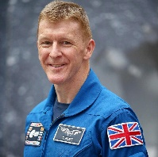  Reading and Writing:  Read about, and research, the work of the British astronaut Tim Peake. Then write a thoughtful letter to him including a couple of questions. | Date:  Comments: | 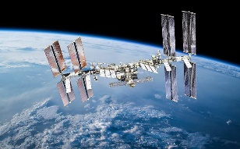  Number:  Research the International Space Station then create a fact-file including only the number-based facts about the ISS. | Date:  Comments: | Music activity:  With adult help, listen to instrumental music composed for space-themed films e.g. 2001: A Space Odyssey, Star Wars, Gravity, Interstellar, First Man, Wall-E, The Martian. How do they make you feel when you listen to them? How has the composer created it to make it sound like space?! Which is your favourite and why? | Date:  Comments:
Spelling:  In addition to practising every week, try using different space inspired fonts/decorative writing to write your spelling words in! | Date:  Comments: | Times Tables:  Please practise your times tables every week. For the sums that you get stuck on try to make them memorable e.g. draw them, make up a song…If you are confident then practise to get even quicker! | Date:  Comments: | Geography activity:  Draw a map of a section of the Moon. Label its physical features. Compare it to the physical features that we have on planet Earth. Is there anything similar? What are all the differences? | Date:  Comments:

