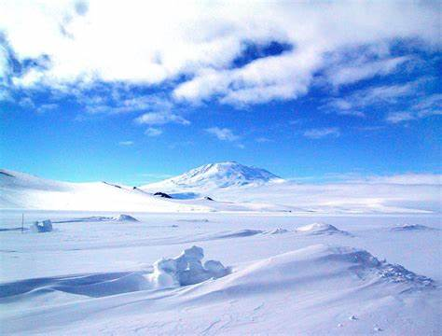
Amazing Antarctica! Sycamore and Silver Birch Classes
Autumn 2 2019
English
Writing
- Antarctic-themed texts
- Key skills – (Y1) composing and recording sentences, thinking about capital letters, full stops and finger spaces, (Y2) focusing on using a range of sentence types, as well as conjunctions (and, because, when, if, so, but), (Y3) continuing to embed our understanding of the difference between simple and compound sentences as well as a range of conjunctions (although, while, since, until), introduction of fronted adverbials in our writing, understanding of speech
- Handwriting – continuing to focus on joined hand-writing, (Y2) thinking about the size of our writing and the relationship between the lower case and upper case letters, (Y3) developing a confident, quicker joined script
- Y1- Phonics- building on existing phonics knowledge and introducing alternative sounds
- Y2/3 Spelling – continuing our yearly spelling programme ‘No Nonsense Spelling’ – (spellings will come home associated with this programme weekly)
Reading
- Whole class reading activities linked to our focus texts and other similar texts
- Y1/2- Continuing to use our phonic skills to decode new words and use word patterns to help us with this (linked to spelling)
- Focusing on our inference skills, and the author’s use of language for effect
- Recognising different themes and convention of texts
Mathematics
- Place value – (Y1) reading and writing whole numbers from 1-20 in numbers and words, beginning to use a number line to count on and back with whole numbers, counting forwards and backwards to 100 (Y2) reading, writing and comparing numbers up to 100, counting in steps of 2, (Y3) counting on in 2s, 3s, 4s, identifying, representing and estimating numbers using different visual representations
- Problem Solving – (Y1) solving practical problems involving length and time, (Y2) solving multiplication and division problems, (Y3) reasoning and explaining problems using our known facts
- Multiplication and division- (Y1) counting in 2s, doubling and halving amounts and sharing equally within numbers to 20, (Y2) use multiplication and division facts for 2 and 10 x table, (Y3) multiplication and division fact for 3x and 4x tables, using arrays and repeated addition
- Fractions – (Y1) understanding that halving involves 2 equal parts of shape or quantity, (Y2) recognising 1/3, 1/4 of a length of a shape, objects of quantity, (Y3) understanding tenths, comparing and ordering fractions with the same denominator, finding fractions of quantities
- Y2/3- Mental Maths – continue to work on our mental maths skills
Science: Living Things and Habitats
- Omnivore, carnivore and herbivores
- Research and write posters on Antarctic animals
- Basic needs for survival
- Identify different world habitats and animals that live there
- Understand how animals are adapted to live in their habitats and the threat of global warming
- Food chains

RE: Incarnation
- Understand the story of Jesus’ birth and why Jesus is important to Christians
- Learn how Christians use the nativity story to guide their beliefs and actions at Christmas
- Think about what we have to be thankful for
Music
- Learn the Christmas Play songs and work towards our lower school nativity performance
- Relate these to the musical dimensions of ‘structure’ (how a piece of music is put together) and ‘duration’ (long and short sounds)
Art and Design
- Understand the concept of printing to create wrapping paper
- Work safely with basic tools to create a final piece
Geography
- Identifying continents, oceans, countries, cities/towns and key physical features
- Identifying hot and cold places on a map (equator and poles)
- Understanding the physical geography and human geography of Antarctica
- Comparing Antarctica to East End
P.E.
Dance
- Responding to imaginatively to music, creating dance sequences on our own and in groups
- Focusing on icebergs and penguins
Games: Invasion Games (rugby, netball and basketball)
Computing
- Use a range of tools in the art package
- Use a digital camera to take pictures and add captions
- Y3 consider how digital images can be altered and the associated risks
PSHCE
- Understanding what constitutes a healthy lifestyle and the importance of personal hygiene
- (Y2 and Y3) Understanding growth, change and responsibilities
- (Y3) Understanding of health and safety and basic emergency aid procedures
Role Play Corner Inside An Igloo!

