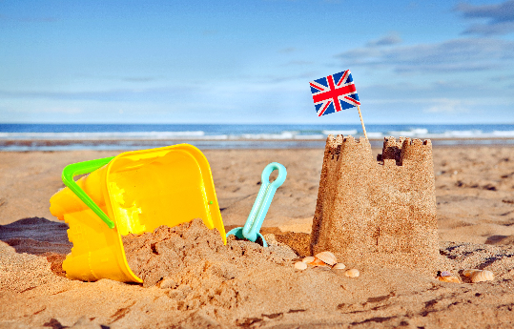
The Seaside!
Sycamore and Silver Birch Classes
Summer 1 2022
English
Writing
- Y1 focussing on applying phonic knowledge and alternative sounds when reading new words, real or alien, in preparation for the Y1 phonic screening, plus opportunities to demonstrate our knowledge of sentence writing.
- Y2 using commas in a list, and apostrophes within contractions and for singular possession (e.g. the girl’s hair). Preparing for end of key stage assessments.
- Y3 continuing to focus on writing tools such as fronted adverbials and different conjunctions within compound and complex sentences.
- Handwriting – Y1 focussing on letter formation, Y2 focussing on developing our joined script, with well-sized finger spaces and, for Y3, remembering to join all the time in our writing.
- Fiction – retelling stories from the point of view of a different character.
- Spelling – learning about suffixes and word groups to support spelling, as well as continuing to learn common exception words and spelling patterns for each specific year group. Spelling tests continue each week.
Reading
- Whole class reading activities linked to our focus text of The Lighthouse Keeper’s Lunch and similar texts.
- Focus on comprehension and reading with understanding of text.
- Y1 decoding skills of unknown words.
- Y1 focus on application of phonic strategies in preparation for Y1 phonics screening.
- Y2 answer questions, make predictions and make links between different stories, character and themes.
- Y3 understand and discuss different characters and their motivations and actions within a text.

Mathematics
- Addition and subtraction - using efficient strategies (Y3 within 1000, Y2 2-digit to 2-digit, Y1 within 20).
- Multiplication and division – Y1 1 step problems using concrete apparatus, Y2 recalling and using facts, Y3 deriving new facts, chunking for division and grid method for multiplication.
- Problem-solving – within a range of contexts, including measures, time, money, and open-ended investigations.
- Preparation for end of key stage assessments, including test preparation and strategies (Y2 only).
- Geometry – similarities and differences when comparing shapes, shapes in different orientations, and more or less than a right angle (Y3).
- Measure – measuring and comparing heights, lengths and units of time in non-standard units (Y1), and standard units (Y2) and solving problems involving scaling up and down within these units of measure (Y3).

Science
- Living things and their habitats
- Understanding the terms living, dead and never alive
- Thinking about animal habitats and what animals are suited to living there
- How animals adapt to their environment

R.E Ideas about God
- What we think God looks like
- Judaism - stories from the Jewish faith and what they tell us about how Jewish people see God
- Comparing Christian and Jewish views of God

Geography
- Learning about the 7 continents and 5 oceans
- Identifying seaside locations around the UK
- Learning about physical and human landscape features

Music- recorders
- Learning about the musical element ‘duration’ – long and short sounds
- Listening to a variety of recorded music to explore the duration of different sounds, focusing on ‘Portsmouth’ by Mike Oldfield
- Learning the basic musical skills of playing a recorder

P.E.
- Striking and fielding – rounders skills
- Athletics – running, jumping and shotput

Computing
- Using simple simulation programs
- E-safety
- Importing digital photos
- Working on data handling activities (Y1 and Y2) and an introduction to spreadsheets (Y3)

PSHCE
- Relationships, stereotypes and discrimination
- Thinking about what is special and unique about us
- Respecting other people’s similarities and differences
- What bullying is and what to do about it

DT
- Thinking about what makes a healthy sandwich
- Planning, making and evaluating a healthy sandwich, and eating it as a picnic!

Role Play Corner
A seaside shop

Topic Vocabulary
Seaside, Ocean, Continents, Habitat, Life process, Shore,
Lighthouse, Human and physical features, Compass, Promenade, Pier

