Homework Grid Spring 2: Once Upon A Time!
English |  | Maths |  | Topic/Creative
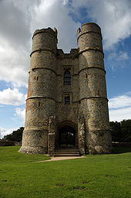  Research ‘Donnington Castle’ and create an information guide all about it. This can be hand written or done on the computer.  Y2: Can you include some questions for your reader? For example, ‘did you know…?’  Y3: Don’t forget to use subheadings and paragraphs! | Date:  Comments: | Continue to practise your current level of mental maths challenge to help you move up to a new level.  Practise the level you are on by repeating it, writing it down and asking your family to help by testing you. Record your practice in your homework book.  Year 1: Can you count onwards and backwards from any given number (up to 20 and beyond)? | Date:  Comments: | 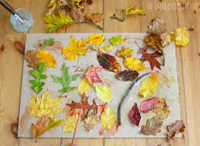  Go on a nature hunt and create a collage of all the things you find. You can add leaves, grass, petals and even sticks to your collage. | Date:  Comments:
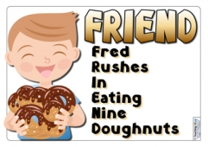  Focus on your Common Exception Words (CEW). Choose a few to practise their spellings. You could make up a silly mnemonic, a song or even a rap to help you remember how to spell them and record in your homework book. | Date:  Comments: | Adding and subtracting!  Have a go at adding and subtracting some numbers. Remember, to show your workings out!  Y1: Use numbers up to 20. (practise number facts i.e 12+8=20, 20-12=8)  Y2: 2 digit and 2 digit (blank number line)  Y3: 3 digit number and 3 digit number (column method) | Date:  Comments: | 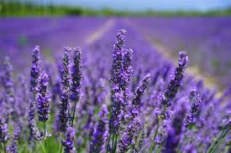  Research a plant from a different country. Can you write down some facts about it and draw it? | Date:  Comments:
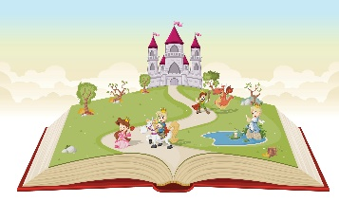  Create your own ‘Once upon a time’ fairy tale story. You need to plan your story, with a clear beginning, middle and end. | Date:  Comments: | Sumdog!  https://www.sumdog.com/user/sign_in  Year 1: Counting in 2s, 5s and 10s.  Log on to Sumdog and practise your maths skills!  Year 2: x2, x5, x10 tables  Year 3: x3, x4, x8 tables | Date:  Comments: | 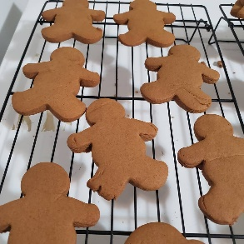  Bake some Gingerbread Man cookies.  Measure out the scales accurately and then decorate your Gingerbread Men! | Date:  Comments:
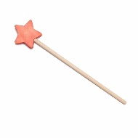  If you had a magic wand, and could make three wishes, what would you wish for and why?  Write your answer in full sentences and don’t forget to explain your reasoning using a range of conjunctions.  Y2: because, so, or, but, and  Y3: although, when, if, because, while | Date:  Comments: | 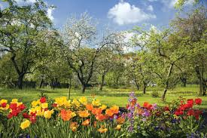  Statistics  Look for signs of Spring and create a bar chart of what you have found. For example- bluebells, lambs and calves.  Year 3- don’t forget to include your y and x axes. | Date:  Comments: | 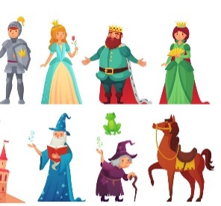  Choose your favourite fairy tale character and draw them. You could colour them in too using paints, pencils, crayons or any other resources you can find. | Date:  Comments:
Please choose one activity a week, and record which activity has been completed by adding the date into the box provided. Please add comments, should you wish to, regarding your child’s engagement/enjoyment/understanding of each activity. Please choose at least two from each column during each half term.

