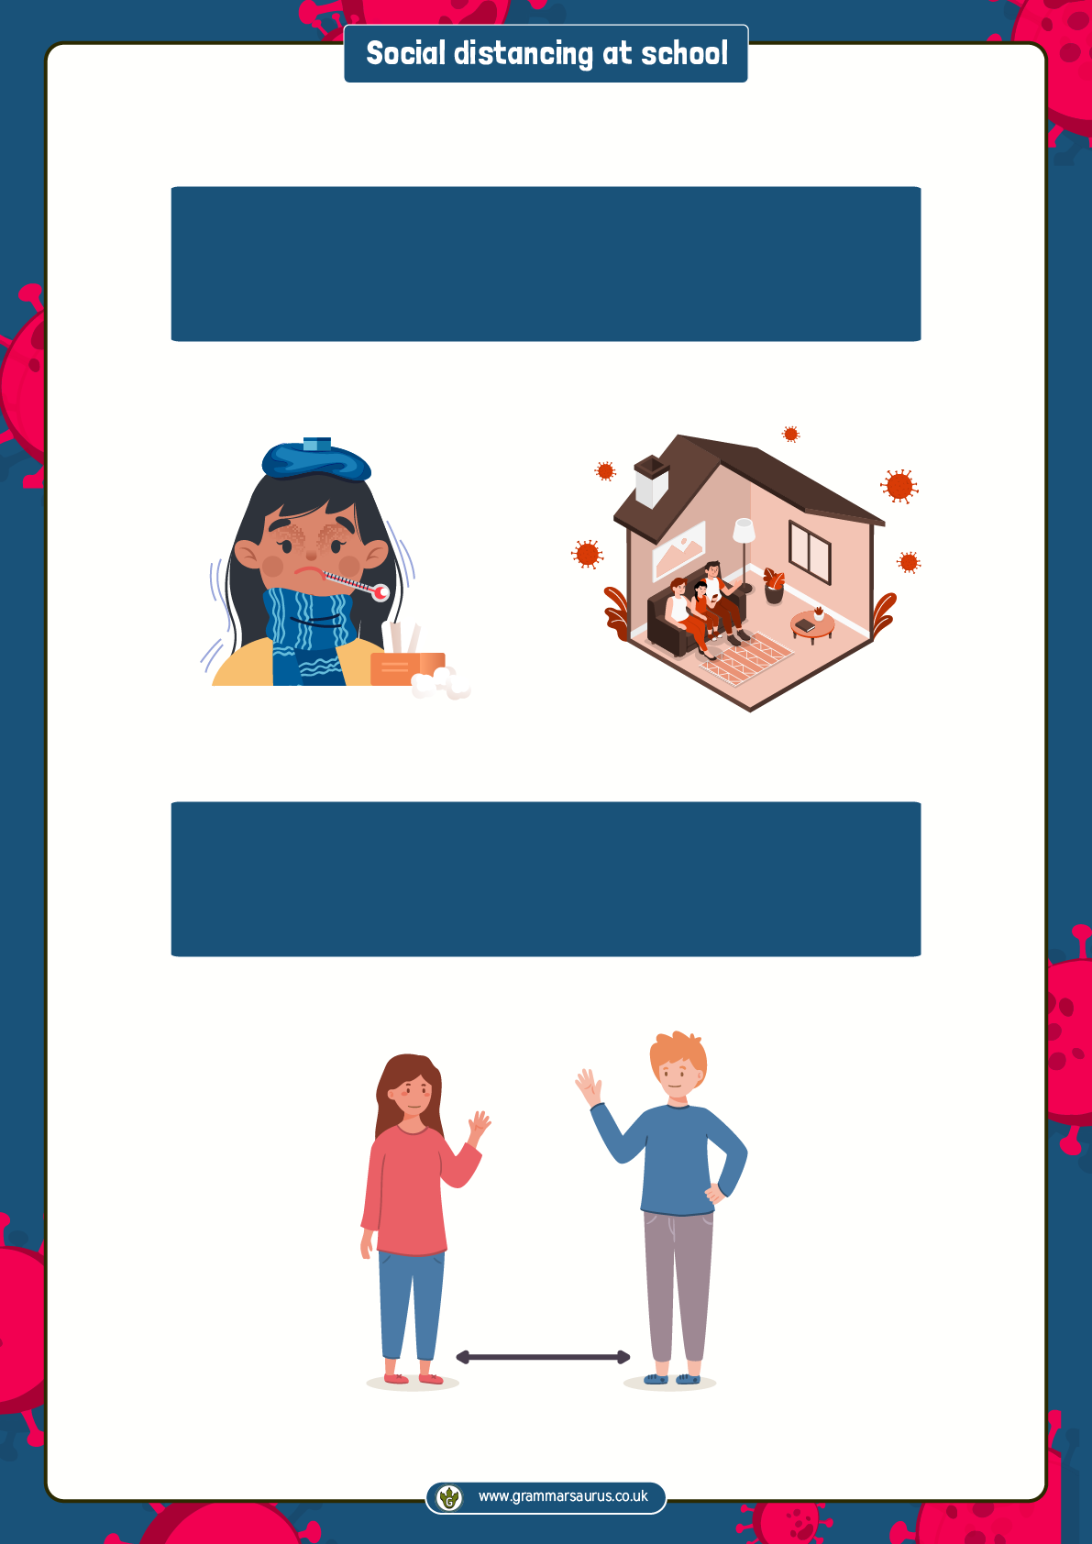

We have been staying in our houses because of the illness called Coronavirus. Coronavirus can make people feel very poorly.

To keep ourselves safe, we must keep socially distant from others, unless they live in our houses.

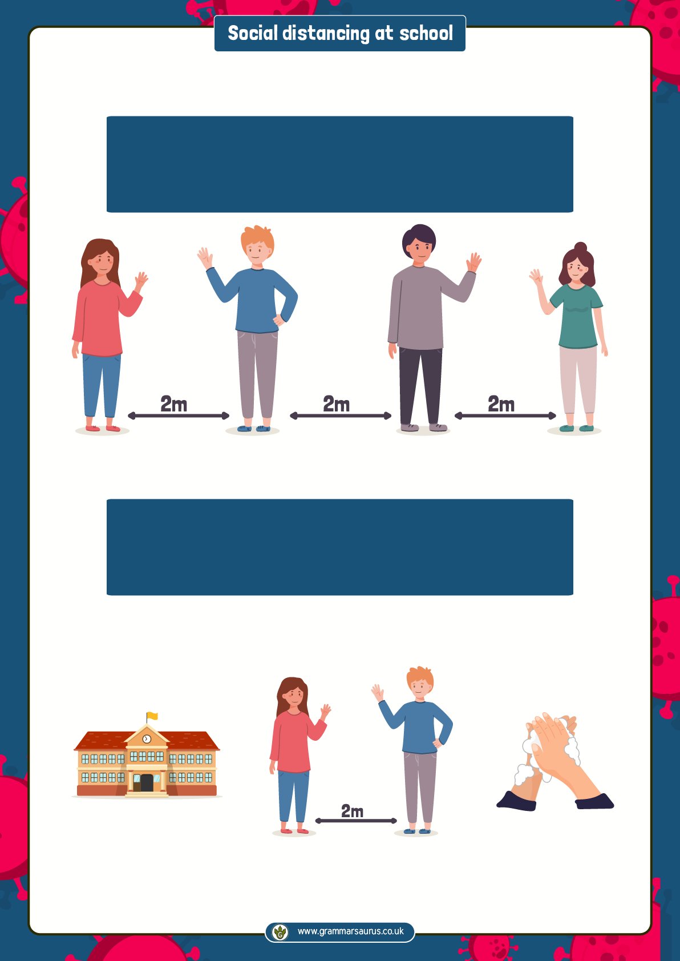

When we can go back to school, we will still have to try to stay 2m apart from our friends and our teachers, and we must wash our hands lots of times a day.

Social distancing means we have to stay at least 2m away from people when we are outdoors and not at home.

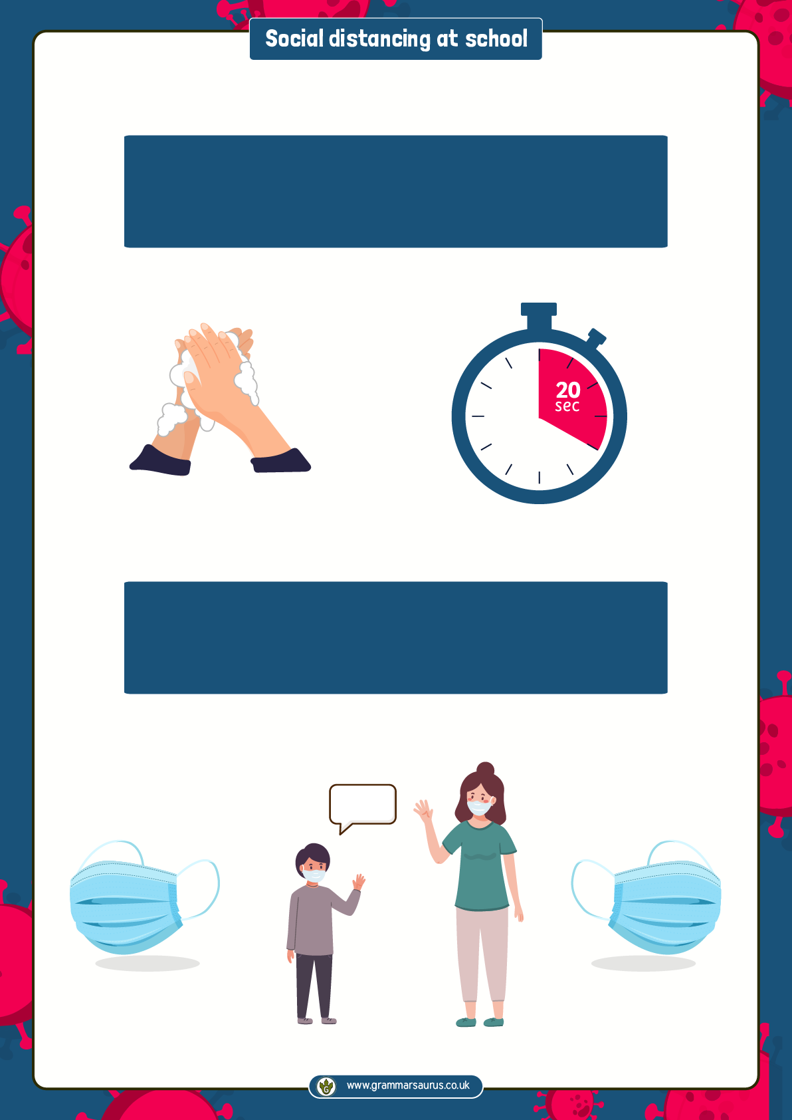

Some people might wear masks which cover part of their faces. This is another way to keep safe and stop them spreading any germs. It might look a little frightening but I will get used to it and can tell my adults if I am feeling worried.

Washing our hands will help us stay safe too. We must wash our hands for 20 seconds using soap and water.

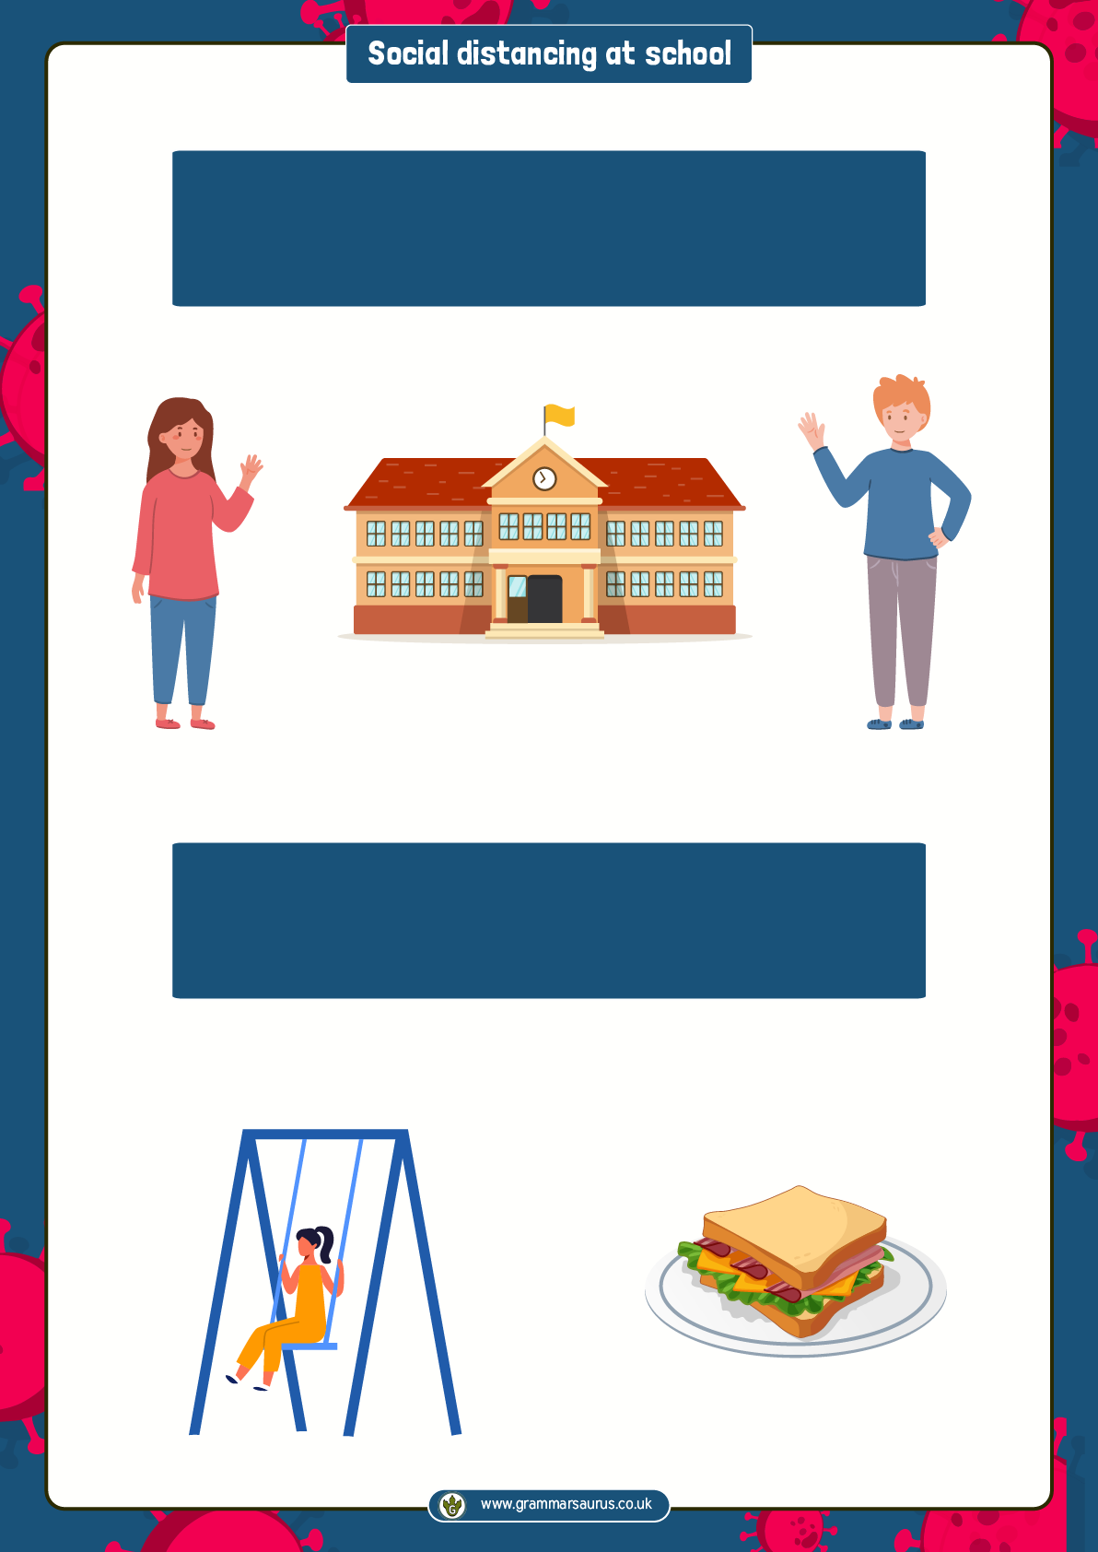

Our playtimes and lunchtimes will be different too. This is to keep us safe. We might need to eat at different times and play in our small groups. This might make me feel sad but I will still have fun playing with the people in my group.

We might have to start and finish school at different times to our friends. This is to make it easier to stay 2m away from people who do not live in our houses.

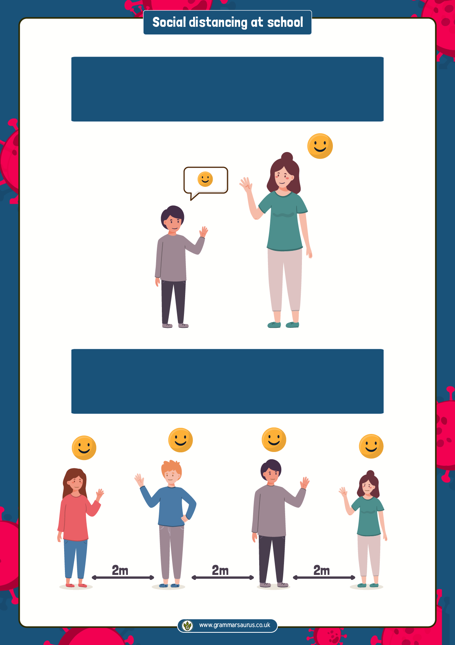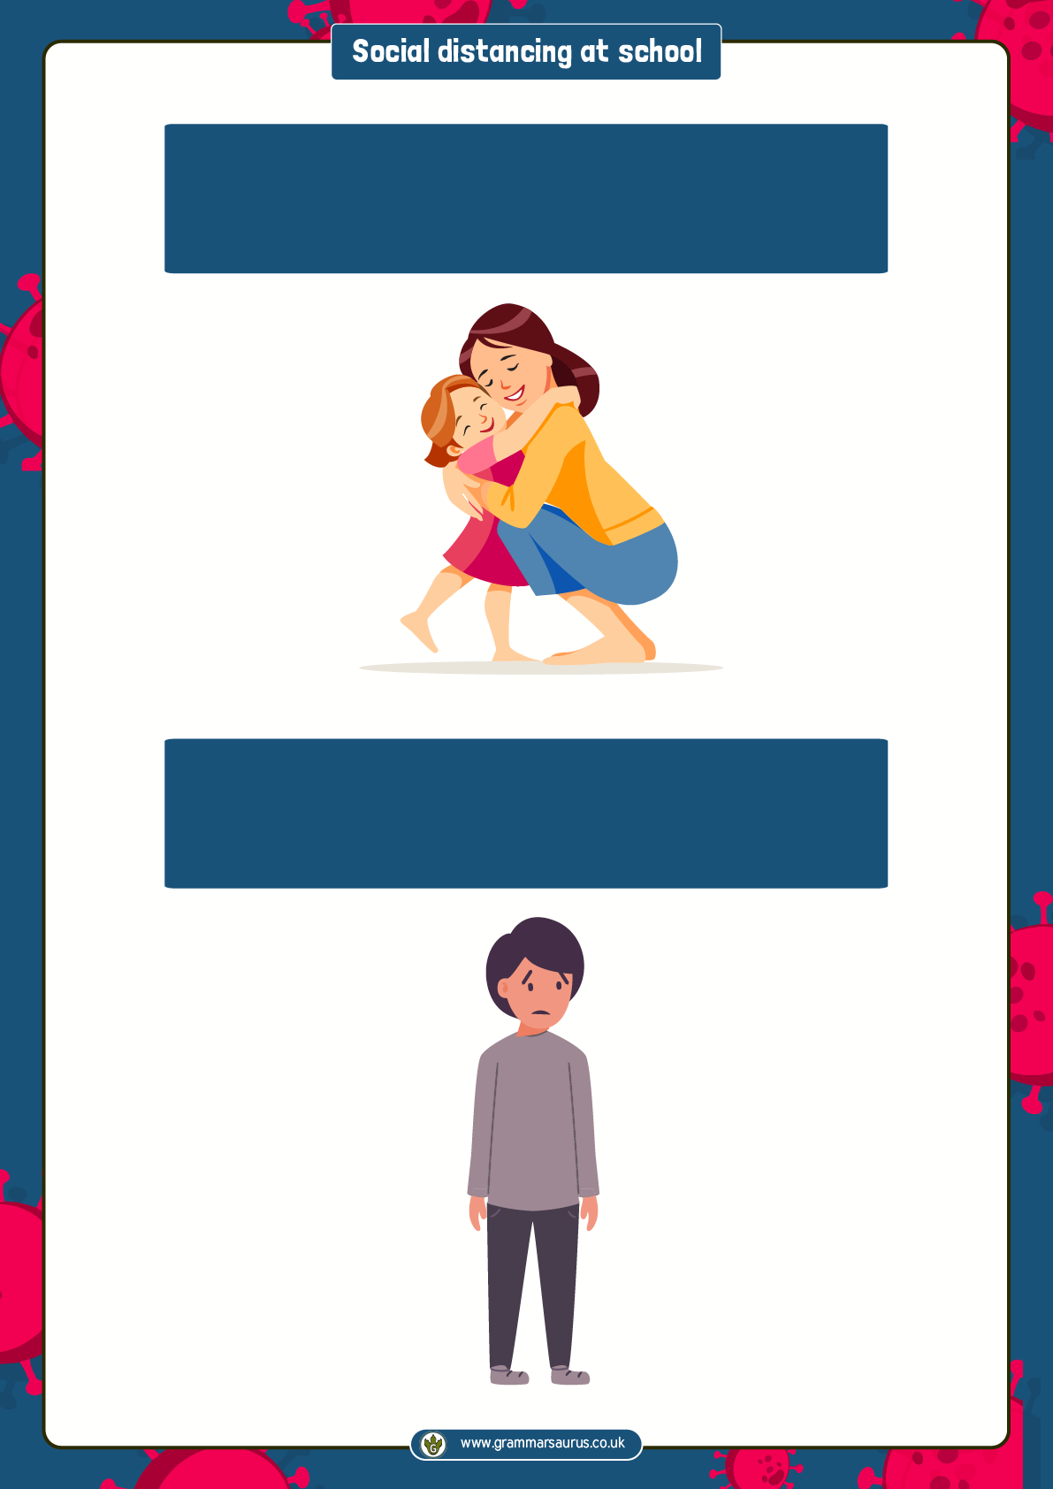

It will feel strange because I must try not to hug, high-five or touch anyone that does not live in my house, but no one will be cross with me if I forget.

Things may feel different for a while. This might make me feel sad or worried.



If I feel sad or worried, I can talk to my trusted adults at home or at school and they will help me feel better.

Social distancing may be strange but it will help keep everyone happy, healthy and safe.