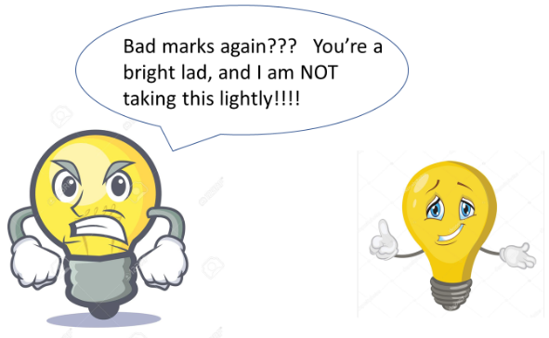
Y5 and Y6 Homework Grid: Lighting It Up (Light and Electricity)
Please choose one activity a week and record which activity has been completed by adding the date into the box provided. Please add comments, should you wish to, regarding your child’s engagement/enjoyment/understanding of each activity. Please choose at least two from each column during each half term.
English |  | Maths |  | Topic/Creative
Writing for pleasure:  At home, pretend you are living in a century when electricity has not yet been invented. What is it like? Was life more difficult or simpler before electricity was discovered?  Record your experience by writing a diary entry.  Y5: Think about using descriptive vocabulary and various synonyms.  Y6: Can you apply all the punctuation you know in the diary entry? | Date:  Comments: | Measure:  Cut two pieces of string/ribbon so each one is 1m long. Use these to work out the rough perimeter and area of your garden or the rooms in your home in metres.  Can you draw a floor plan of your house or garden showing your measurements? You will need to scale down the measurements on your plan. | Date:  Comments: | What are the benefits of saving electricity?  In what ways can we save electricity?  Create a persuasive poster that will persuade others to save electricity.  Y6: Can you use a triple, hyperbole, emotive language or alliteration? | Date:  Comments:
Enjoying your reading?  Research the history of electricity. Who discovered electricity? How was it discovered? When was it discovered? What is electricity? How does it affect your life?  Make an information sheet to summarise your findings.  Y5: Think about organisational features such as bullet points, subheadings, paragraphs, captions, etc.  Y6: Think about the purpose and reader of your information text. Have you used the correct tone? | Date:  Comments: | Puzzle:  Can you put the numbers 1 to 8 in each of the squares so that each side adds up to the middle number?  Can you create your own puzzle like this? | Date:  Comments: | Science:  Can you create or design a mini-circuit?  What do you need?  What will your energy output be sound/light/movement?  How will it be connected?  Will the materials be insulators or conductors?  What will your electricity source be (battery)?  How could you investigate how to make the bulb brighter or the sound louder or the movement quicker? What would you do?  What would you need?  How would you make it a fair test?  Y6: Which factors will be controlled and what will the variables be? | Date:  Comments:
Writing for pleasure:  Write a poem about the many ways you use electricity. Maybe you watch TV or play video games, help with the laundry or do the vacuuming.  OR  Make rhyming riddles for different electrical appliances and machines in your home.  Y5: Can you use a simile and a metaphor?  Y6: Can you use lots of figurative language? | Date:  Comments: | Investigate factors in the times tables to 12x12.  Can you rank the top 5 factors which appear the most? What is special about them that makes them appear so often?  Which factors appear the least? Can you explain why?  Y6: Explore, define and give examples of factors, multiples, prime numbers, factor pairs, prime factor pairs and composite numbers to help you revise the mathematical vocabulary. | Date:  Comments: | Make a clock that doesn’t need electricity by creating a sundial.  Paper plates and sticks are a great place to start, but you can be more creative if you wish!  Can you label your clocks with Roman Numerals?  Y6: Use this activity to revise the Roman Numerals! | Date:  Comments:
Spelling Practice:  Make a list of words with these prefixes and suffixes and then explain how the meaning of the word changes when you add one of these prefixes or suffixes.  Prefixes: anti, bi, tri, co, re, auto, im, il, ir, in, sub, inter, super, etc.  Suffixes: ment, ful, ness, sure/ture, ous, cian/tion/sion, ation, less, etc. | Date:  Comments: | Statistics:  Look at the electrical appliances in your home.  Which ones create sound only, light only, sound and light, movement, temperature changes, anything else?  Consider the most visual way to represent your findings. | Date:  Comments: | Invent a simple tool that is driven by wind power.  Can you design it, plan the make of it and then evaluate its usefulness? | Date:  Comments:

