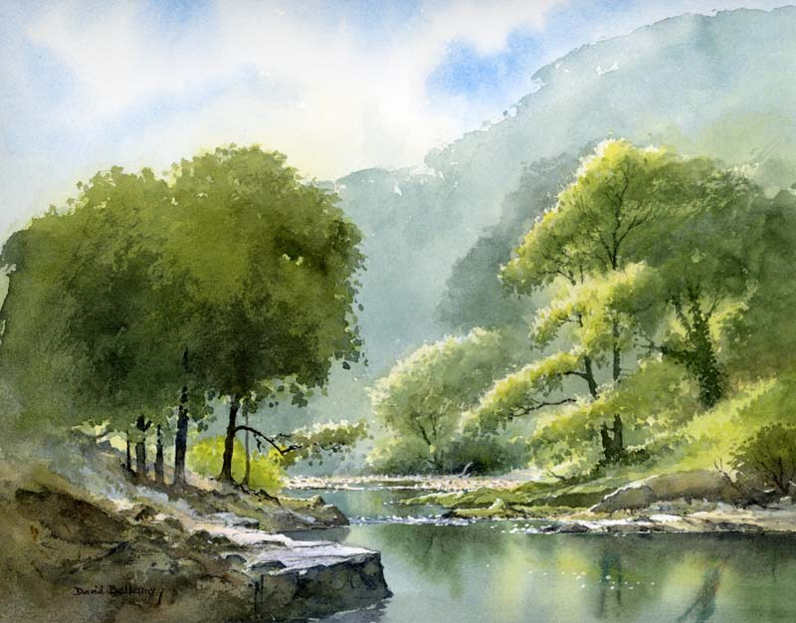
‘Go with the flow’

In English writing, we will be…
- Writing an explanation text explaining the water cycle.
  - Using a dictionary and thesaurus to define and increase our vocabulary.
  - Using a range of conjunctions and cause and effect language.
  - Using expanded noun phrases to add detail.
  - Using formal language and technical vocabulary.
  - Using basic punctuation, commas to clarify meaning and punctuation for parentheses.
- Practising our writing skills through short pieces of writing inspired by a traditional novel ‘Watership Down’.
  - Writing descriptions of characters and settings.
  - Organising paragraphs around a theme and ensuring clarity and cohesion in writing (Y4).
  - Using paragraphs and the correct speech punctuation (Y5).
- Developing our skills of using a dictionary, planning, proof-reading, understanding the marking code and responding to feedback.

In English reading, we will be…
- Comparing, analysing and annotating a variety of explanation texts.
- Analysing, clarifying, summarising and retrieving facts from a traditional novel by reading extracts.
- Y4: Identifying themes and conventions presented in a traditional novel using visual literacy techniques and drama and roleplay.
- Understanding the different ‘Reading Roles’ to help us to think about texts thoroughly. Please see the attached sheet.

In our ‘English Grammar, Punctuation and Spelling’, we will be…
- Reviewing our knowledge of the basic grammar terms, word classes and punctuation uses.
- Reviewing previous spellings patterns, practicing Y3/Y4 spelling words, Y5/Y6 spellings words and introducing new spelling rules and learning different spelling strategies.
- Y4: Using expanded noun phrases, fronted adverbials, relative clauses and relative pronouns.
- Y5: Using modal verbs, adverbs, and relative clauses.

In Mathematics, we will be…
- Place Value: Y4: Finding 1000 more than any given number and recognising the place value of each digit in a four- digit number. Y5: Reading, writing and comparing numbers to at least 1,000,000 and determining the value of each digit. Y4 and Y5: Identifying the value of each digit and multiplying and dividing by 10, 100, 1000. Y5: Interpreting negative numbers in context and solving place value reasoning problems.
- Calculations: Practising mental adding and subtracting skills. Solving problems involving addition and subtraction using formal methods. Y4: Adding and subtracting three digit numbers using a variety of strategies. Y5: Identifying multiples, factors, prime numbers and factor pairs. Multiplying and dividing whole numbers.
- Measure: Estimating, comparing, measuring and calculating with different units of metric measurement. Y4: Measuring and calculating the perimeter of a rectilinear figure in centimeters and meters. Y5: Converting between different units of metric measure.
In Science, we will be…
- Learning about the states of matter: solids, liquids and gases and the water cycle and conducting practical investigations.

In Geography, we will be…
- Recognising the features of a river and locating rivers on maps.

In Art, we will be…
- Practising watercolour techniques to create a watercolour landscape.

In PSHCE, we will be…
- Creating a class charter and understanding a range of relationships.

In French, we will be…

Learning and revising key communication skills and general greetings (Mrs Bartlett).

In Music, we will be…

Focusing on structure, timbre and dynamics inspired by rivers (Mrs Rennison).

In RE, we will be…

Investigating the concept of freedom and justice in Christianity (Mrs Bartlett).

In PE, we will be…
- Creating a dance inspired by rivers (Mrs Bartlett).
- Playing invasion games with a focus on rugby (Mr Bint).

In Computing, we will be…
- Learning about E-Safety and creating presentations using PowerPoint or Google Slides.

This term’s vocabulary will be…
Science - States of Matter and Water Cycle: solid, liquid, gas, water vapour, melt, freeze, heat, cool, evaporate, condense, thermometer, temperature, evaporation, condensation, precipitation, transpiration, atmosphere, etc.
Geography – Rivers: source, mouth, estuary, delta, erosion, meander, floodplain, tributary, channel, weir, etc.

