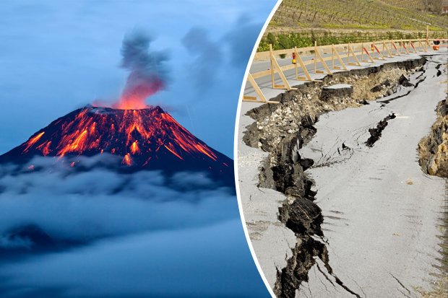Volcanoes & Earthquakes

All year groups will take time to focus on embedding learning and practising skills from previous year group’s expectations, in order to build confidence and fill potential gaps in learning. We will do this throughout the year as and when needed, if needed at all, and at a level specific to each child.

In English we will be…
- Practising our writing skills through short pieces of writing.
- Writing an explanation text about the rock cycle and the formation of fossils.
- Writing short information texts about aspects of volcanoes and earthquakes.
- Writing poetry about the forces of nature.
  - Using expanded noun phrases.
  - Using adverbs to describe verbs.
  - Using figurative language such similes, metaphors, onomatopoeia and personification.
- Developing our skills of planning, self-editing, peer-editing and evaluation.

In our reading we will be…
- Analysing, clarifying, summarising and retrieving facts from information texts.
- Identifying features of different genres.
- Understanding the different ‘Reading Roles’ to help us answer comprehension questions. Please see the attached sheet.

In our ‘English Grammar, Punctuation and Spelling’ we will be…
- Reviewing our knowledge of the basic grammar terms, word classes and punctuation uses.
- Reviewing previous spellings patterns, practising Y5 and Y6 spellings words, introducing new spelling rules and learning different spelling strategies.

In Mathematics we will be…
- Place Value: Reading, writing and comparing numbers up to 10,000,000. Rounding any number up to 1,000,000. Identifying the value of each digit and multiplying and dividing by 10, 100, 1000. Y6: Generating and describing linear number sequences.
- Calculations: Practising mental adding and subtracting skills. Solving problems involving addition and subtraction using formal methods.
- Y5: Identifying multiples, factors, prime numbers and factor pairs. Multiplying and dividing whole numbers.
- Y6: Multiplying and dividing up to 4-digit numbers by a 2-digit number using a formal method.
- Fractions: Comparing and ordering, adding and subtracting fractions (Y5: same denominator). Recognising and converting mixed numbers and improper fractions.
- Y6: Using equivalence and common multiples to simplify fractions. Multiplying simple pairs of proper fractions. Knowing that fraction and division are linked and use short division to change common fractions into decimals (3/8 = 3÷8 = 0.375).
- Geometry: Identifying 3-D shapes including cubes and other cuboids from2-D representations (nets).
- Y6: Comparing and classifying shapes based on properties, angles and symmetry. Identify parts of the circle (radius, diameter, and circumference).
- Measure: Measuring and calculating the area and perimeter of shapes (Y5: composite rectilinear shapes in cm and m).
Converting between different units of metric measure.

In Science we will be…
- Learning about rocks, soil, fossils and evolution and inheritance.

In Art we will be…
- Observing the work of sculptors.
- Creating sculptures of volcanoes.

In PSHCE we will be…
- Creating a class charter and learning about the United Nations Convention on the Rights of the Child.

Discussing the wider world and global issues.

In Geography we will be…
- Learning about volcanoes and earthquakes.
- Using our location knowledge and mapwork skills to identify volcanoes and tectonic plates.
- Studying the physical and human geography of volcanoes and earthquakes.

In French we will be…

Learning and revising key communication skills - Rigolo 2 Salut Gustave / Bonjour!

In Music we will be…

Looking at dynamics and tempo and composing music to represent a volcano eruption.

In RE we will be…

Learning about different views of creation - Understanding Christianity: Creation.

In PE we will be…
- Creating a dance inspired by volcanoes.
- Playing invasion games: rugby and football.

In Computing we will be…
- Learning about E-Safety.
- Creating PowerPoint presentations on Active Earth.

