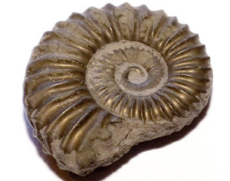Fossils
This term our topic is Fossils. We will also be continuing our work in upper school worship to explore the role of bees and the importance of protecting them in our environment – this forms part of the work Y6 will take to the leaver’s service at Winchester Cathedral after half term.
Y6 will also do SATs this half term during the week beginning Monday 13th May 2019 – more details on the week to follow. Y5 will work in Maple during the tests each morning but will re-join us after break each day. Further details for Y6 parents will follow separately.
Many Thanks
Mrs Braidley

In our writing we will be…
- Writing newspaper articles about a rare fossil discovery
  - Exploring the role of active and passive voice
  - Examining Parenthesis and using commas for clarity
  - Punctuating direct speech
- Writing poetry in a variety of styles and formats
- Developing our skills of editing and evaluation

In our reading we will be…
- Exploring the ways in which grammar and vocabulary can be used for affect in a variety of different genre.
- Developing test skills – answering 3 point questions, checking and monitoring skills and understanding question stems.
- Examining different forms of non-fiction presentation and the purpose of those organizational elements.

In maths we will be…
- In depth focus on securing fluency in written methods for Long division and multi-digit multiplication
- Discussing efficient methods
- Working with fractions and the 4 mathematical operations
- Constructing time graphs to reflect real life events
- Y6 - revision

In Science we will be…
- Rocks, fossils and evolution and inheritence

In Design Technology we will be…
- Electrical systems

In PSHE we will be…

Protected Characteristics and Discrimination

In Art we will be…
- Working on a bee themed art project in both paint and sculpture

In French we will be…

Rigolo 2 Les Vetements

In Music we will be with Mrs Wellings…

Writing our own songs using some musical notation and begin to understand ways to create simple harmonies.

In RE we will be…

Good and Evil - Diwali

In PE we will be…
- Rugby and cricket with Mrs Braidley
- Aiming, jumping and balancing with Mrs Wellings

In Computer Studies we will be…
- Creating databases

