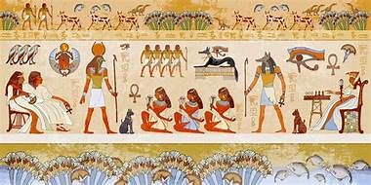
Willow Homework Grid:
I I did this independently with no help.
S I did this with some support.
H I needed lots of help and found it tricky.

English |  | Maths |  | Topic/Creative
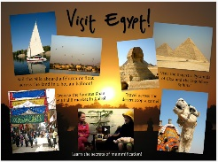  Reading and Writing:  Research Egypt and the famous pyramids and Sphinx in Cairo. Create a tourist brochure / leaflet persuading tourists to visit this destination. Remember to highlight the key features of the country including its weather, its location, its famous tourist hotspots and other features of modern Egypt.  Y5: Use paragraphs and expanded noun phrases.  Y6: Engage your reader and persuasive language. | Date:  Comments: | 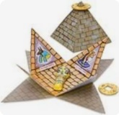  Shape:  Make 3D models using nets of cubes, cuboids, square-based pyramids and other pyramids such as pentagon-based pyramids, tetrahedron (triangle-based pyramid), hexagon-based pyramids, etc. Use the models to make an Ancient Egyptian model city/town. You might need a large cardboard base to stick your models on to create buildings, etc. | Date:  Comments: | 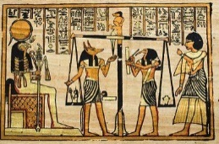  Art Activity:  Create a piece of art mimicking the style of Egyptian pyramid wall decoration. Think about the colours and lines that you will draw to produce the same style of illustration. If you have the time, you could even tea-stain some paper to make it look even more authentic! | Date:  Comments:
 |  |  |  | 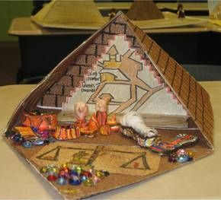  DT activity:  1) Make a 3D diorama for an Ancient Egyptian scene. A diorama is usually a shoebox/open box that models a miniature version of a scene or habitat. | Date:  Comments:
 |  | 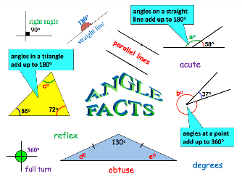  Angles:  TO DO AFTER OUR GEOMETRY LESSONS  Make a poster on different types of angles. Use examples to show the angle rules. a) different types of angles b) angles on a line c) angles at a point d) interior angles of a triangle e) interior angles of a quadrilateral  Y6: Investigate the interior angles of a pentagon, hexagon and an octagon. Ask to borrow a protractor if you need one! | Date:  Comments:
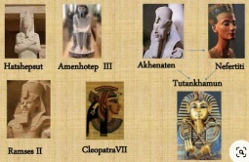  Reading and Writing:  Research a famous Ancient Egyptian and create a fact file on them. Examples: Nefertiti, Cleopatra, Hatshepsut (queens) or Ramesses, Tutankhamun, Akhenaten (Pharaohs). | Date:  Comments:
 |  |  |  | PSCHE / Family Discussion activity:  Think about a time capsule! If you were an Egyptian pharaoh, what would you choose to put into your tomb to keep with you in the after-life? What objects are really important to you? What would this communicate to people in the future about you and your life today? | Date:  Comments:
Writing:  Create an information booklet/sheet / poster / PowerPoint about the Ancient Egyptians. This could be done over a few weeks. You can use the following subheadings to research and include: Who were the Ancient Egyptians? Where did the Egyptians live? Who were the Ancient Egyptian gods and goddesses? What is mummification? Other aspects: clothes, homes, food, famous buildings (Pyramids / Sphinx), entertainment, leisure, etc.  Y5: Use correct punctuation, paragraphs  and formal language.  Y6: Engage your reader and try to use a  variety of sentence structures. | Date:  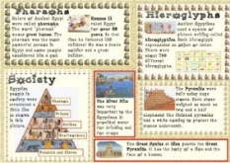  Comments:
 |  |  |  | Science activity:  Make a glossary. Find out the definitions of these words: dissolve, solvent, solution, soluble, insoluble, solid, liquid, particles, suspension, evaporate, condense, reversible, irreversible, etc. | Date:  Comments:
 |  | 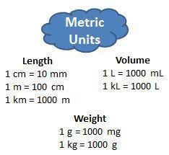  Measures:  Complete the Purple Mash converting units of measure activities. The task has been set as a ‘2Do’ for you. | Date:  Comments:
 |  |  |  | History activity:  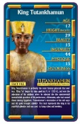  Make some Ancient Egyptian gods and goddesses or pharaohs or queens top trump cards. Research the different gods and goddesses or pharaohs and queens and find out what they are rulers of, their age when ruling, whether  they are good or evil, etc. Then, rank them and use scores to create a card for each one. | Date:  Comments:
Spelling Practice:  Make your own spellings crossword or a word search using 13 of the Y5/Y6 words (category to curiosity). | Date:  Comments:
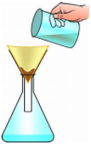  Maths and Science activity: Investigation  Use a measuring jug and measuring scales to mix the following items in a large container: 150g small stones, 50g soil, 475ml of water, a teaspoon of salt, some leaves and some metal paperclips if you have any.  What happened to the salt in the water? How can you separate the different materials? What equipment can you use? How could you separate the paper clips without using your fingers? How can you separate the salt and the water? You can record your findings by drawing a labelled diagram and showing the equipment you used to separate each material. |  |  |  |  | Date:  Comments:

