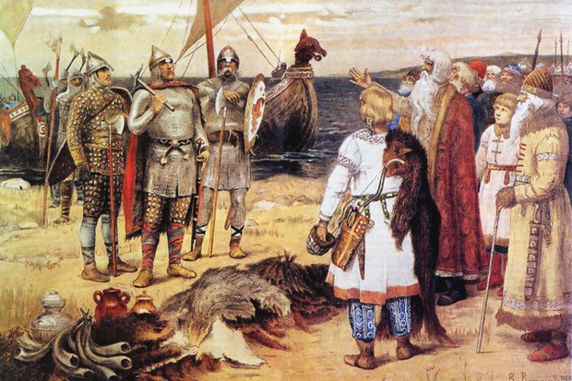
Raiders Across the Seas – Vikings and Anglo Saxons

In English we will be…
- Reading and writing recounts with a Viking theme, including diary entries and newspaper reports.
- Reading and writing adventure stories that focus on creating character descriptions.
- Practising our writing skills:
- Varying sentence structures and using a variety of punctuation such as dashes, brackets and commas to add in relative clauses.
- Using a range of cohesive devices to achieve flow and cohesion.
- Using fronted adverbials effectively.
- Using the correct modal verbs.
- Using the appropriate genre features and showing an awareness of the reader.
- Developing our skills of planning and structuring our writing into paragraphs.
- Developing our skills of self-editing and peer-editing.

In Mathematics we will be…
- Solving problems involving using column addition and subtraction and multiplication and division.
- Learning fractions, decimals (and percentages Y5 only) and finding equivalences.
- Drawing and measuring angles in shapes.
- Solving time and timetables problems; calculating time durations.
- Reading and recognising Roman numerals.
- Practising mental arithmetic involving larger numbers and using place value knowledge.

In Science our topic will be…
- Learning about friction including air and water resistance.

In Design Technology we will be…
- Using our technical knowledge to understand mechanical systems.
- Designing, making and evaluating a Viking Longboat.

In PSHCE we will be…

Learning about keeping safe at home, in school, in our local community and online and identifying risks in these places.

In History we will be…
- Learning about the Vikings and the Anglo-Saxons struggle for the Kingdom of England to the time of Edward the Confessor.

In French we will be…

Learning to tell the time (Rigolo 1 Quelle heure est il?).

In Music we will be…

Looking at duration, dynamics and tempo through Viking saga songs.

In RE our topic will be…

Understanding Christianity and Resurrection.

In PE we will be…
- Developing our skills in net and wall games (badminton).
- Developing our skills in creative dance.

In Computing we will be…
- Giving instructions and creating a computer game using the programme Scratch.
Topic words for this term:
-Vikings, Scandinavian, Baltic, Iceland, Britain, Anglo-Saxon period 450-1066 and the North Sea.
-barbarian, empire, raiders, invaders, settlements, slaves, warrior, brutality, battlefield, pillage, raids, conquest, voyagers, travellers and navigation.
- archery, axe, spear, shield and helmet.
-monk, monastery, freeman, blacksmiths, longship, thatched house, runes, longhouse and Norse language.
-sagas, descendants, myths, heathen and Gods.

