Date: Name: | 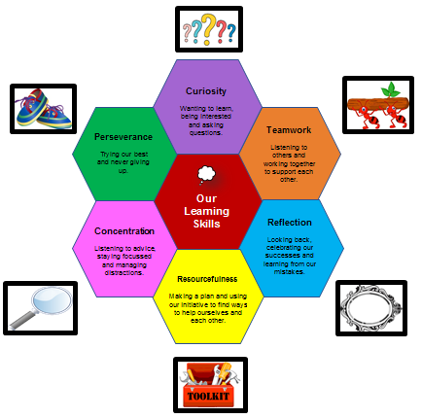
My Brave Day Plan!
What am I going to do?
What will it be like?
What will I be learning – what will I be ‘brave’ about?
What resources will I need?

