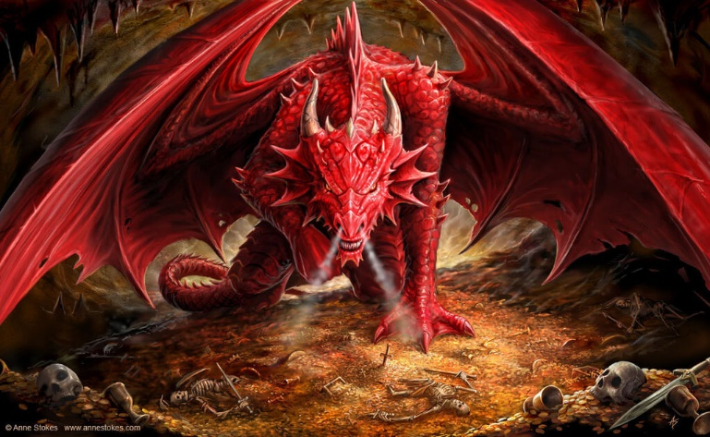

In English writing we will be…
- Creating a dragon using our imaginations and then producing short pieces of writing inspired by it
- Writing an instructional text on how to feed our dragon
  - Using paragraphs and headings to structure our writing
  - Using imperative verbs in the correct tense
  - Using modal verbs and adverbs (Y5)
- Writing descriptions of dragons and mythical creatures, settings and plot
  - Using expanded noun phrases, fronted adverbs and adverbial phrases
  - Using a varied and rich vocabulary including figurative language such similes, metaphors and onomatopoeia
  - Using conjunctions and adverbial phrases to build cohesion within a paragraph (Y5)
- Developing our skills of using a dictionary, planning, proof-reading, understanding the marking code and responding to feedback

In English reading we will be…
- Comparing, analysing and annotating a variety of instructional texts
- Identifying the features of different myths and legends involving mythical creatures
- Summarising and retrieving facts from texts
- Understanding and using the different ‘Reading Roles’ to help us to think about texts thoroughly and from a more critical perspective
In our English Grammar, Punctuation and Spelling we will be…
- Reviewing our knowledge of the basic grammar terms, word classes and punctuation uses.
- Reviewing previous spellings patterns, practising the spelling lists for our year groups, introducing new spelling rules and learning different spelling strategies.
- Practising our GPS learning by writing short dictated sentences
- Using inverted commas and other punctuation to correctly punctuate direct speech
- Using adverbial and prepositional phrases, and relative clauses, to extend our sentences (Y5)

In Mathematics we will be…
- Place Value: Finding 1000 more than any given number and recognising the place value of each digit in a four-digit number. Rounding to the nearest 100. Multiplying and dividing by 10 and 100 (Y4) Reading, writing, ordering and comparing numbers to at least 1,000,000, determining the value of each digit. Rounding up to the nearest 100,000. Multiplying and dividing by 10, 100 and 1000. (Y5)
- Calculations: Practising mental adding and subtracting skills. Solving problems involving addition and subtraction using a variety of methods. Checking our answers using the inverse operation (Y4) Solving multi-step addition and subtraction problems in contexts (Y5) Using place value and known and derived facts to multiple and divide mentally (Y4) Identifying multiples, factors, prime numbers and factor pairs. Multiplying and dividing part and whole numbers by 10 and 100 (Y5)
- Measure: Estimating, comparing, measuring and calculating with different units of metric measurement
In Science we will be…
- Learning about the differences in the life cycles of mammals, birds, insects, amphibians and plants
- Describing the life process of reproduction in some plants and animals

In Art and D.T. we will be…
- Designing and creating a Modroc dragon egg and learning sculpting skills with wire and paper mâché

In P.S.H.C.E. we will be…
- Creating a class charter and learning about the United Nations Convention on the Rights of the Child.

Discussing how to keep safe online

In French we will be…

Learning and revising key communication skills and general greetings

In Music we will be…

Listening and responding to ‘A Bao A Qu’ by Mason Bates. Inspired by this, we will be composing our own pieces about our dragons using different musical structures e.g. palindromes and rondos

In R.E. we will be…

Understanding Christianity and considering ‘What would Jesus do?’

In P.E. we will be…
- Creating a dance, inspired by the mythical creature the phoenix, using different techniques like mirroring, unison and canon
- Playing invasion games with a focus on football

In Computing we will be…
- Learning about E-Safety
- Creating a game using the coding program Scratch

This term’s vocabulary will be…
Science Life Cycles: reproduce, reproduction, foetus, sperm, babyhood, childhood, adolescence, adulthood, metamorphosis, egg, tadpole, larva, pupa, seed, seedling, stamen, stigma, sepal, petal, ovary, pollen, style, germinate, germination, fertilise, fertilisation, pollinate, pollination, disperse, dispersal, etc.

