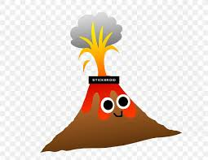
Willow Homework Grid: Volcanoes & Earthquakes

Please choose one activity a week and record which activity has been completed by adding the date into the box provided. Please add comments, should you wish to, regarding your child’s engagement/enjoyment/understanding of each activity.
English |  | Maths |  | Topic/Creative
Writing for pleasure:  Imagine you have been awarded a medal for extreme bravery during a major volcanic eruption. Write a recount of the event and how you came to receive the award.  Don’t forget to use time conjunctions. | Date:  Comments: | Investigate volcanoes on the planet Mars.  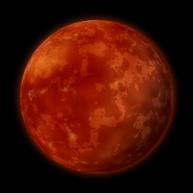  Are they similar or different to Earth’s volcanoes? Make a comparison chart. Think about the size, shape, type and age when comparing them. What maths have you used when creating this chart? | Date:  Comments: | 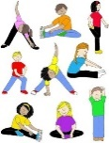  PE activity:  Invent a warm-up game for PE called ‘Volcano!’ Your game must include physical stretches, movement and increase the heart rate. Draw a diagram and write a set of instructions to help us play it.  Y6: Can you include a way to build stamina during your warm-up? | Date:  Comments:
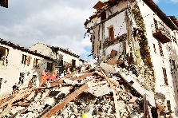  Enjoying your reading?  Do some research on different earthquakes including information about how they begin, how they are measured, the deadly effects of an earthquake, the impact on the land and what are the consequences for the people who live near the earthquake site.  Y5: What ‘fun’ facts engaged you as the reader?  Y6: Can you spot any formal language or technical language? | Date:  Comments: | Statistics:  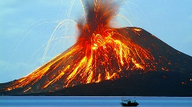  Make a data table for 6 famous volcanoes. You could include:  • Dates of eruptions  • Temperatures  • Height of the volcano  • Distances from major cities  Can you represent some of this information as a bar chart?  Y5: Round the heights and distances to the nearest 100.  Y6: Round the heights and distances to the nearest 1000. | Date:  Comments: | DT/Art activity:  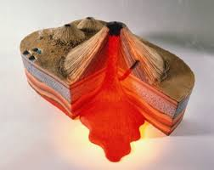  Create a 3D model of a volcano.  Try creating your model around a bottle and then use baking powder, vinegar, food colouring and some washing-up liquid to create oozing ‘lava’!  Y6: Can you label all the features of a volcano? | Date:  Comments:
Writing for pleasure:  Find out about a major volcanic eruption from the last 5 years and use pictures or photographs to create an information report about this eruption.  Y5: Don’t forget subheadings and paragraphs!  Y6: Can you write an introduction and a summary/conclusion? | Date:  Comments: | Mental Maths:  Make a ‘Times Tables Tips’ poster for your bedroom. Show quick strategies for remembering the multiplication facts for x0 to x12.  Y6: Present quick ways of working out ?x13, ?x15 and ?x20 mentally. | Date:  Comments: | History activity:  Make a timeline of volcanic eruptions or devastating earthquakes.  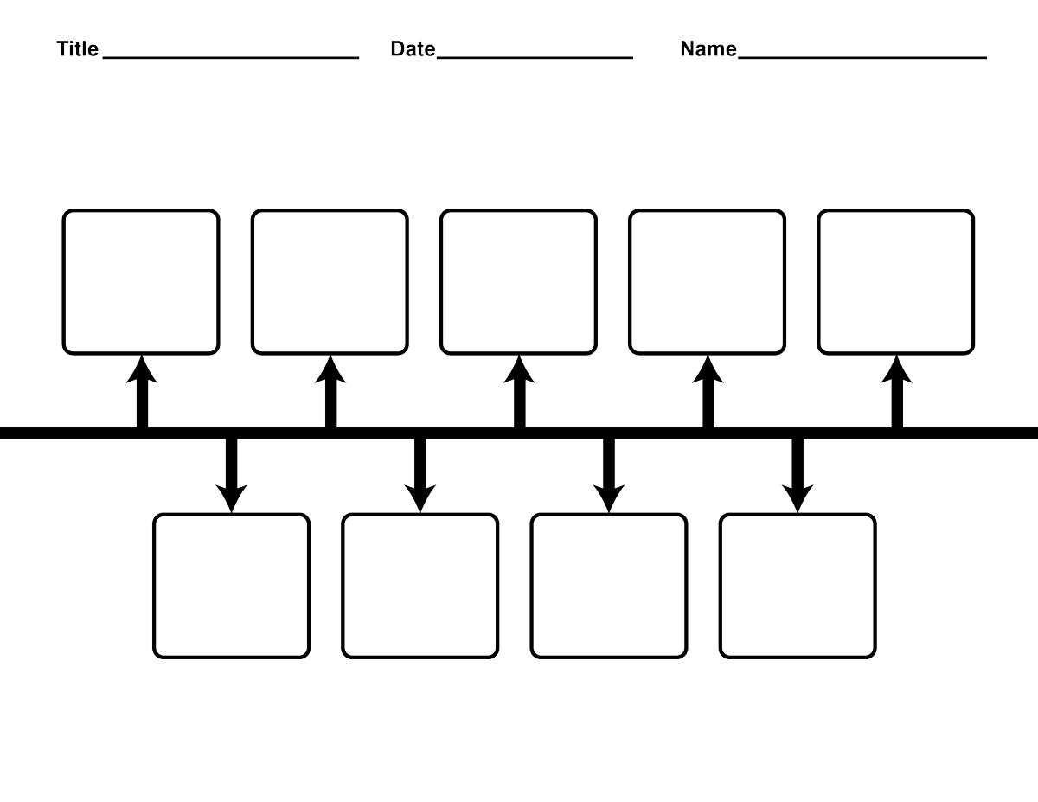 | Date:  Comments:
Spelling Practice:  Make your own spellings crossword using the first 15 Y5/Y6 words (accommodate to bruise). Remember your clues can be synonyms of the word, a definition of the word or a sentence with the word missing. | Date:  Comments: | Number and Calculations:  Y5: Write a 7-digit number.  Y6: Write an 8-digit number.  a) Write the number in words.  b) Write the number in expanded form.  c) What is the value of the tens digit, thousands digit and hundred thousands digit?  d) Write the new number when you x10 x100 x1000.  e) Write the new number when you ÷10 ÷100 ÷1000.  f) Double the number.  g) Half the number.  h) What other maths skill can you use with your number?! | Date:  Comments: | 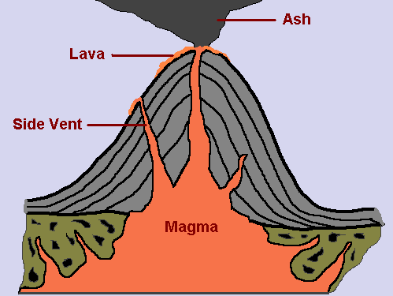  Geography activity:  Make a volcanoes and earthquakes glossary. Find out the definitions of these words: tectonic plates, fault lines, epicentre, hypocentre, liquefaction, mantle, magma, pyroclastic flow, landslide, tsunami, active, dormant and extinct.  Y5: You can label a diagram of a volcano or earthquake to help learn the new vocabulary. | Date:  Comments:

