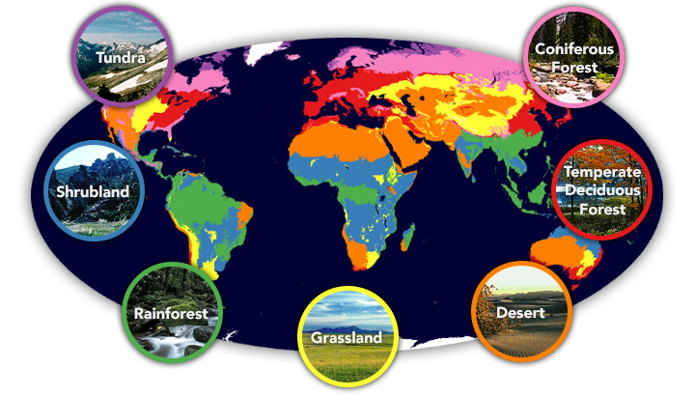Home, Sweet Biome
(Biomes and saving our planet)

In our writing we will be…
- Writing narratives including descriptions of a story setting using examples from ‘The Hobbit’ and ‘Harry Potter’.
- Writing character descriptions.
  - Using figurative language such similes, metaphors, onomatopoeia and personification.
  - Using language that describes the mood and atmosphere of a setting.
  - Varying sentence structures and using a variety of punctuation such as dashes, brackets and commas to add in relative clauses.
  - Using a range of cohesive devices to achieve flow and cohesion.
- Writing persuasive leaflets to reduce plastic waste.
- Writing balanced arguments / discussion texts on themes involving our world and its future.
  - Discussing controversial issues and contributing ‘for and against’ arguments.
  - Evaluating discussion texts and their purpose.
  - Using a range of conjunctions and using organisational and presentation skills to make the most impact on the reader.
- Developing our skills of editing and evaluation.

In our reading we will be…
- Using visualizing, clarifying and summarizing to help us understand a text.
- Exploring the ways in which grammar, punctuation and vocabulary can be used for effect.
- Taking on ‘Reading Roles’ to help us answer questions. Please see the back of this sheet.

In our ‘English Grammar, Punctuation and Spelling’ we will be…
- Reviewing our knowledge of all grammar terms and punctuation uses.
- Understanding complex verbs and verb tenses.

In Mathematics we will be…
- Calculating large numbers mentally - Y5: adding and subtracting and Y6: all four operations.
- Solving problems and perfecting columnar addition and subtraction.
- Solving expressions using the order of operations – Y5: using mental maths, Y6: including indices, square roots, etc.
- Y5: explaining formulas Y6: algebra
- Translating and reflecting shapes on a coordinates plane (Y5: 1st quadrant, Y6: all four quadrants).
- Converting and measuring in different units of measure (Y5: metric and Y6: metric and imperial units).
- Understanding multiples and factors, factor pairs, prime numbers, prime factors and composite numbers.
- Practising short and long multiplication and division methods.
- Working out ratio and proportion in context.
- Learning fractions, decimals and percentages.
- Working out the area, perimeter and volume of shapes.

In Science we will be…
- Looking at Living Things and their Environment.
- Finding out how plants and animals are categorised.
- Using a range of keys to identify different plants and animals.

In Design Technology we will be…
- Developing our technical knowledge of how recipes can be adapted
- Designing, making and evaluating a snack using ingredients from a biome.

In PSHE we will be…
- Discussing the wider world and global issues.

In Geography we will be…
- Using our location knowledge to identify longitude, latitude, etc. on a world map.
- Describing key aspects of different biomes.
- Studying the physical and human geography of a key region in North or South America.

In French we will be…
- Learning how to talk about different animals.

In Music (with Mrs Wellings) we will be…
- Looking at pitch and structure through the ‘Carnival of the Animals’.

In RE our topic will be…
- Living Difference – Ummah: Community

In PE we will be…
- Developing our invasion games skills through netball and basketball
- Developing our skills in gymnastics (with Mrs Wellings)

In Computing we will be…
- Investigating The Crystal Rainforest simulation programme.

