Homework Grid Summer 1: Uganda!
English |  | Maths |  | Topic/Creative
Research an animal from Uganda and create a riddle about it.  Year 2/3: can you use expanded noun phrases and similes in your riddles?  Don’t forget to add a question mark at the end of your riddles! | Date:  Comments: | Continue to practise your current level of mental maths challenge to help you move up to a new level.  Practise the level you are on by repeating it, writing it down and asking your family to help by testing you. Record your practice in your homework book.  Year 1: Can you count onwards and backwards from any given number (up to 20 and beyond)? | Date:  Comments: | Use as many exciting materials as you can to create a collage of the Ugandan flag. | Date:  Comments:
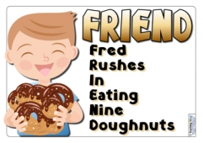  Focus on your Common Exception Words (CEW). Choose a few to practise spellings. You could make up a silly mnemonic, a song or even a rap to help you remember how to spell them and record in your homework book. | Date:  Comments: | Adding and subtracting!  Have a go at adding and subtracting some numbers. Remember, to show your workings out!  Y1: Use numbers up to 20 (practise number facts i.e 12+8=20, 20-12=8)  Y2: 2 digit and 2 digit (blank number line)  Y3: 3 digit number and 3 digit number (column method) | Date:  Comments: | 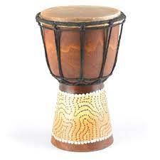  Create your own drum using resources around your house! | Date:  Comments:
Research Uganda and create a fact file about the country. This can be done on the computer or hand written. Think about the different animals that live there, the different cities and the food they produce.  This is a link to a useful website: https://www.kids-world-travel-guide.com/facts-about-uganda.html  This is a child friendly search engine: https://www.kiddle.co/ | Date:  Comments: | Purple Mash!  https://www.purplemash.com/login/  Year 1: Counting in 2s, 5s and 10s.  Log on to Purple Mash and practise your maths skills!  Year 2: x2, x5, x10 tables  Year 3: x3, x4, x8 tables | Date:  Comments: | 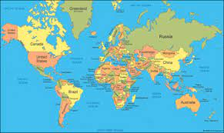  Draw or print out a map of the Word and highlight or colour in any countries that you have a particular link or interest in and tell me why! | Date:  Comments:
Research a story from another culture and verbally retell it. You can film yourself performing it if you would like to! | Date:  Comments: | Make a Ugandan shop, selling things you have found around the house that are likely to come from Uganda (for example: coffee, peanuts or sugar). Ask an adult or your siblings to buy some things from your shop!  Y1: add two items together  Y2: add two items together and work out the change from £1  Y3: add two items together and work out the change from £5 | Date:  Comments: | Find a recipe and make your own bread. You could add your own flavour to the bread too- for example, you can add some olives to make olive bread.  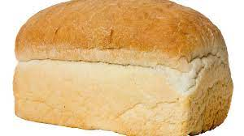  Year 2/3: Can you write the instructions and the ingredients for your bread? | Date:  Comments:
Please choose one activity a week, and record which activity has been completed by adding the date into the box provided. Please add comments, should you wish to, regarding your child’s engagement/enjoyment/understanding of each activity. Please choose at least two from each column during each half term.

