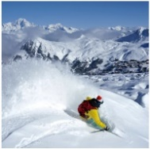
Willow Homework Grid: Alpine Adventures
I I did this independently with no help.
S I did this with some support.
H I needed lots of help and found it tricky.

English |  | Maths |  | Topic/Creative
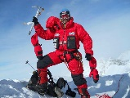  Writing:  Write a biography (an account of a person’s life) about a famous explorer. You will need to research the explorer and find out about their expeditions and achievements. Here are some mountaineers you could research: Sir Edmund Hillary, Tenzing Norgay, Junko Tabei or Reinhold Messner.  Y5: Can you use multi-clause sentences and include a relative clause in your writing?  Y6: Can you try to use different adverbials in your writing? | Date:  Comments: | Calculations:  Please practise multiplication (mental and written methods).  Y5: Mental Y5: Two-digit x one-digit Y5 or Y6: Long multiplication Y6: Decimals  600 x 8 900 x 7 80 x 80 280 ÷ 7 12² 420÷60 56x7 45x3 78x9 67x4 73x6 92x4 546x71 465x32 738x93 687x44 7213x68 9862x49 6.45x1.7 40.5x3.2 6.89x7.9 78.6x82 31.27x4.5 2.609x7.82  If you did this last term, try these:  Y5: a) 895 ÷ 5 b) 8792 ÷ 7 c) 9180 ÷ 6 d) 4689 ÷ 11  Y6: a) 6527 ÷ 31 b) 4895 ÷ 46 c) 8572 ÷ 39 | Date:  Comments: | Science activity: Choose your own activity!  1) Investigate two local microhabitats. Look closely at what creatures and plants live in this habitat. Can you draw, label and compare the two habitats?  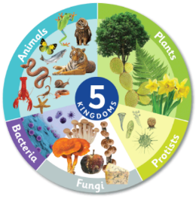  2) Living things are classified into groups depending on their shared characteristics. Carl Linnaeus developed a system which puts all living things into one of five kingdoms:  Animals - all multicellular animals  Plants - all green plants  Fungi - mushrooms, moulds, yeast  Protists – single-celled organisms, amoebas, algae  Prokaryotes/Monera - bacteria  Draw a poster / information sheet showing the five kingdoms with an explanation and examples.  3) Try this website game: http://www.oum.ox.ac.uk/thezone/animals/animalid/games/index.htm  4) Find out about what animals live in mountainous habitats. | Date:  Comments:
Reading and EGPS:  Choose a chapter or a page from a book that you are reading. Create a table with these headings in your book. Identify the different grammar terms and record them in the table.  Expanded noun phrases Prepositions Adverbials  Determiners Pronouns Conjunctions  Y5: Relative clauses Y5 & Y6: Parentheses Y6: Examples of active and passive voice | Date:  Comments: | Measure and Statistics:  Easy:  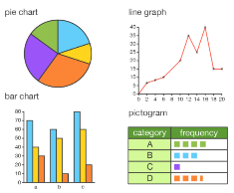  Research the top ten highest summits of the world and record them in a table. Then, convert their heights in metres and kilometres. Y6: cm, m and km.  Use the data to create a labelled bar graph showing the 10 summits.  Challenge:  Y5: Choose one mountain and create a temperature line graph showing the temperatures over a year.  Y6: Create a pie chart showing the number of people who climbed the 10 mountains in one year. | Date:  Comments:
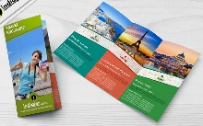  Writing:  Pick a tourist mountain destination and create a travel brochure that persuades people to come and visit.  Y5: Use expanded noun phrases that include prepositional phrases and a formal tone.  Y6: Use persuasive devices such as emotive language, repetition and make opinions sound like facts! | Date:  Comments: | 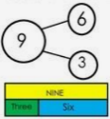  Calculations and Problem-Solving:  1) Write four problems relating to the mountains topic. Each one must include at least one operation.  Y5: Use decimal numbers for addition and subtraction.  Y6: Use multi-steps/more than one operation for each problem.  2) Solve your own problem.  3) Use a bar model / part-whole model or another pictorial model to represent your problem. | Date:  Comments: | Geography activity: Choose your own activity!  1) Create a fact file about a particular mountain range.  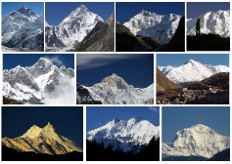  2) Research the different types of mountains (fold, fault-block, dome, volcanic and plateau) and write a description of each type using diagrams.  3) Draw a map of the world and locate and mark the highest mountains in the world. | Date:  Comments:
Spelling Practice:  Choose the spelling strategy that will help you to learn the Y5/Y6 words (necessary to restaurant). You can either create a crossword or write them in sentences or create a quiz to help you learn them.  Spellings: necessary, neighbour, nuisance, occupy, occur, opportunity, parliament, persuade, physical, prejudice, privilege, profession, programme, pronunciation, queue, recognise, recommend, relevant and restaurant. | Date:  Comments: | 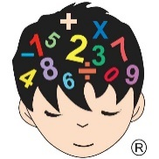  Mental Maths Practice:  Was there anything in your daily mental maths practice this week that you need further practise with? Use this session to practise this skill. | Date:  Comments: | 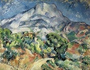  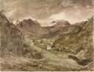  Art activity:  Create a picturesque landscape of a mountains scene. You could use paint, water colours, collage, colouring pencils, oil pastels, a computer art package such as Paint, pencil, or any art medium that you wish. If you need inspiration, look at the work of famous artists such as John Constable or Paul Cezanne. | Date:  Comments:

