Homework Grid Autumn 1: The Magic Toymaker
English |  | Maths |  | Topic/Creative
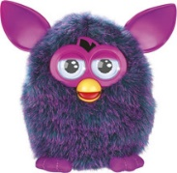  On the computer or using books, research either what a Tamagotchi is or what a Furby is, and create a fact file giving information about what the toy is, what it does, why is what popular, etc. Your fact file could be made on the computer and printed for your homework book, or written. | Date:  Comments: | Continue to practise your current level of mental maths challenge to help you move up to a new level.  Practise the level you are on by repeating it, writing it down and asking your family to help by testing you. Record your practice in your homework book.  Year 1: Can you count onwards and backwards from any given number (up to 20 and beyond)? | Date:  Comments: | 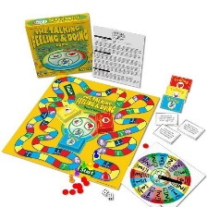  Can you make up your own board game or your own playground game? Think about the rules of the game, as well as the equipment you will need.  Year 3: Can you write some instructions on how to play the game? | Date:  Comments:
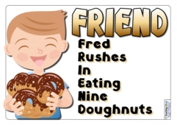  Focus on the Common Exception Words (CEW) for your year group. Choose a few to practise their spellings. Make up a silly mnemonic (like ‘friend’ above) to help you remember how to spell them and record in your homework book. | Date:  Comments: | Do a survey about your friends/family’s favourite toys.  Collect the information in a tally chart and then make a bar graph to show your results.  Year 2/Year 3 Can you ask and answer questions about your information, like: What was the most/least popular toy? How many people liked…? How many more people chose… than … | Date:  Comments: | 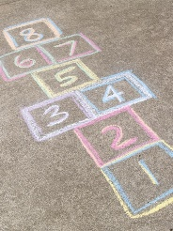  Can you find out about a game from a different country?  What is it called and which country does it come from? How is it played? Can you draw a picture of someone playing the game or have a go at playing it yourself! | Date:  Comments:
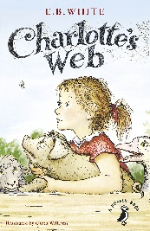  Write a book review about a book you have recently read or a favourite one of yours.  What is it about? Who are the characters and what are they like? Which was the funniest/saddest/best bit and why? Would you recommend it to a friend? Why/why not? | Date:  Comments: | Sumdog!  https://www.sumdog.com/user/sign_in  Log on to Sumdog and practise your maths skills!  Year 1: count and compare numbers to 20.  Year 2: x2, x5, x10 tables  Year 3: x3, x4, x8 tables | Date:  Comments: | Can you create a drawing or a painting of your favourite toy? Think about the colours and the shapes of the toy. What effects can you use to add texture? | Date:  Comments:
Write about what toy you think is better: Lego or a puzzle. Why do you think this?  Year 1: Remember capital letters and full stops.  Year 2: Can you include these conjunctions in your writing: and, but, because?  Year 3: : Can you include these conjunctions in your writing: although, when, if? | Date:  Comments: | How many ways can you make...  Remember - you can use multiplication, addition, subtraction and division!  Year 1: How many ways can you make 10 then 20!  Year 2: Pick a number between 1-50. How many different ways can you make this number? Think of at least 10 ways you can make the number.  Year 3: Pick a number between 100- 200. How many different ways can you make this number? Think of at least 10 ways you can make the number | Date:  Comments: | Interview an adult in your house. What was their favourite toy when they were a child? You could film the interview with your adult! You could ask them about which toys they loved/didn’t like and why, what their toys were made of, and what toys they wished they had had! | Date:  Comments:
Please choose one activity a week, and record which activity has been completed by adding the date into the box provided. Please add comments, should you wish to, regarding your child’s engagement/enjoyment/understanding of each activity. Please choose at least two from each column during each half term.

