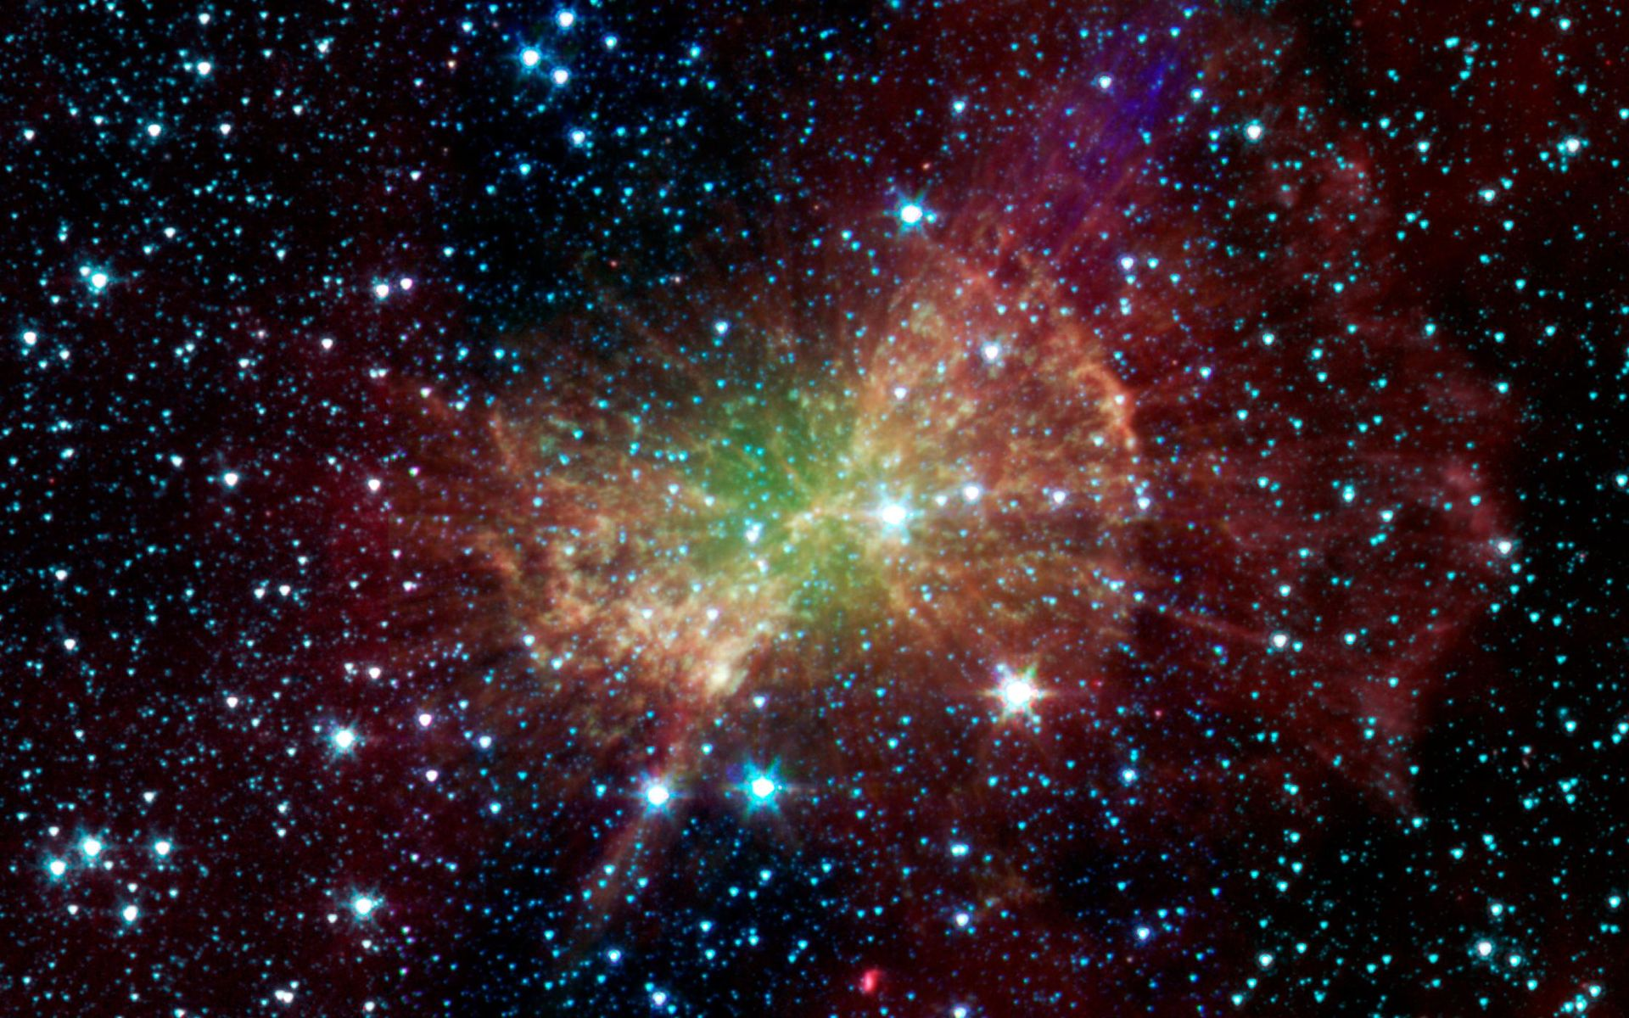
Space

In English we will be…
- Reading a range of poetry related to space.
- Reading a range of recounts related to travel.
- Exploring space poetry with a focus on:
  - Understanding, analysing and explaining poems.
  - Using the reading roles to think about the language, structure and impact on the reader.
  - Using figurative language including similes, metaphors, alliteration, onomatopoeia, personification, etc.
  - Performing poetry!
- Exploring visual literacy using the film Wall-E:
  - Retrieve information and make inferences from soundtracks, opening scenes and characters.
- Writing a range of short pieces about space and journeys into space including:
  - Recounts, biographies, short adventure stories, diary entry, etc.
  - Using cohesive devices including conjunctions and adverbials.
  - Using correct punctuation.
- Developing our skills of planning, self-editing and evaluation.

In our ‘English Grammar, Punctuation and Spelling’ we will be…
- Practising Y5 and Y6 spellings words.
- Spellings words with different suffixes, silent letter words and homophones.
- Identifying the different word classes.
- Revising our knowledge of adverbs, subject and object, plurals, hyphens, apostrophes and modal verbs.
- Y6: subjunctive form, passive and active and tenses.

In Mathematics we will be…
- Place Value: partitioning in different ways, revising decimals and rounding. Y6: place value problem solving.
- Calculations: practising mental maths strategies, practising multiplication and division facts, using written methods through problem solving. Y5: using decimal numbers and Y6: using knowledge of order of operations (BIDMAS).
- Y6: Finding percentages of amounts.
- Measure: Problem solving involving measures. Solving time and timetable problems. Y6: imperial and metric units (km and miles). Y5: Using four operations and decimal notation.
- Geometry: Revising properties of 2D and 3D shapes and calculate missing angles in shapes. Drawing and translating simple shapes on a coordinates plane. Y6: Four quadrants coordinate plane and extending this to reflecting shapes.
- Revision of key mental maths skills

In Science we will be…
- Learning about Earth and Space:
describing the movement of the Earth, and other planets, relative to the Sun in the solar system; describing the movement of the Moon relative to the Earth; describing the Sun, Earth and Moon as approximately spherical bodies; using the idea of the Earth’s rotation to explain day and night and the apparent movement of the sun across the sky.

In Art we will be…
- Creating lunar landscapes.

In PSHCE we will be…
- Learning about the world of work in the wider world.

In French we will be…

Learning how to give directions in French.

In RE we will be…

Understanding the concept of rituals and the significance of them for Christians and Jewish people.

Considering rituals that are done during Easter time.

In Computing we will be…
- Learning how to use an art and design computer package to create a space picture.

Please note: This is the initial plan for this term but may change when we are back in the classroom and are able to assess where the children are in their learning. This term we are focussing on revising and consolidating rather than introducing new learning in Maths and EGPS.

