Willow Homework Grid: Earth and Space
I I did this independently with no help.
S I did this with some support.
H I needed lots of help and found it tricky.

English |  | Maths |  | Topic/Creative
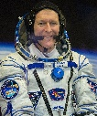  Writing:  Write a biography (an account of a person’s life) about Tim Peake. You will need to research Tim Peake and find out about his education, work and achievements.  Y5 – Can you use multi-clause sentences and include a relative clause in your writing?  Y6 – Can you try to use different adverbials in your writing? | Date:  Comments: | Number and Calculations:  Please practise multiplication (mental and written methods).  Y5: Mental Y5: Two-digit x one-digit Y5 or Y6: Long multiplication Y6: Decimals  600 x 8 900 x 7 80 x 80 280 ÷ 7 12² 420÷60 56x7 45x3 78x9 67x4 73x6 92x4 546x71 465x32 738x93 687x44 7213x68 9862x49 6.45x1.7 40.5x3.2 6.89x7.9 78.6x82 31.27x4.5 2.609x7.82 | Date:  Comments: | Science activity: Choose your own activity!  1) Create a fact file about all the planets or one particular planet.  2) Research the International Space Station and write down the most interesting facts.  3) Think of a way to explain the different phases of the moon. Could you use a model or drawings?  4) Explain why we have day and night using a model or drawings. | Date:  Comments:
Reading  There are lots of books/videos/web pages that include information on Space. Can you practise the pre-reading roles when you read the information to help you fully understand what you are reading?  Y6 – What language structures and vocabulary can you identify that show what genre the text is?  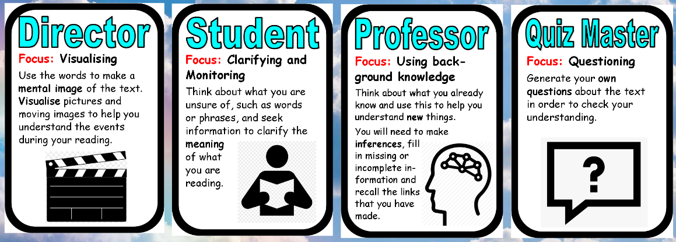 | Date:  Comments: | Coordinates and shape:  Y5: Draw a 10x10 coordinates plane on squared paper.  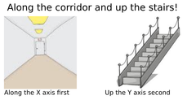  Then, plot these shapes and label the shape you have drawn. 1) (1, 3) (3, 3) (1, 1) (3, 1)  2) (3, 5) (5, 7) (6, 6) (4, 4)  3) (1, 6) (3, 6) (1, 9)  4) (9, 5.5) (8, 4) (10, 4)  Y6: Draw a four quadrants coordinates plane from -9 to 9. Then, plot these coordinates and label the shape with the letter and the name of the shape. | Date:  Comments: | PSCHE activity:  Can you interview someone (a parent/relative) about their job/career? Here are some of the questions you could ask:  - What is your job?  - Is this what you always wanted to be when you were younger?  - How did you become interested in the job you do now?  - What qualifications did you need to get your job?  - What do you have to do in your job?  - What skills do you need to have to be successful at your job?  - What are the advantages and disadvantages of your job?  - What type of person would you recommend your job to? | Date:  Comments:
Writing:  Complete one of the writing tasks set about the 12 crazy planets short film. I have included the link here and the writing tasks below to choose from. Ensure you included the Y5 / Y6 objectives in your writing.  The Planets on Vimeo  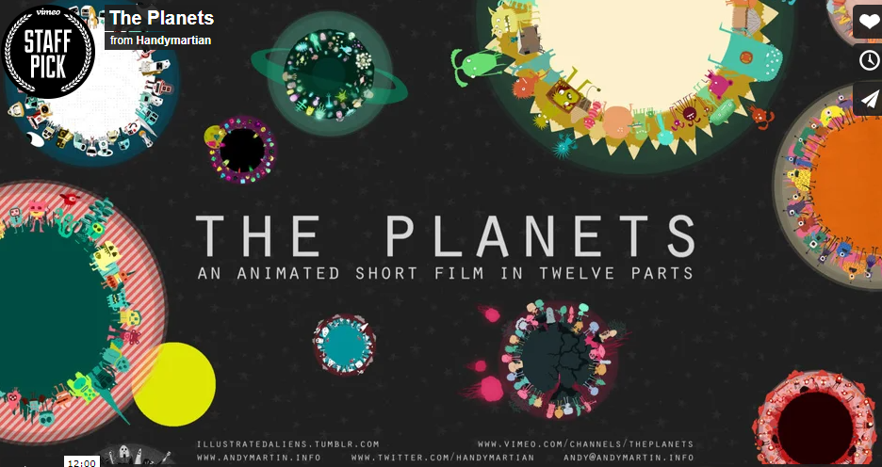 | Date:  Comments: | Number, Place Value and Statistics Practice:  Using the information about the planets below, can you practise these skills using the numbers?  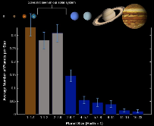  -Ordering the numbers  -Partitioning the numbers  -Rounding the numbers (nearest whole number/to 10/to 100/to 1000)  -Writing them as Roman Numerals  -Drawing a bar graph to represent some of the data  -Calculating some of them to find totals! | Date:  Comments: | Discussion activity:  Here are some controversial statements/questions involving space. Please discuss these with your family and think about whether you agree or disagree with them. Can you explain why and give examples when you discuss them? Can you articulate the for and against points for each statement?  - We should dump our waste on the moon instead of using landfills on Planet earth.  - Should billions of pounds be spent on space research and travel when there is so much poverty on our planet?  - Aliens do exist.  - Mankind’s contribution to climate change has caused global destruction so we should look for another planet to live on.  - The rich and elite should be allowed to go on holidays to space if they can afford a rocket ticket. | Date:  Comments:
Spelling Practice:  Our focus this term is to ensure we know the definitions of all the spellings we learn. Please write sentences that include the Y5/Y6 words (government to muscle).  Spellings: government, guarantee, harass, hindrance, identity, immediate(ly), individual, interfere, interrupt, language, leisure, lightning, marvellous, mischievous and muscle. | Date:  Comments: | 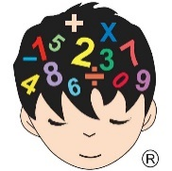  Mental Maths Practice:  Was there anything in your daily mental maths practice this week that you need further practise with? Use this session to practise this skill. | Date:  Comments: | 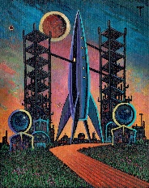  Art or DT activity:  Can you create your own Peter Thorpe inspired art work? Think about using mediums if you wish. How could you make yours different but still be space-related?  DT: What can you create using junk modelling that is space-related? | Date:  Comments:
Planets data to help with maths activity:  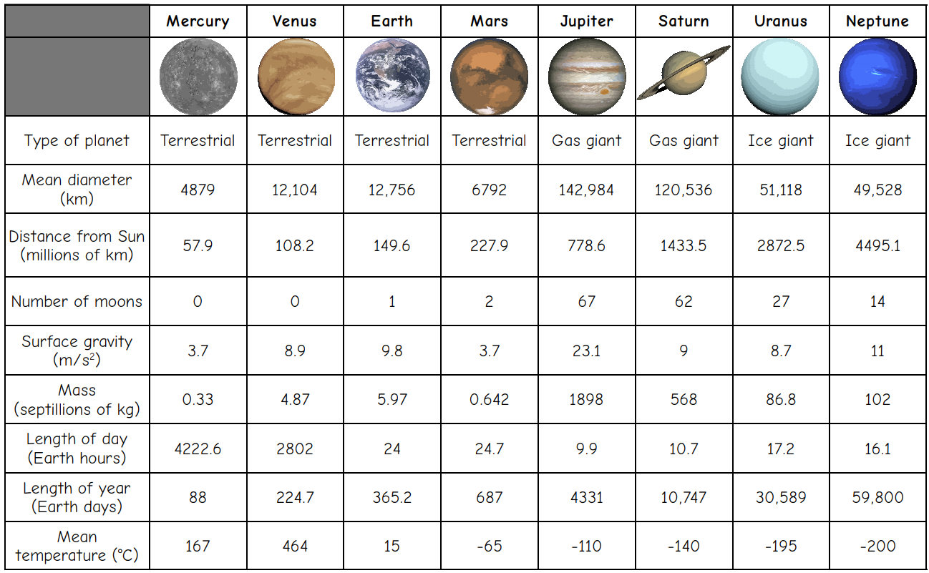 | English writing tasks linked to the Planets Short Film:  Tasks to choose from:  1) Write a mini setting description for one or more of the planets. 2) Write descriptions of the different alien forms. Either choose one type to describe in detail or mini-descriptions of more than one. 3) Write a dialogue between you (as an astronaut) and the aliens or a dialogue between the aliens.  4) Create a holiday brochure for a chosen planet persuading humans to visit. 5) Discuss and write a set of rules for the argumentative aliens on planet 6. 6) Write a narrative (story) about one of the planets that describes how people live there.  7) Write an adventure story about an astronaut that tries to escape from one of the more volatile planets. 8) Write a sci-fi (science fiction) adventure story based on one of the planets. 9) Write a comparison of two planets. Share the pros and cons of living on both planets and compare the similarities and differences between the two planets.  10) Write a poem/song/rap based on the song at the end or on all the planets. 11) Write a recount as if you are an astronaut that landed on one of the planets. You could do this as a diary entry. 12) Write detailed instructions on how to survive on one of the planets OR a mini-set of instructions on how to survive on each planet.  13) Choose your own writing task!  Don’t forget…  -to use correct punctuation including capital letters!  -to use expanded noun phrases.  -to use the correct genre features.  -to vary your sentence structures (multi-clause/fronted adverbials/conjunctions).  -to use formal / informal language correctly.  -to embellish any adverbs, verbs or adjectives! Use a thesaurus if you need to.

