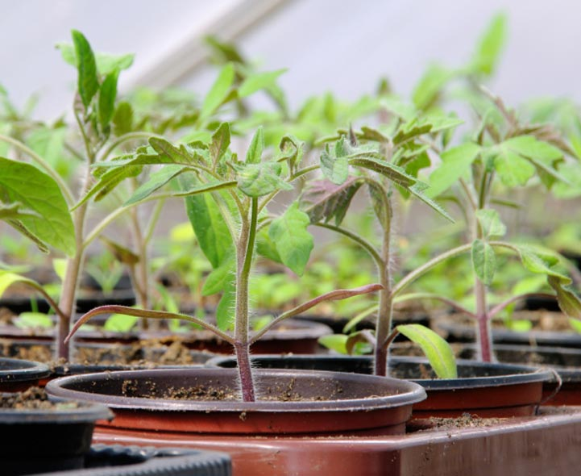
Grow Your Own- Plants!
Sycamore and Silver Birch Classes
Summer 1 2020
English

Writing
- Y1 composing and recording sentences, thinking about capital letters, full stops and finger spaces
- Y2 focussing on using a range of sentence types, as well as conjunctions (and, because, when, if, so, but), using language for impact- including the use of expanded noun phrases, and making simple revisions and editing our work
- Y3 continuing to embed our understanding of the difference between simple and compound sentences as well as a range of conjunctions (although, while, since, until) and continuing to implement fronted adverbials, headings and subheadings, speech and the use of paragraphs in our writing
- Handwriting Y1/Y2 thinking about the size of our writing and the relationship between the lower case and upper case letters, Y3 developing a confident, quicker joined script
- Phonics Y1 consolidating all the alternative sounds, and practicing reading them within both known (real) and unknown (alien) words
- Spelling Y2/3 continuing our yearly spelling programme ‘No Nonsense Spelling’ – working on key word patterns each week in conjunction with the common exception words for each specific year group (spellings will come home associated with this programme weekly)

Reading
- Whole class reading activities linked to our focus texts and other similar texts
- Y1/2 continuing to use our phonic skills to decode new words, and use word patterns to help us with this (linked to spelling)
- Y3 thinking about what’s written ‘between the lines’
- Understanding character motivation using inference skills, and the author’s use of language for effect
- Recognising different themes and convention of texts
- Asking and answering questions about the text

Mathematics
- Addition and Subtraction Y1 numbers within 20, Y2 calculate with 2 digit numbers, Y3 develop a range of strategies to calculate number sentences
- Place value Y1 Use a number line to order whole numbers, Y2 partition numbers into different combinations of tens and ones, Y3 count up and down in tenths
- Problem Solving Y1 begin to use pictorial representations to find a solution, Y2 recall multiplication and division facts for 2,5,10 times tables and use them to solve simple problems
- Geometry Y1 name common 2D and 3D shapes, Y2/Y3 describe the properties of 2D and 3D Shapes and for Y3, compare them
- Statistics Y2 read scales in divisions of 1s,2s,5s,10s, Y3 interpret and present data using bar charts, pictograms and tables

Science
- Identifying what plants need to grow and be healthy
- Knowing how seeds and plants work
- Understanding that plants reproduce to make more plants

PSHCE
- Using a range of emotional vocabulary to describe their own and others’ feelings in a range of situations
- Suggesting ways of managing negative emotions and strategies that promote mental wellbeing

Music
- Understanding the different ways sounds can be made
- Recognising the different pitch of sound in music
- Playing accurately and with control of technique on a range of percussion instruments

Computing
- Using Scratch software to learn how to code, follow and give instructions, create algorithms and identify errors in a program

Art and Design
- Researching and learning about the work of Andy Goldsworthy
- Using nature as a stimulus for still life drawings and considering the effects the use of colour has on the viewer
- Working with mixed media to create a final piece

RE
- Focusing on the Gospel being good news
- Considering how Jesus’ Good news is about friendship, forgiveness and peace
- Looking at stories where Jesus demonstrated forgiveness, peace and friendship and thinking about when we are able to show these qualities

PE
- Learning to hold a bat correctly and rolling, throwing and catching the ball in different ways to hit a target, within the games of Cricket and Rounders

Role Play Corner
- Inside a Garden Centre!

