English |  | Maths |  | Topic/Creative
Writing for pleasure:  Write an adventure story featuring a  river. Make sure it has exciting  events and language to keep the reader  engaged throughout | Date:  Comments: | Choose some maths you find hard. It could be:  - Numbers bonds to 100  - A tricky times table  - Converting across metric measures (cm into m for example) | Date:  Comments: | Use a photograph of a river to  inspire a collage. Choose one  medium for the collage (e.g.  tissue, fabric, wool). | Date:  Comments:
Enjoying your reading?  Read a non-fiction book  about rivers. Write a  detailed book review,  explaining what you learnt and how  the layout helped you to understand  the information. | Date:  Comments: | Research statistics of a range of  different rivers (e.g. length, number  of countries it travels through,  maximum width) and make into a set  of top trumps cards. | Date:  Comments: | Create a sculpture of a river creature or plant.  You could use clay, salt, dough, papier mache or any material of your  choice. | Date:  Comments:
Research one river in detail  and present the information in  a non-chronological report. | Date:  Comments: | Find out the length of at least  10 different rivers and present the information as a bar chart. (If you want some squared paper for this, just ask). | Date:  Comments: | Make a comic strip of the water  cycle with a water droplet as your  main character. | Date:  Comments:
Spelling practice – take a week to really focus on your spellings, taking not only your list, but also words that you have corrected in your written work. | Date:  Comments: | Find (or make) a river boat  timetable. Calculate the times it  would take to travel to different  destinations. Draw a map to  accompany it!  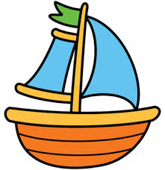 | Date:  Comments: | Build a model of a famous bridge which crosses a river.  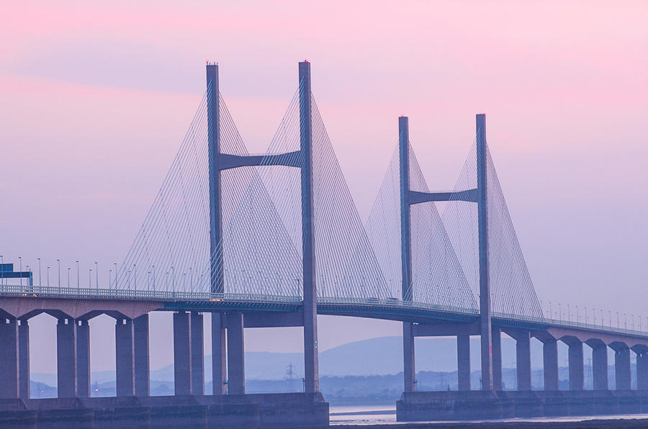 | Date:  Comments:
Y4/5 Homework Grid: Rivers
Please choose one activity a week, and record which activity has been completed by adding the date into the box provided. Please add comments, should you wish to, regarding your child’s engagement/enjoyment/understanding of each activity. Please choose at least two from each column during each half term.

