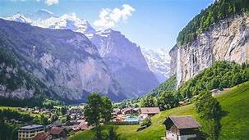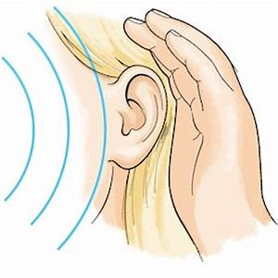
Alpine Adventures & Science of Sound

This term, we will be completing topics that were not finished last term including sewing a European themed tapestry in D.T., locating mountains in Geography and classifying plants in Science. Also, we will be preparing for the Upper School Production which will form part of our timetable.

In English we will be…
- Reading a recount about surviving a mountain expedition from the book “Survivors” and continuing to read our class story: “Asha and the Spirit Bird” by Jasbinder Bilan.
- Writing a range of short pieces based these narratives to develop our writing skills:
  - Using correct punctuation and understanding how to use commas for clarity and effect
  - Using a variety of sentence structures including parentheses, relative clauses (Y5)
  - Using conjunctions, adverbs and prepositions to express time, place and cause (Y4)
  - Using cohesive devices including conjunctions and adverbials
  - Building and expanding vocabulary
- Continuing to develop our skills of planning, proof-reading, self-editing and evaluation.

In our ‘English Grammar, Punctuation and Spelling’ we will be…
- Practising our spellings words.
- Year 4 spelling patterns: /g/ gue /k/ que; /ʌ/ – the UH short vowel sound; /ʒ.ər/ spelt –sure and /tʃər/ spelt –ture; ‘er’ sound /əː/ spelt ear; Long sound /aɪ/ spelt mind, fine, pie, high, fly; /I/ spelt sit.
- Year 5: Spelling words that are plurals; spelling words with the spelling patterns que/gue and ou with an u sound; spelling words beginning with ph/phy/hy/rh/ps/pn and spelling hyphenated words.
- Year 5: Recognising and writing adverbs and adverbials that indicate degrees of possibility; using cohesive devices and parentheses and understanding and writing modal verbs.
- Year 4: Using fronted adverbials with the correct punctuation to show how, when and where something happened; using inverted commas and other punctuation to correctly punctuate direct speech.

In Mathematics we will be…
- Statistics: Drawing and interpreting simple pie charts (Y5)
- Measure: Revising telling the time and converting the time (Y4); solving time and timetable problems; converting units of measure and solving problems related to mass, length, capacity and time; calculating the area, perimeter and volume
- Multiplication and Division Facts: Securing formal methods and solving multi-step problems.
- Fractions, decimals and percentages:
Year 4: Recognising and showing, using diagrams, families of common equivalent fractions; Recognising and writing decimal equivalents to ½, ¼ and ¾; Comparing numbers with the same number of decimal places up to two decimal places.
Year 5: Representing fractions using different models; finding equivalent fractions; calculating fractions involving proper, improper and mixed number fractions; Converting fractions to decimals and using place value knowledge to multiply, divide and round decimals

In Science we will be…
- Identifying how sounds are made, recognizing that vibrations from a sound travel through a medium to the ear and investigating pitch and volume.

In P.E. we will be…
- Practising striking and fielding through rounders and cricket.
- Practising our throwing skills in athletics.

In D.T. we will be…
- Creating and evaluating our class collaborative textile product which celebrates our European community.

In P.S.H.C.E. we will be…
- Year 4: Learning about how to build positive relationships
- Year 5: Covering the Relationships and Sex education curriculum.

In Music we will be…

Learning songs in preparation for our production.

In RE we will be…
- Investigating the concept of God and the impact it has on both Christians and non-Christians.

In Computing we will be…
- Learning how to create spreadsheets
- Continuing our databases unit from last term that we didn’t finish

Key Science Vocabulary:
vibrations, sound waves, volume, pitch, amplitude, energy, particles, reflection, absorption, distance, soundproof, vacuum, ear drum

