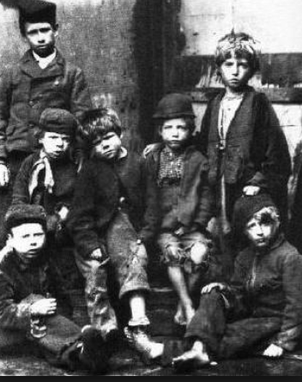
The Victorians
Sycamore Class
Spring 1 2019
English
Writing
- Key skills - Y2 focussing on writing commands and exclamatory sentences, past and present tense and a range of conjunctions, Y3 using inverted commas to punctuate direct speech and using a rich vocabulary
- Handwriting – focussing on developing our joined script, with well-sized finger spaces and, for Year 3, remembering to join all the time in our writing
- Non-fiction – instruction writing, using imperative verbs, thinking about the kind of language needed to write clearly and concisely and, for Year 3, thinking about the audience
- Fiction – writing simple but coherent narratives, using a range of descriptive language and, for Year 3, beginning to create characters, setting and plot
- Spelling – continuing our new spelling programme ‘No Nonsense Spelling’ –learning about suffixes and word groups to support spelling, as well as continuing to learn common exception words for each specific year group. Spelling tests continue each week.

Reading
- Whole class reading activities linked to our focus texts and other similar texts, focussing on our understanding of character motivation using our inference skills, and the author’s use of language to enhance our writing
- Y2 – answer questions, make predictions and make inferences about the texts we read
- Y3 – learning how to use a dictionary, and identifying a range of themes and conventions in different texts

Mathematics
- Embedding our understanding of 2-digit numbers (Y2) and 3-digit numbers (Y3) and practising our counting patterns (Y2 2s, 5s, 10s and 3s and Y3 3s, 4s and 8s)
- Addition and subtraction – Y2 confidence in adding and subtracting a 2-digit number to/from another 2-digit number, Y3 confidence in adding and taking away 2-digit numbers from 3-digit numbers, both of these including missing number problems
- Solving 1 and 2 step problems in a range of contexts
- Multiplication and division – recall and use multiplication and division facts for times tables (Y2 2, 5, 10 and Y3 3, 4, 8) as well as solving problems
- Fractions – finding fractions of shapes and numbers and for Y3, recognising and showing, using diagrams, equivalent fractions with small denominators
- Measures – using standard units to measure volume and for Y3, comparing, adding and subtracting these
- Time – telling the time and drawing the time on clock faces and, for Y3, linking digital and analogue time
- Geometry – using mathematical vocabulary to describe position, direction and movement and for Y3, recognising angles as a property of shape

Science
- Understanding that all animals have basic needs for survival, thinking about a balanced diet
- For Y3 - naming different food groups and understanding their role in our health
- Understanding and using our different senses
- Understanding the importance of exercise, and that our bodies have muscles to make them work
- Y3 – consolidating our understanding of magnets
History
- Understanding how artefacts, pictures and other resources help us to learn about the past
- Comparing our lives now to those of children in Victorian times, learning about Victorian lives, homes, school (including punishments!) and toys
- Researching Queen Victoria and comparing her to Queen Elizabeth II

Art and Design
- Self-portraits using different media
- Creating a portrait of Queen Victoria

Design and Technology
- Design, make and evaluate a wind-up toy

R.E Belonging - Judaism
- Learning about and understanding how Jewish people show they belong to the Jewish faith
- Finding out about a Jewish synagogue

Music
- Learning, composing and performing Victorian street cries

P.E.
- Victorian Drill, and other Victorian playground games
- Invasion Games – football and hockey

Computing
- Sharing digital photos
- E-safety

PSHE
- Thinking about our family
- Understanding we belong to lots of different groups
- Understanding the responsibility we have towards the groups we belong to
- Understanding what it means to be British

Role Play Corner
- A Victorian School!

