Cherry Class
Spring Term I 2019
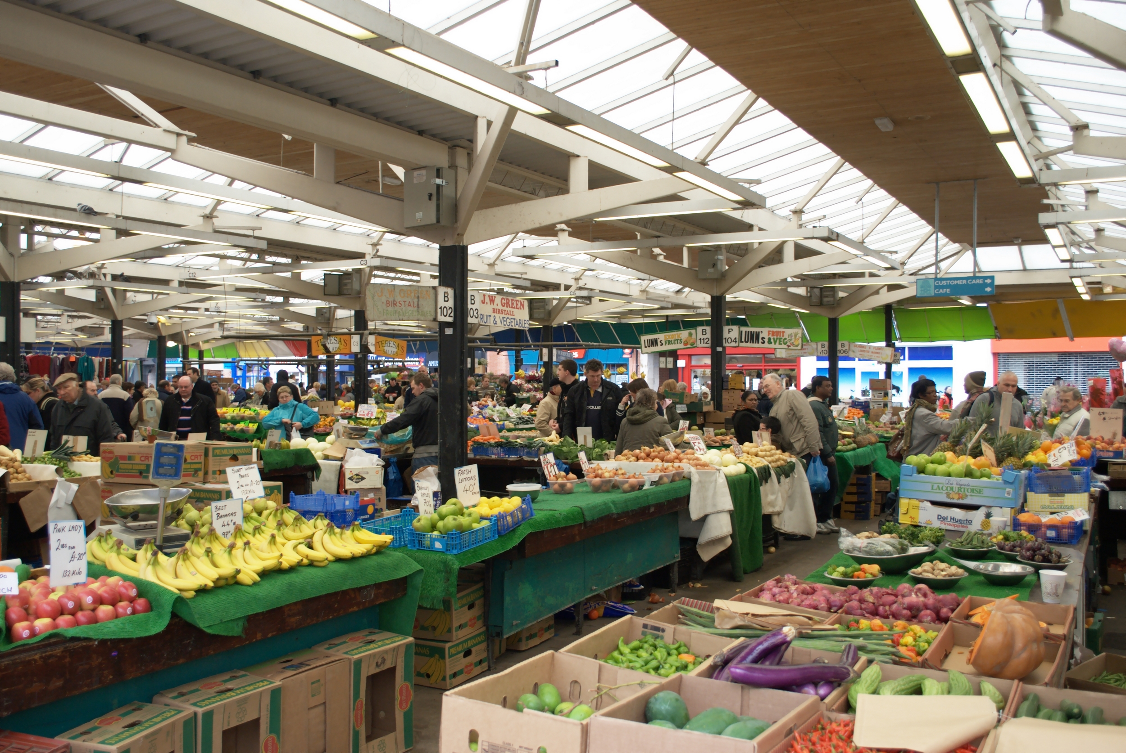
Toys & Shops
Here is a brief summary of our planned learning for this half-term…but remember, no plan in Reception is ‘set in stone’!
KA BP January 2019

A more detailed plan for the half term is available in class.

Communication, Reading and Writing
The Tiger Who Came To Tea
Oliver’s Vegetables
Reading/writing a shopping list
Writing captions about toys
Making posters and menus for a café
Writing toy adventure story

Maths
Finding out about money and coins
Shopping with coins
Adding and subtraction with money
Place value and linking it to money
3D shapes, weighing, measuring

Physical Development
Balances, stretching and curling for good co-ordination in Gym
Dancing

The World
Visit to Newbury Market
Sorting a bag of shopping and putting items on a world map
Toys – pushes and pulls

Technology
Purple Mash
Using a programmable toy: Bee-Bot (instructions)
Word processing

Expressive Arts and Design
Painting toys
Making 3D character dolls and dressing them
Oil pastels – fruit and vegetables

Personal, Social and Emotional
Getting on, falling out and making up
Say no to Bullying

