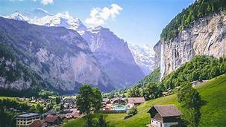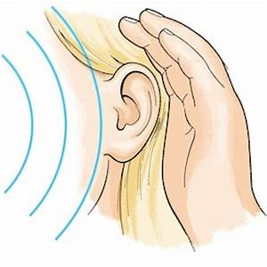
Alpine Adventures & Science of Sound

This term, we will be completing topics that were not finished last term including sewing a European themed tapestry in DT, locating mountains in Geography and classification of plants in Science. Also, we will be preparing for the Upper School Production which will form part of our timetable.

In English we will be…
- Reading a range of narratives set in the mountains and about journeys up mountains and survivor stories.
- Y6: SATs style comprehension questions practice.
- Writing a range of short pieces based on narratives related to mountains to develop our writing skills:
  - Using correct punctuation and understanding how to use commas for clarity and effect.
  - Using a variety of sentence structures including parentheses, relative clauses (Y5) and active and passive voice (Y6).
  - Using cohesive devices including conjunctions and adverbials.
  - Building and expanding vocabulary.
- Developing our skills of planning, proof-reading, self-editing and evaluation.

In our ‘English Grammar, Punctuation and Spelling’ we will be…
- Practising Y5 and Y6 spellings words.
- Spelling words that are plurals; spelling words with the spelling patterns que/gue and ou with an u sound; spelling words beginning with ph/phy/hy/rh/ps/pn and spelling hyphenated words.
- Reviewing our learning of the verb tenses (simple, progressive and perfect forms), clauses, word classes (Y5: pronouns), adverbs that indicate degrees of possibility, cohesive devices, parentheses and adverbials.
- Y6: Learning about the subjunctive form and the use of colons, semi-colons, bullet points and hyphens.

In Mathematics we will be…
- Statistics: drawing and interpreting simple pie charts. Y6: representing and interpreting data on pie charts. Finding the mean, mode and median.
- Measure: Solving time and timetable problems.
- Multiplication and Division Facts: securing formal methods and solving multi-step problems. Y6: using long multiplication with decimal numbers and long division with answers given as remainders, fractions or decimals. Understanding ratio, proportion and scale factor.
- Measure 1: converting units of measure including metric and imperial and solving problems related to mass, length, capacity and time. Calculating the area, perimeter and volume of shapes. Y6: converting km to miles and vice versa, calculating the area of parallelograms and triangles using formulae and solving SATs style problems.
- Fractions: representing fractions using different models, finding equivalent fractions, calculating fractions involving proper, improper and mixed number fractions. Y6: Calculating fractions with all four operations and solving fraction problems.
- Fractions, decimals and percentages: representing FDPs pictorially, converting fractions to decimals and using place value knowledge to multiply, divide and round decimals. Y6: finding percentages of amounts, converting FDPs and applying this to solve reasoning problems.

In Science we will be…
- Identifying how sounds are made, recognising vibrations from a sound travel through a medium to the ear and investigating pitch and volume.

In PE we will be…
- Practising striking and fielding through rounders and cricket.
- Practising athletics skills such as the push throw, the pull throw and the fling and heave throw.

In DT we will be…
- Creating and evaluating our class collaborative textile product which celebrates our European community.

In PSHCE we will be…
- Covering the Relationships and Sex education curriculum.
- Y6: Preparing for transition to secondary school.

In Music we will be…

Learning songs in preparation for our production.

In RE we will be…
- Investigating the concept of God and the impact it has on both Christians and non-Christians.

In Computing we will be…
- Learning how to create spreadsheets.

Key Science Vocabulary:
vibrations, sound waves, volume, pitch, amplitude, energy, particles, reflection, absorption, distance, soundproof, vacuum, ear drum, etc.

