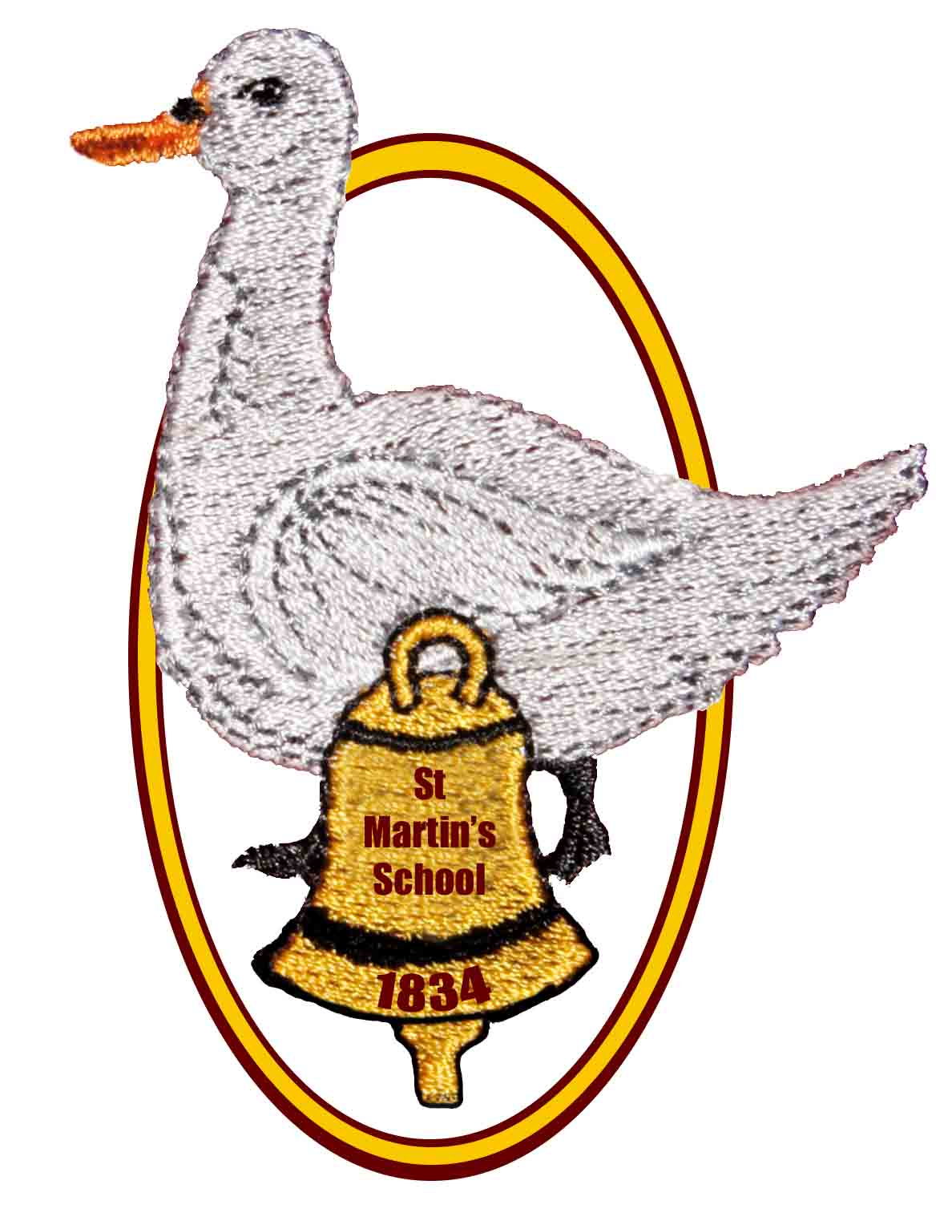

St Martin’s School

Headteacher: Mrs K. Bartlett Chair of Governors: Mrs A Rowe and Mrs L Chorley

OPEN MORNING, AFTERNOON AND EVENING

for parents of children who are due to start school in September 2022

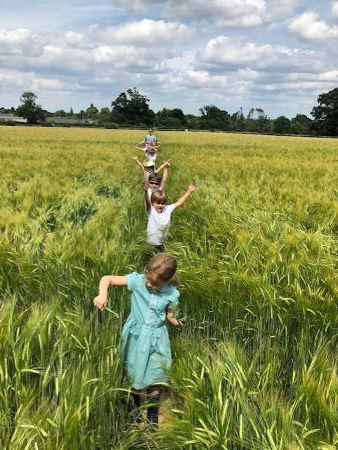We would like to invite you to find out more about

## St Martin’s

## Church of England (Aided)

## Primary School

**East End, Newbury, RG20 0AF**

**on**

**Thursday 4th November**

**9.30am, 1:30pm or 6.00pm**

**We are planning to start each session with a short presentation by the Headteacher and Deputy Headteacher, followed by a tour of the school led by our school ambassadors and an opportunity to look round the school grounds.**

**We are asking anyone who would like to attend, to phone the school and book in to a session. This will allow us to monitor numbers and complete an accurate risk assessment and ensure we keep everyone as safe as possible in the current circumstances.**

**In the meantime, please explore our school website to find out more about us – the page for Cherry Class 2020 shows you how we supported our new Year R children last year and the staff films can give you a feel for the ethos of our school.**

**If you have any questions or would just like a chat with the Headteacher about St Martin’s School, please contact us on 01635 597796**

**or e-mail**

[**adminoffice@st-martins.hants.sch.uk**](mailto:adminoffice@st-martins.hants.sch.uk)

**Come and see our new Year R outdoor area, which is being installed during October 2021!**