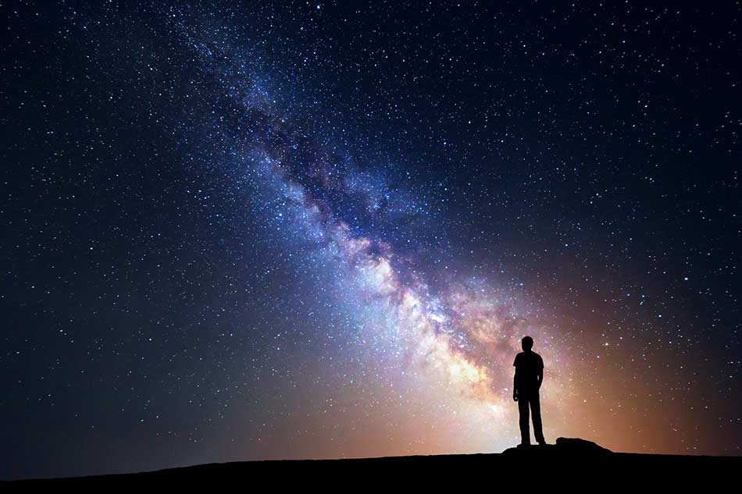
- Space

In English we will be…
- Reading a range of poetry related to space
- Reading a range of recounts related to travel
- Exploring space poetry with a focus on:
  - Understanding, analysing and explaining poems.
  - Using the reading roles to think about the language, structure and impact on the reader.
  - Using figurative language including similes, metaphors, alliteration, onomatopoeia, personification, etc.
- Performing poetry
- Exploring visual literacy using the film Wall-E:
  - Retrieve information and make inferences from soundtracks, opening scenes and characters
- Writing a range of short pieces about space and journeys into space including:
  - Recounts, biographies, short adventure stories, diary entry, etc.
  - Using cohesive devices including conjunctions and adverbials
  - Using correct punctuation
- Developing our skills of planning, self-editing and evaluation
- Practising our handwriting so that we are using a cursive script, including lead-ins

In our ‘English Grammar, Punctuation and Spelling’ we will be…
- Practising Year 4 and Year 5 spellings
- Revising word classes
- Learning how to make nouns plural and looking for regular and irregular patterns
- Learning the difference between plural nouns and possessive nouns
- Using apostrophes correctly to mark possession
- Using commas to clarify meaning and avoid ambiguity and also after fronted adverbials

In Mathematics we will be…
- Place Value: Revising partitioning; ordering, comparing and rounding decimals to 2 d.p. and whole numbers Y5: Using decimal numbers to 3 d.p.; rounding to the nearest whole number
- Calculations: practising mental maths strategies, practising multiplication and division facts; using written methods when problem solving Y5: using decimal numbers
- Measure: Time Y4: reading, writing and converting time between analogue and digital 12 and 24-hour clocks; solving problems involving converting from hours to minutes; minutes to seconds; years to months; weeks to days Y5: Revising reading, writing and converting time between analogue and digital 12 and 24-hour clocks and solving problems involving converting between units of time
- Geometry: Drawing and translating simple shapes on a coordinates plane; learning the types of angles; revising properties of 2D shapes Y5: drawing angles and calculating missing angles in shapes

In Science we will be…

Learning about Earth and Space: describing the movement of the Earth, and other planets, relative to the Sun in the solar system; describing the movement of the Moon relative to the Earth; describing the Sun, Earth and Moon as approximately spherical bodies; using the idea of the Earth’s rotation to explain day and night and the apparent movement of the sun across the sky

In Art we will be…
- Analysing the work of the artist Peter Thorpe
- Creating space-themed abstract art in his style
- Creating a final composition using I.C.T. to layer our hand-drawn elements

In P.S.H.C.E. we will be…

Learning about the employment in our new unit, the World of Work

In French we will be…

Learning how to give directions in French

In R.E. we will be…

Understanding the concept of rituals and the significance of them for Christians and Jewish people

Considering Easter rituals

In Computing we will be…
- Learning how to use an art and design computer package to create a space picture

Please note: This is the initial plan for this term but may change when we are back in the classroom and are able to assess where the children are in their learning. This term we are focussing on revising and consolidating rather than introducing new learning in Maths and EGPS.

