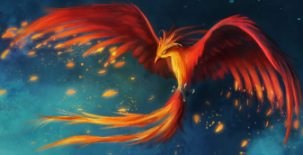
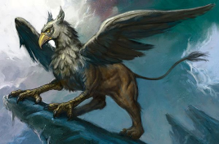
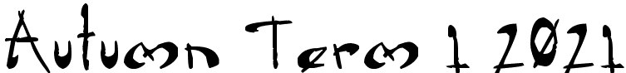
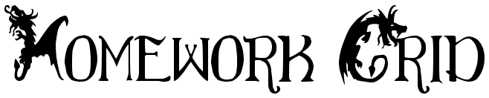

Hello Maple families! This term our topic is Mythical Creatures! Here are some homework activities for you to choose from. Please choose at least two from each column for this half-term, and record which activities have been completed by adding the date into the box provided. Let me know how you get on! I look forward to seeing your books soon!
English |  | Maths |  | Topic
Reading and writing:  With the help of an adult, find a book or story that contains a mythical creature. Perhaps you have one at home already, or you could get one out of the library. If you enjoyed it, please write the blurb for the back cover. Try to make it sound as exciting as you can, and make me want to read it. If you did not like the story or book, I’d like to know why. Write about what you didn’t like about it. Be as specific and as detailed as you can. | Date: | Place Value, Number and Calculations:  Begin by choosing a 4-digit number (or 7-digit number if you are in Year 5 and would like the challenge).  a) Write the number in words  b) Write the number in expanded form  c) What is the value of the tens digit, hundreds digit and thousands digit (tens of thousands digit for Y5)?  d) Write the new number when you multiply and divide your chosen number by 10 and 100 (and 1,000 Y5)  e) Write the new number when your number is doubled  f) Write the new number when your number is halved | Date: | 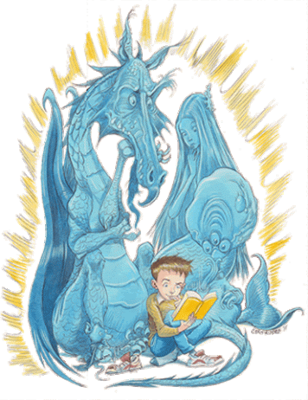  Art:  Using adult support to navigate the internet, research illustrators of children’s books that contain dragons e.g. Chris Riddell, Freya Hartas, Axel Scheffler, Becky Cameron and Cressida Cowell. Which dragons do you like best? Choose one illustrator to study. What materials and techniques have they used? Try to mimic their style to copy a dragon that they have illustrated or to illustrate your own dragon in their style. | Date:
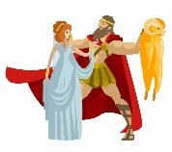  Reading and Writing:  Research a story with a mythical beast that interests you. I can recommend one of the Greek myths for a thrilling adventure! Create a comic strip to retell the story ensuring you retrieve the key details and identify the main characters, settings and plot. | Date: | Measure:  Choose a hybrid mythical creature e.g. a faun which is half-human and half-goat. Then find the average mass in kg of the animals that compose it. Next add them together to give that creature a total mass. You could try this for other mythical creatures too! If you would like to, you could estimate the fraction of each animal and add the fractions of average mass instead e.g. faun = ½ average human mass + ½ average goat mass | Date: | 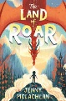  D.T.:  Create a 3D model/map of your own imaginary kingdom where mythical creatures live – just like Roar in our class story ‘The Land of Roar’. Don’t forget to name it, and to write a little bit about it to describe it to me! To make your model, you could use craft materials or construction toys that you own! | Date:
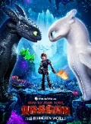  Reading and Writing:  Watch a film, or read a book, with a dragon featured in it e.g. Raya and the Last Dragon, How to Train Your Dragon. Then, write a description of the dragon. Think about the dragon’s appearance (what it looks like) and its behaviour. | Date: | Measure:  Create a recipe for a magical potion that can turn the deadliest dragon into another mythical creature! Write the solid ingredients in both grams and kilograms and the liquid ingredients in millilitres and litres. | Date: | 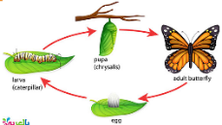  Science:  Research the life cycle of your favourite animal or an unusual animal. Draw the life cycle using diagrams, annotations and arrows. Remember to use the correct science vocabulary when you label the diagram. | Date:
Reading and Writing:  With the help of an adult, do some research to find out about mythical creatures. Can you find any that you have not have heard about before? Then tell me which is your favourite mythical creature and why. Draw it and include a little description of it too please. | Date: | Rounding:  Answer the place value questions about rounding on Purple Mash. The task has been set as a ‘2Do’ for you, but please make sure your login details are set-up first! | Date: | P.E.:  Create a dance based on a mythical creature, like our Phoenix dance in P.E.. You could set it to a piece of music or perform without music. You could write a little about what you do in your dance, or you could take photos of it, or ask someone to take a video of it. | Date:
Spelling:  Make your own spellings crossword using the first 15 Y3/Y4 words for Year 4 (accident to busy) or the first 15 Y5/Y6 words for Year 5 (accommodate to bruise). Remember your clues can be synonyms of the word, a definition of the word or a sentence with the word missing. | Date: | 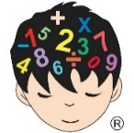  Times Tables:  Make a ‘Times Tables Tips’ poster for your bedroom. Show quick strategies for remembering the multiplication facts up to x12. If there are any facts that you always get stuck with, make a special poster just for those. | Date: | P.S.C.H.E./Family Discussion:  Discuss the different ways your family can keep safe when online. Discuss the potential dangers of using social media, exploring YouTube videos, gaming sites and being on a screen for an unlimited time. Can you all think of strategies to help keep you safe online and keep your screen habits healthy? | Date:

