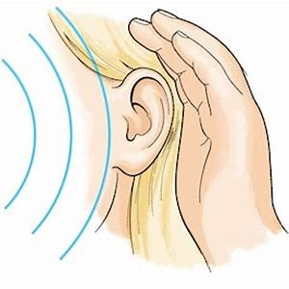
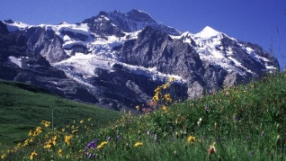
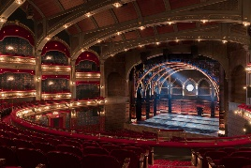

Hello Maple families! This term we are continuing with our Alpine Adventures topic but we will also be investigating the Science of Sound and of course our production ‘Mystery at Magpie Manor’ will form a large part of our learning this term too! Please choose at least two from each column for this half-term, and record which activities have been completed by adding the date into the box provided. You can also add comments about how your child got on if you wish! I look forward to seeing your books soon!
English |  | Maths |  | Topic
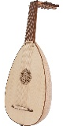  Reading and Writing:  Choose one instrument to research. Create a leaflet for people who know nothing about the instrument already. Include an introduction and a conclusion. Possible topics for paragraphs include: what it looks like; what it sounds like; how the sound is made and pieces of music that feature it. | Date: | Fractions:  Divide one day at the weekend into 24 hours. Record what you did for each hour of the day. Then for each activity write it as a fraction of the day. For example, if you slept for 12 hours, then sleep would be $\frac{12}{24}$  Year 5: Simplify each fraction into its lowest form  Challenge: You could divide the day into 48 half hours | Date: | 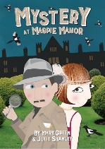  Art:  Create an Art Deco style poster for our production! You could do this by hand or using a computer. | Date:
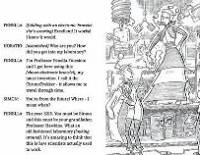  Reading:  With adult support, try to find an example of a play-script, either belonging to a member of your family or by visiting the library. How is it different to a normal story book? What is similar and what is different? Did you enjoy reading it? Try to explain your reactions and feelings about it. | Date: | Statistics:  Collect some data over a week (or longer). It could be the height of a young plant, or the minutes of sleep you have, the number of steps you walk… Create a table first that shows your data. Then present it in a graph. Remember to label your y- and x- axis, and work out your intervals carefully. Let me know if you need squared paper for this! | Date: | D.T.:  Make a musical instrument using mainly materials found in your recycling bin. Sing one of your favourite songs accompanied by your instrument. You could even send us a video of your performance! | Date:
Writing:  Turn a small section of one of your favourite books into a play-script. You might like to read a play-script first as inspiration, or to research the features of a play-script, before you begin. Remember to include stage directions! | Date: | Measure:  With adult support, using Google Maps (or similar) find the distances from your house to five of your favourite places. Record the distances to the nearest 10, 100 and 1,000 units (miles or km). | Date: | 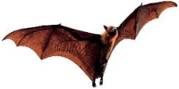  Science:  Research an animal that has a way of hearing that is very different to our own. Then draw a little labelled diagram and write a little explanation to go with it to explain how it hears. | Date:
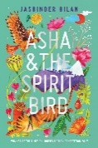  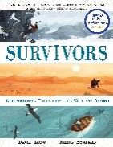  Writing:  Make up your own survivors adventure recount that could feature in the Survivors collection that we are enjoying in our classwork. Or, write an additional chapter of ‘Asha and the Spirit Bird’ including a new, imagined adventure for Asha and Jeevan. | Date: | Measure:  With adult support, try to measure your garden! Draw a little map if that helps and label the measurements on it.  Year 5: Can you calculate the area by multiplying the length by the width? You may need to create separate rectangles then add them together if you garden isn’t a standard rectangle!  Challenge: You could calculate the area of just the grass or just the flower beds! | Date: | P.E.:  With the support of your families, set up an athletics competition in your garden! Try to include a running event, a jumping event and a throwing event! You could then record your measurements and try to improve, or write a newspaper report telling us all about your special competition! | Date:
Spelling:  In addition to practising every week, try to be tested at home on the Spelling List for your year group. Year 4 it’s the Year 3/4 Spelling List and Year 5 it’s the Year 5/6 Spelling List. | Date: | Times Tables:  Please practise the Times Tables facts but multiplied by 10s, 100s, (Y4) 1,000s, 10,000s and 100,000s (Y5 and Y6) instead e.g. 7 x 12 = 85, 7 x 120 = 840 e.t.c..  Challenge: Include decimal numbers, and division too | Date: | History:  Our production, ‘Mystery at Magpie Manor’ is set in the 1920s. With adult support, do a little research into that time period. How was life different then? Try to present your findings creatively. | Date:

