Peace Pole Challenge

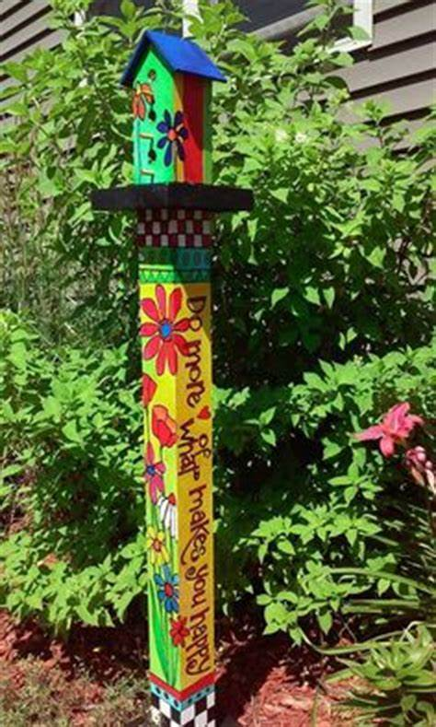
We know that many of you will be getting fed up at home and may be stuck indoors for a little while.

Why not get involved in making something to show that you care for people in your neighbourhood and around the world by making a special peace pole?
Don’t worry, it doesn’t have to be like the one in the picture. You can make a simple paper one using the information below. All we ask is that as many of you as possible display your peace pole in your window to show that you are thinking of others while the doctors and nurses help to cure people of this nasty virus.

What is a Peace Pole?

A peace pole is a world- famous symbol of hopes and dreams, a sort of silent prayer for unity and love on Earth. They are all different, but every peace pole has the same message on it - May Peace Prevail On Earth. There are more than 250,000 peace poles in across countries the world. There’s even one in the North Pole!
This year church schools, churches and parishes in the Portsmouth and Winchester dioceses are creating peace poles as part of the Diocesan Education Team’s ‘Standing Together’ project. The project highlights work that is bringing about peace and unity in our communities. These peace poles will be large and made of wood, a bit like a fence post. They will symbolize a school or church’s vision for peace and simultaneously link this work with that of people of all faiths and nationalities worldwide who are striving for a world where people care for and look after each other without prejudice.
Design your own Peace Pole

Research the history and design of peace poles, before writing and planning ideas for your own. There are so many beautiful ones to inspire. You will find lots of information by doing a Google search.

Decide what words, pictures and colours you would like on your pole. If you’re stuck for ideas, there’s plenty of images on the internet to get your imagination going!

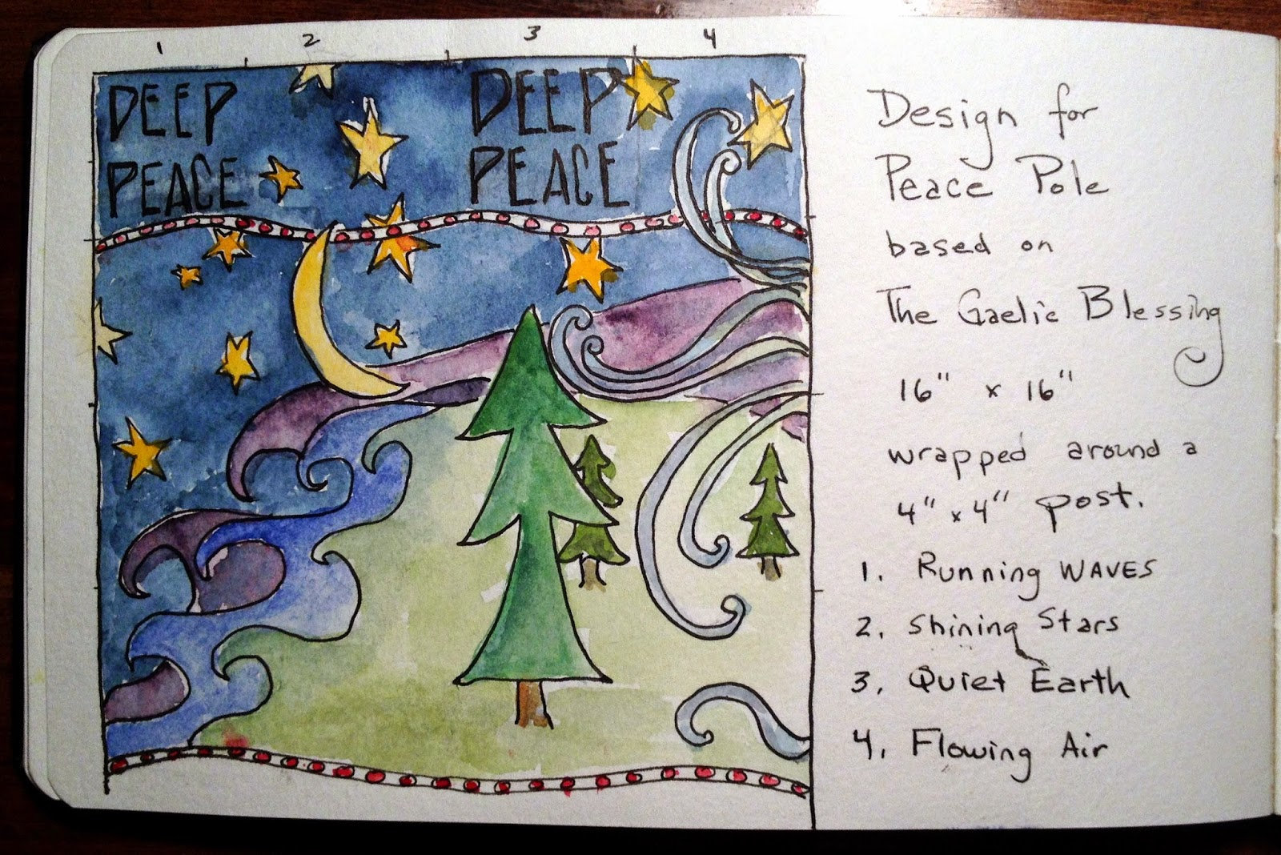
Draft your design on a strip of paper or card (the inside of a cut up cereal packet is great for this). Remember that somewhere you must write the message ‘May peace prevail on Earth’ on your peace pole design.

You may like to write in different languages, click the ‘translation’ link on the home page of the website below:
https://www.peace-pole.com/make-your-own

If you have a printer at home, you can find a 3D peace pole outline online at https://www.activityvillage.co.uk/sites/default/files/styles/medium/public/images/cuboid_net_460.jpg?itok=qjFMKol7
Once you are happy with your design, you can make a best version of your pole, using colours to bring your design to life. You can make a flat pole on paper or card or roll your paper to make a cylinder pole that you can stand up.
You can use crayons, felt tips, or paint if you have any at home. However, a simple pencil or pen pole can look great too. Of course, you don’t need to stop at colouring in – poles can be decorated with fabric, shapes, covered in cardboard doves with prayers on, whatever you have at home to make your pole special.

Display your design in a window and show the world you are standing together for love and peace

If you can, take a photograph and consider uploading your design onto the peace pole project website – and don’t forget to email a copy to school if you can!

Of course, if a grown-up wants to help you create a larger wooden pole for your garden, that would be great!

Enjoy making your peace pole and being part of standing together for a better world!

Thank you

