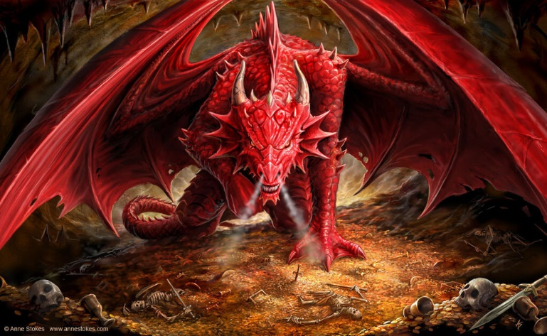

In English writing we will be…
- Practising our writing skills through short pieces of writing.
- Writing an instructional text involving dragons.
  - Using imperative verbs, modal verbs and adverbs of possibility (Y6).
  - Using basic punctuation and commas to clarify meaning and avoid ambiguity in writing.
  - Using various sentence starters including adverbials, subordinating conjunctions and imperative verbs and using conjunctions to extend sentences.
- Writing descriptions of dragons and mythical creatures, settings and plot.
  - Using expanded noun phrases, fronted adverbs and adverbials (Y6).
  - Using figurative language such similes, metaphors and onomatopoeia.
  - Using paragraphs and the correct speech punctuation (Y5).
- Developing our skills of using a dictionary, planning, proof-reading, understanding the marking code and responding to feedback.

In English reading we will be…
- Comparing, analysing and annotating a variety of instructional texts.
- Identifying features of different myths and legends involving dragons and other mythical creatures.
- Analysing, clarifying, summarising and retrieving facts from a range of texts.
- Understanding the different ‘Reading Roles’ to help us to think about texts thoroughly and from a more critical perspective. Please see the attached sheet.

In our ‘English Grammar, Punctuation and Spelling’ we will be…
- Reviewing our knowledge of the basic grammar terms, word classes and punctuation uses.
- Reviewing previous spellings patterns, practising Y5 and Y6 spellings words, introducing new spelling rules and learning different spelling strategies.
- Y5: Using modal verbs, adverbs, and relative clauses.
- Y6: Understanding synonyms, antonyms and object and subject.

In Mathematics we will be…
- Place Value: Reading, writing and comparing numbers up to 10,000,000. Rounding any number up to 1,000,000. Identifying the value of each digit and multiplying and dividing by 10, 100, 1000. Y6: Decimal numbers, negative numbers and place value reasoning problems.
- Calculations: Practising mental adding and subtracting skills. Solving problems involving addition and subtraction using formal methods. Y5: Identifying multiples, factors, prime numbers and factor pairs. Multiplying and dividing whole numbers. Y6: Multiplying and dividing up to 4-digit numbers by a 2-digit number using a formal method.
- Measure: Estimating, comparing, measuring and calculating with different units of metric measurement. Y5: Converting between different units of metric measure. Y6: Convert between standard units of metric and imperial measure up to three decimal places.

In Science we will be…
- Learning about the differences in the life cycles of mammals, birds, insects, amphibians and plants.
- Describing the life process of reproduction in some plants and animals.

In Art and DT we will be…
- Designing and creating a Modroc dragon egg and learning sculpting skills with wire and paper mâché.

In PSHCE we will be…
- Creating a class charter and learning about the United Nations Convention on the Rights of the Child.

Discussing how to keep safe online.

In French we will be…

Learning and revising key communication skills and general greetings.

In Music we will be…

Listening and responding to ‘A Bao A Qu’ by Mason Bates and composing our own pieces about dragons using different musical structures e.g. palindromes and rondos.

In RE we will be…

Understanding Christianity and considering ‘What would Jesus do?’

In PE we will be…
- Creating a dance inspired by the mythical creature, the phoenix, using different techniques like mirroring, unison and canon.
- Playing invasion games with a focus on football

In Computing we will be…
- Learning about E-Safety.
- Creating a game using the coding program Scratch.

This term’s vocabulary will be…
Science Life Cycles: reproduction, foetus, sperm, babyhood, childhood, adolescence, adulthood, metamorphosis, egg, tadpole, larva, pupa, seed, seedling, stamen, stigma, sepal, petal, ovary, pollen, style, germinate, germination, fertilisation, pollinate, pollination, disperse, dispersal, etc.

