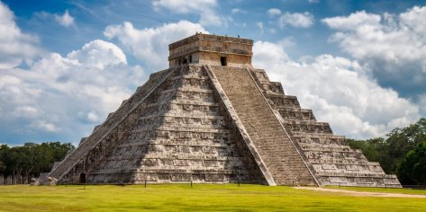
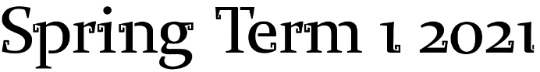
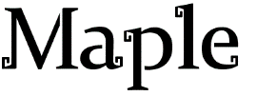
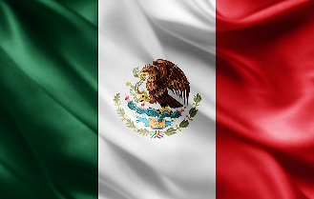

Hello Maple families! This term our topic is Mexico and The Mayans! Please choose at least two from each column for this half-term, and record which activities have been completed by adding the date into the box provided. You can also add comments about how your child got on if you wish! I look forward to hearing what you have learnt about!
English |  | Maths |  | Topic
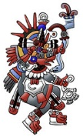  Reading:  With an adult, try to find a Mexican or Mayan myth. Once you have read it, summarise it in five steps (perhaps the story mountain steps: opening, build-up, conflict, resolution and ending). | Date:  Comments: | Measure:  With an adult, find a recipe for a Mexican dish for 4 people e.g. Chilli con carne on BBC Goodfood. Imagine you are having a party for 20 people. How much of each ingredient will you need now? Remember to include the units of measurement. Extension: With an adult’s help, work out how much it would cost approximately to buy the ingredients. | Date:  Comments: | 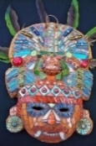  Art activity:  Design and draw a Mayan mask to celebrate a Mayan God. Annotate your design with materials that you would use and who the mask is celebrating. Lots of Mayan masks used mosaic for decoration, like the ones found in Roman times. If you have materials, you could make it. | Date:  Comments:
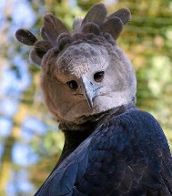  Reading:  Research animals that can be found in the Mexican rainforest and make a fact-file for each one. Try to find information from more than one source i.e. books and (with an adult) the Internet. | Date:  Comments: | 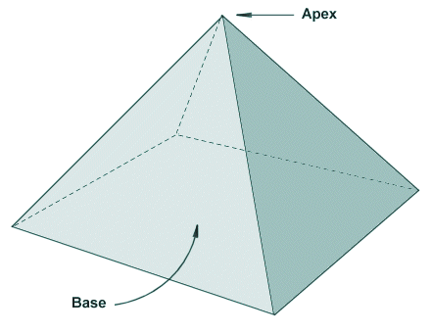  Shape:  The Mayans constructed pyramids. Make fact-files for triangular- and square-based pyramids. What are their properties? Can you draw them using a ruler? Can you label them? Can you create 2D nets for them? Can you make them from straws (or similar)? | Date:  Comments: | 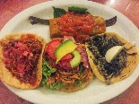  D.T. activity:  Research traditional Mexican foods e.g. salsa, guacamole, quesadillas, enchiladas, fajitas and nachos. Draw the dish and label the key ingredients. You could have a go at making one them with your family! | Date:  Comments:
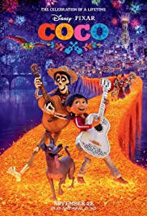  Writing:  With an adult, watch the Disney film Coco (PG) and then write a film review OR write a description of one of the characters OR continue the story after the film ends OR write a different ending. | Date:  Comments: | Shape:  Create a Mexican/Mayan colour-themed (green, red and white or gold, azure blue, orange) mosaic pattern on squared paper (please let me know if you need some from school to do this!)  Y4: It must have at least one line of symmetry  Y5: It must have at least two lines of symmetry | Date:  Comments: | 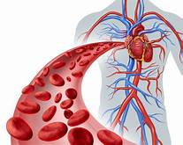  Science activity:  Make a glossary for human circulation. Find out the definitions of these words: heart, blood vessels, arteries, veins, capillaries, aorta, red blood cells, platelets and white blood cells. | Date:  Comments:
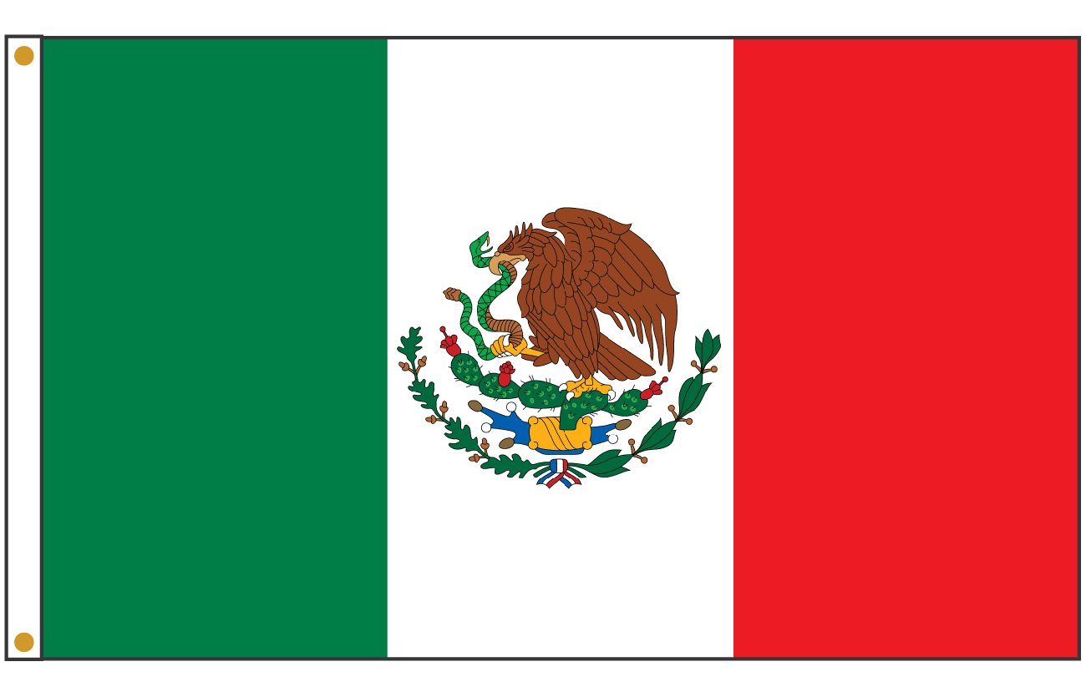  Reading and Writing:  Choose one tourist destination in Mexico or one of the famous Mayan ruins to research. Create a leaflet persuading tourists to visit this destination. Include an introduction and a conclusion.  Y4: Use headings and sub-headings  Y5: Write in paragraphs that flow from one to the next | Date:  Comments: | Number and Calculation:  The Maya were the first civilisation to create the number zero, as a placeholder. A placeholder is very important in maths, especially in long multiplication. Create and calculate some long multiplication sums (Y4 up to 3-digits; Y5 up to 4-digits) and highlight the placeholders you see and what they represent. For example, 1307, the placeholder represents zero tens. | Date:  Comments: | Music/P.E. activity:  With an adult, listen to the instrumental piece of music “Jálale – Instrumental” by the Mexican Institute Of Sound from the Coco soundtrack. Use an instrument you have at home, or make a simple one from recycling, or use your body to make an instrument (singing, beat-boxing, clapping etc) to accompany the piece of music. Alternatively you could make up a dance! Perhaps you could film it! | Date:  Comments:
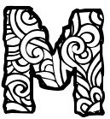  Spelling:  In addition to practising every week, try using different Mexian or Mayan inspired fonts/decorative writing to write your spelling words in! | Date:  Comments: | Times Tables:  Please practise your times tables every week. For the sums that you get stuck on try to make them memorable e.g. draw them, make up a song…If you are confident then practise to get even quicker! | Date:  Comments: | Geography activity:  Draw a map of Mexico and label it with your favourite topic i.e. where animals can be found, cities, beaches, battles, food, Mayan ruins – have fun while still being factually correct! | Date:  Comments:

