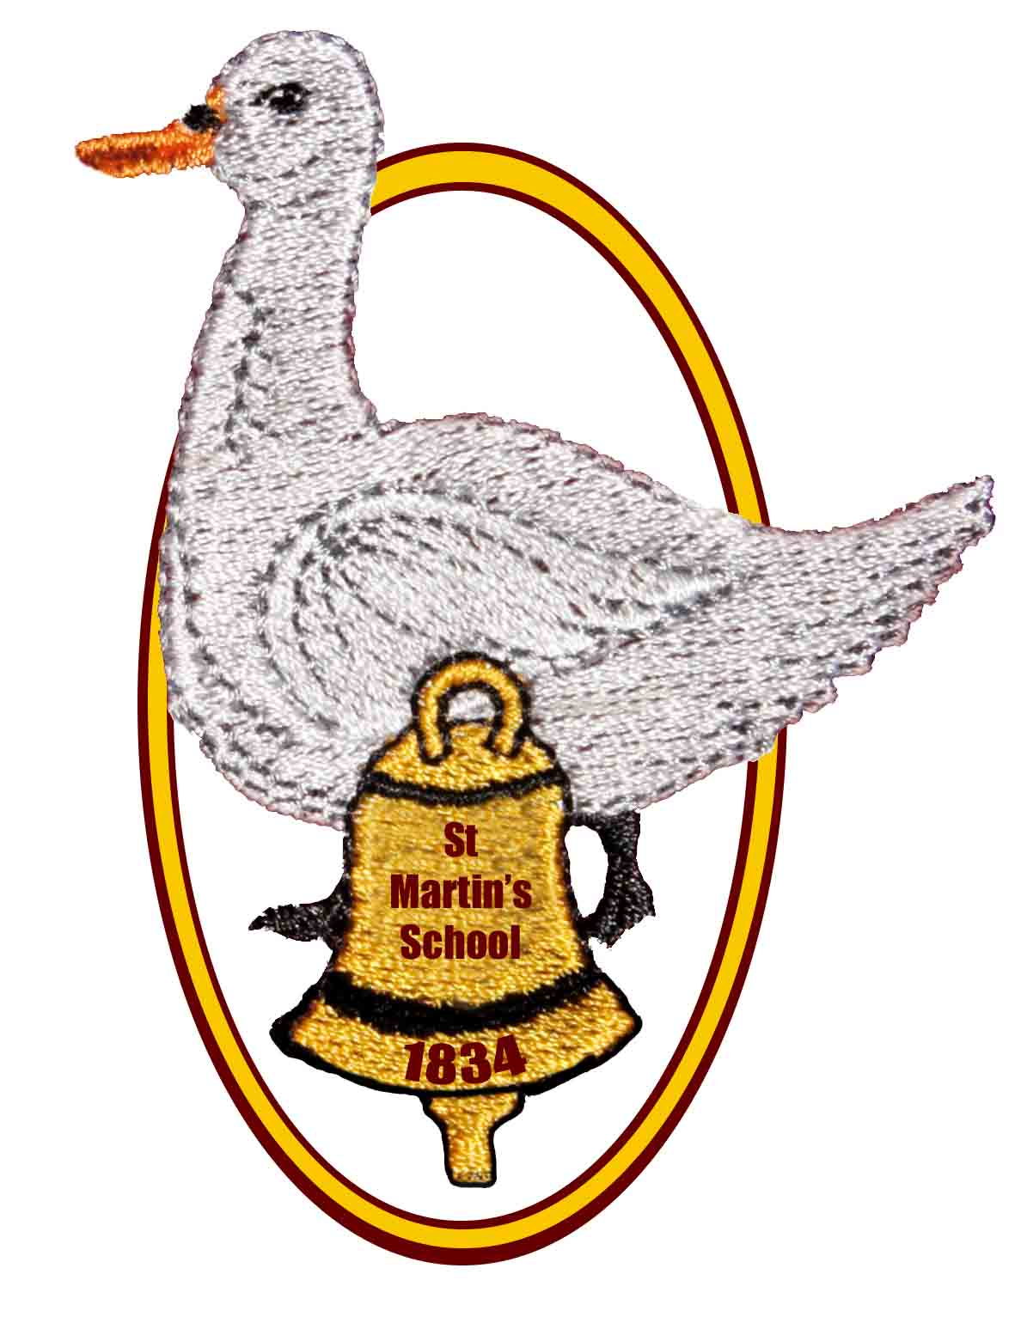
St Martin’s CE (Aided) Primary School

East End, Newbury, Berkshire RG20 0AF

Telephone: 01635 597796

E-mail: adminoffice@st-martins.hants.sch.uk

Headteacher: Mrs K Bartlett

Uniform Policy

Status: Draft / Final

Date policy produced/reviewed: 01.11.17

Policy produced/reviewed by: Headteacher

Ratified by the governing body: 29.11.17

Signed:

Position:

Date of next review: November 2020

St Martin’s CE (Aided) Primary School
Uniform Policy

We believe that a uniform looks smart, is practical, and contributes to a sense of belonging and to the health and safety of your child in the school environment. We actively encourage our children to wear school uniform and to take a pride in being part of the school community.

Some of our uniform can be bought in high street shops, but some school specific items need to be bought from Skoolkit, Kennet Centre, Newbury - www.skoolkit.co.uk

Uniform
*Maroon sweatshirt or cardigan with embroidered school logo
*White polo shirt, blouse or shirt
*Tailored grey school trousers, shorts, skirt or pinafore
*Black closed in school shoes or boots (no open toes, high heels, casual sandals or trainers) – black laces if laces required
*Green and white checked gingham dress or separates for the summer

Physical Education
*Black or navy shorts
*School T-shirt in the correct house colour (North – Blue, South – Yellow, East – Red and West - Green)
*Black jogging bottoms and sweatshirt or black tracksuit for outdoor activities when it is cold
*Plimsolls or trainers that can be securely fastened
*A hair tie, if necessary (long hair must be tied back for all P.E. activities)

Other items available
*Reversible waterproof school jacket - for outdoor use only

Jewellery
For health and safety reasons jewellery is not permitted in school with the exception of:
- one stud earring in each ear, which should be removed by the child for P.E. or covered with tape brought from home;
- a watch with a clear display that your child can use (no novelty watches), which should be removed for P.E.
If you are considering having your child’s ears pierced, we would recommend that it is done at the start of the summer holidays, allowing time for the healing process and giving your child the opportunity to become familiar with removing and replacing the earrings. Please be aware that, on the grounds of health and safety, we are not permitted to remove or replace children’s earrings.

If your child needs to wear jewellery for medical or religious reasons please discuss this with the Headteacher.

Accessories
We encourage plain hair accessories for school, and make up, nail varnish and tattoos are not suitable for school.

Hats
Hats can be worn for warmth or sun protection as necessary during break times and lunchtimes.

Second Hand Uniform
A selection of second hand uniform is available for a small donation to our School Association. Please contact the School Office is you are interested.

All uniform must be clearly labelled with the child’s name.

